yr

CORAF/WECARD

Forun for Agncuiural Research in Africa

The Government of the Gambia



REVIEW OF THE NATIONAL AGRICULTURAL AND FOOD SECURITY INVESTMENT PLANS (NAFSIPS) AND DETERMINE IMPLEMENTATION CAPACITY GAPS

Report prepared by

Mamadi B. Ceesay

Baba Galleh Jallow

Ebrima Camara

July 2016

MAP OF THE GAMBIA

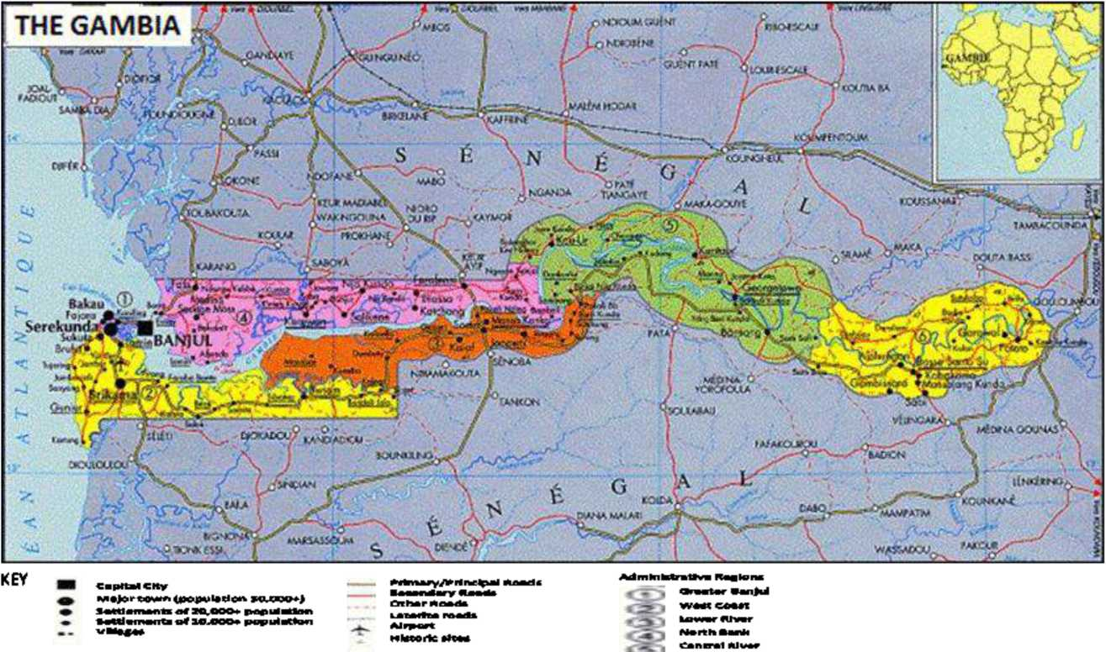

MOP**'

**REVIEW OF THE NATIONAL AGRICULTURAL AND FOOD SECURITY  
INVESTMENT PLANS (NAFSIPS) AND DETERMINE IMPLEMENTATION  
CAPACITY GAPS**

Contents

MAP OF THE GAMBIA i

Contents i

Executive summary iv

ABBREVIATIONS AND ACRONYMS vi

1. . INTRODUCTION 1
   1. Background 1
   2. Agricultural and Food Security Context 1
      1. Agricultural sector 1
      2. Food and Nutrition Security 2
   3. Review of Macroeconomic and Sector policies and Strategies 2
      1. Vision 2020 2
      2. Agriculture and Natural Resources Policy (ANRP 2009-2015) 3
      3. Trade Policy (2011-2016) 3
      4. Programme for Accelerated Growth and Employment (PAGE 2012-2015) 3
      5. Vision 2016 4
      6. Other Related Policies 4
   4. Brief Review of the Gambia National Agricultural Investment Plan (GNAIP) 4
   5. Main Priority Speculations/Value chains 5
      1. Rice Value Chain 6
      2. Coarse grains Value Chain 6
      3. Groundnut 7
      4. Horticulture Value Chain 8
      5. Livestock Value Chain 9
      6. Fisheries value chain 10
   6. Objectives of GNAIP/NAPSIP Review 11
2. METHODOLOGY 11
   1. Review of GNAIP and Development Framework Documents 11
   2. Identification of Potential Areas of Innovation and Actors 11
      1. Institutional and Human Capacity Assessments 11
   3. Data Analysis and synthesis 12
   4. Difficulties encountered in the study 12
   5. Limitations of the study 12
3. RESULTS AND DISCUSSIONS 13
   1. Growth Performance of the Sector 13
   2. Investments in the GNAIP 14
      1. Public Sector Financing of the Agricultural sector 14
      2. Public Sector Investment-project Interventions 16
      3. Commercial Sector Loans 16
      4. Private Sector Investment 17
   3. Priority Investment areas and major value chains 18
      1. Rice value chain 18
      2. Coarse grain value chain 20
      3. Groundnuts Value Chain 26
      4. Horticulture Value Chain 27
      5. Livestock value chains 30
      6. Fisheries Value Chains 32
      7. Value chain Support Services and Cross Cutting Issues 34
   4. Institutional and Human Capacity Assessment 35
      1. Level 1: Enabling Environment 35
      2. Level 2: Organizational Capacity 36
      3. Level 3: Individual staff of Participating Organizations 37
   5. Lessons Learnt 38
4. CONCLUSIONS AND RECCOMMENDATIONS 38
   1. Conclusions 38
   2. Recommendations 40

BIBLOGRAPHY 41

ANNEXES 42

1. TERMS OF REFERENCE 42
2. GNAIP Investment Programmes, Result Framework and Value Chain Actors 46
3. Value Chain Maps 81

List of tables

1. SWOT Analysis of the Rice value chain 6
2. SWOT Analysis of Coarse Grains 7
3. SWOT Analysis of Groundnuts 7
4. SWOT Analysis of the horticulture value analysis 8
5. SWOT Analysis of the Livestock Value Chain 9
6. SWOT Analysis of the fisheries value chain 10
7. Projects to meet GNAIP Funding Gap 16
8. Credit to Private Sector (and Personal loans) by sector, 2011 to 2014 17
9. Private investments in the agriculture sector (2010-2014) 17
10. Achievement in Lowland Rice Area and Productivity by Ecology 18
11. Average score for policy level institution 35
12. Average score for Institutional/Organizational Level Capacity 36
13. Level 3 (a) Individual Human Capacity (Institutional Staff) 37
14. Level 3 (b) Individual Human Capacity (farmers) 38

Annex 2 Table 1: GNAIP Priority Programmes, Commodity Value Chains and Proposed Strategies 46

Annex 2 Table 2: CAADP 2015-2025 Results Framework and the Components of The GNAIP 69

Annex 2 Table 3: Value Chain Actors for Gambia’S NAFSIP (GNAIP) 74

Annex 2 Table 4: Area, Yield and Production of Major Crops by end 2015 80

Annex 2 Table 5: Contributions to GNAIP Funding Gap through other sectors 81

***List of Figures***

1. GDP, Agriculture and Natural Resources Sector Growth Rates 13
2. Agriculture and Natural Resources Sectors' Contribution to Real GDP Annual Growth Rate (2005-2015) .. 14
3. Proportion of National Budget Allocated to The ANR Sector 15
4. ANR Sector Budget Execution 15
5. Paddy Rice Cultivated Area GNAIP Period 19
6. Total Paddy Rice Production NAFSIP Period 19
7. Coarse Grain Total Cultivated Area NAFSIP Period 21
8. Coarse Grain Total Production NAFSIP Period 21
9. % Crops Cultivated Areas Achieved by 2015 22
10. % Crops Yields Achieved by 2015 23
11. Coarse Grain Total Production NAFSIP Period 24
12. % Production Achieved by 2015 25
13. G/nuts Total Cultivated Area NAFSIP Period 26
14. G/nuts Total Production NAFSIP Period 27
15. Communal & Non/communal Farmers by Sex & Region 28

Figure 14: Production of Vegetables in 2013 29

1. Livestock Population 2011 and 2014 31
2. Atlantic and Inland Fishery Catches 2011-2015 33
3. Per Capita Consumption of Fish in the Artisanal Sub-sector 34

Annex 3 Figure 1: Rice Value Chain Map 82

Annex 3 Figure 2: Coarse Grain Value Chain Map 83

Annex 3 Figure 3: Groundnut Value Chain Map 84

Annex 3 Figure 4: Vegetable Value Chain Map 85

Annex 3 Figure 5: Commercial Broiler Meat Marketing Chain 86

Annex 3 Figure 6: Commercial Egg Production Value Chain 87

Annex 3 Figure 7: Pig Value Chain 88

Annex 3 Figure 8: Fish Value Chain: Production, Trade, Processing, and End Markets 89

Executive summary

*In pursuit of Africa’s agricultural growth and transformation goal for the period 2015-2025 endorsed by the African Union heads of States and government in Malabo in 2014, there has been renewed commitment to the African Union Commission/New Partnership for Africa’s Development (AUC/NEPAD) pioneered Comprehensive Africa Agricultural Development Program (CAADP). The CAADP process entailed developing Regional Agricultural Investment Plans (RAIPs) and National Agricultural and Food Security Investment Plans (NAFSIPs). The AHC-Staff is undertaking exhaustive studies to determine current and future capacity needs to propel African agriculture and recommend appropriate capacity strengthening actions to address overall national capacity needs. Led by FARA CORAF/WECARD is supervising four studies in each of the selected countries in West Africa.*

*This study is concerned with Reviewing the NAPSIP and Determining Gaps and have the objectives (i) to conduct an exhaustive review of the weaknesses in terms of human and institutional capacities for the selected Post-Compact CAADPs to implement the NAPSIPs; and, (ii) to furnish the information for the formulation of a framework of development of the global human resource capital to sustain the implementation of the CAADP. The methodology employed for the assignment comprised both primary and secondary data collection, collation and analysis with desk review and key informant interviews using checklist/questionnaire. The questionnaire has been administered at three levels described below.*

*The review revealed that an annual growth rate of 4% was realized instead of the annual targeted 8% under GNAIP. Government’s budgetary allocations to the ANR sector during the GNAIP period, did not reach the 10% required under the Maputo Declaration; investments through donor funded projects could not fill the funding gap; and, Commercial Bank loans to agriculture averaged less than 5% for the period.*

*Achievements in the priority investment areas were generally below the targets set @ i) in the rice value chain only 24,000 Mt of a planned 70,000 Mt for the lowlands was achieved attributed to the very low productivity(yield/ha). Similarly, productivity for upland rice was low with yields of 0.850 Mt/ha against a 2.5 Mt/ha per ha); ii) in the horticulture value chain some 250 ha out of a planned 1,000 ha have been developed and equipped with boreholes, overhead tanks and reticulation systems by public sector projects. A number of horticulture development models using out-grower schemes supported by GCP are being implemented with facilitation of the private sector (GHE and Radville); iii) in the Coarse grain value chain, significant expansion of area took place, however productivity has been stagnant at 0.88 Mt/ha out of a targeted 1.3 Mt/ha and value addition limited. Achievements registered on production of coarse grains was 169,208 Mt of the targeted 222,000 Mt; iv) in the groundnut value chain, significant area expansion was registered with an achievement of 106,000ha out a planned 100,000 ha, the productivity attained (0.815 Mt/ha) is below the targeted (1.2 Mt/ha). Furthermore, quality issues relating to high aflatoxin contamination remain critical for the export market of HPS; v) in the livestock value chains, a revamped Department of Livestock Services (DLS) has been established and a number of public sector projects implemented (LHDP, PROGEBE, FAO TCP and TELEFOOD); and, vi) in the fisheries value chain a number of achievements were realized comprising the formulation of strategic framework documents; infrastructure comprising fish markets, jetty and access roads through public sector projects( GAFDP and Japanese Assistance).*

*Level 1: Enabling Environment: Assessment of institutional and human capacities revealed that Political support was highlighted as satisfactory. Involvement in GNAIP processes, outreach and communication of GNAIP were considered moderately unsatisfactory. In this regards, the absence of a communication strategy was a major gap. The principal coordination structure- the Central Project Coordination Unit (CPCU) experienced several changes in coordinator. This together with changes at the senior policy level (Permanent secretary and Minster) resulted in less than optimal coordination during GNAIP implementation.*

***Level 2: Organizational capacity: t****he strategic plan was reported to have a clear mission/vision with an appropriate structure aligned for leadership. Stakeholders were clearly identified and their input into the planning/programming processes rated as satisfactory. However, the human resource capacity aspects of the organizations were considered unsatisfactory for their effective functioning and implementation of the Plan due to weaknesses in performance management and staff development; critical capacity issues; and, in management of financial resources.*

***Level 3: Individual staff capacities: c****apacity gaps were considered significant with staff registering unsatisfactory scores for skills and incentives. Furthermore, resource gaps (finance, farming equipment, production inputs) were constraints to improving their production and productivity and expansion of enterprises.*

*Key lessons learnt center on performance targets, coordination, communication and capacity building*

***Recommendations:***

*Government needs to honour its commitment to the Maputo Declaration and allocate 10% of its budgetary resources to the ANR sector from the 6.7% average of the GNAIP period. Similarly, the ANR sector Ministries needs to improve their budgetary execution rate to absorb the financial resources allocated; and, ii) government needs to make concerted efforts to further promote the development in forestry and livestock subsectors through availability of increased investment resources, given their resilience and positive growth during the GNAIP period.*

*ANR sector Ministries need to make urgent efforts to update both the ANR Policy and medium-term GNAIP (2017-2020) through an inclusive participatory process involving all value chain actors.*

***Level 1: Enabling Environment***

*ANR Sector Ministries need to develop and implement an accompanying communication strategy for the follow-up GNAIP hinged on sharing information with all stakeholders at various levels of decision-making and for all value chain actors.*

*ANR Sector Ministries need to strengthen and capacitize the Central Project’s Coordinating Unit (GNAIP Coordinating Structure) with relevant manpower for coordination. Similarly, the various decision-making organs, including the high level inter-ministerial body need to convene regular meeting to provide oversight.*

*ANR sector Ministries need to undertake effective and vigorous resource mobilization to attract both traditional and non-traditional donors for increased investment resources to the sector. A key element of this has to be the creation of a forum to allow periodic but frequent Joint ANR Sector Reviews with donors in which civil society is an active partner.*

***Level 2: Organizational capacities***

*ANR Sector Ministries need to build the capacity of both public and private organizations particularly in performance management and staff development, critical capacity issues and management of financial resources for effective delivery on programmes/plans.*

***Level 3: Individual human capacities***

*ANR Sector Ministries need to undertake capacity building at all levels of decision-making and for value chain actors at all stages. In this regards acquisition of relevant skills and provision of performance incentives are crucial.*

ABBREVIATIONS AND ACRONYMS

|  |  |
| --- | --- |
| AAITG  ABS  AES  AHC-STAFF | ActionAid International The Gambia  Agribusiness Services  Agricultural Engineering Services  African Human Capital in Science, Technology and Agri-preneurship for Food  Security Framework |
| ANR  AUC  CAADP  CBPP  CEES  CORAF/WECARD  CPCU CRRS CRRN CU  DOA  DLS  FAO  FADSEP  FARA  FTS  GAFSP  GASTA  GCCI GEAP  GHE  GLMA  GNAIP HTS  MDG 1C  MOA  MOFEA MOTIE NA  NACOFAG NAFSIP  NaNA  NARI  NAWFA  NBR  NCD  NEA  NEPAD | Agriculture and Natural Resources  African Union Commission  Comprehensive Africa Agriculture Development Programme  Contagious Bovine Pleuro-Pneumonia  Communication, Education and Extension Services  West and Central Africa Council for Agricultural Research and Development  Central Project Coordination Unit  Central River Region South  Central River Region North  Concern Universal  Department of Agriculture  Department of Livestock Services  Food and Agriculture Organization  Food and Agriculture Sector Development Project  Forum for Agricultural Research in Africa  Food Technology Services  Global Agriculture and Food Security Programme  Gambia Agrochemical and Seed Traders Association  Gambia Chamber of Commerce and Industry  Gambia Environmental Action Plan  Gambia Horticultural Enterprises  Gambia Livestock Marketing Agency  Gambia National Agricultural Investment Plan  Horticulture Technical Services  Millennium Development Goals  Ministry of Agriculture  Ministry of Finance and Economic Affairs  Ministry of Trade, Regional Integration and Employment  National Assembly  National Coordinating Farmers Association of the Gambia  National Agricultural and Food Security Investment Plan  National Nutrition Agency  National Agricultural Research Institute  National Women Farmers Association  North Bank Region  New Castle Disease  National Environment Agency  New Partnership for Africa’s Development |

|  |  |
| --- | --- |
| NFPG PPR PPS PSU SWMS TANGO TATM WAAPP WCA WCR WFP | National Farmer’s Platform, The Gambia  Pestes de Petites Ruminantes  Plant Protection Services  Planning Services Unit  Soil and Water Management Services  The Association of Non-Governmental Organizations in The Gambia  Taiwanese Agricultural Technical Mission  West African Agricultural Productivity Project  West and Central Africa  West Coast Region  World Food Programme |

**Currency Equivalents**

(July 2016)

Local Currency = Dalasi (GMD)

|  |  |
| --- | --- |
| USD 1 =  GMD 1= | GMD 40  USD 0.025 |

1. INTRODUCTION

* 1. Background

In pursuit of Africa’s agricultural growth and transformation goal for the period 2015-2025 endorsed by the African Union heads of States and government in Malabo in 2014, there has been renewed commitment to the African Union Commission/New Partnership for Africa’s Development (AUC/NEPAD) pioneered Comprehensive Africa Agricultural Development Program (CAADP). The CAADP process, entailed developing Regional Agricultural Investment Plans (RAIPs) and National Agricultural and Food Security Investment Plans (NAFSIPs). The African Human Capacity in Science, Technology and Agr-preneurship for Food Security Framework (AHC-Staff) seeks to undertake exhaustive studies to determine current and future capacity needs to propel African agriculture and recommend appropriate capacity strengthening actions to address overall national capacity needs. In this regard, the project will address national capacity needs for knowledge/technology generation, dissemination, adaption and utilization in priority of the NAFSIPs (synonymous to GNAIP). While the global process for the implementation of the AHC-STAFF will be led by FARA, in West and Central Africa, CORAF/WECARD will supervise actions at the regional level, coordinate the implementation at country level and capitalize the results to develop a regional capacity building strategy for the effective implementation of the CAADP. The main results expected from each country comprise:

1. Review of the NAFSIPs to determine gaps;
2. Assess Human capital requirements along technology and value chains;
3. Assess and forecast qualitative human capital requirements in agriculture and agribusiness; and,
4. Analyze yield gaps of key agricultural commodities identified in the NAFSIPs.

It should be noted that for each country, the results of these studies will be consolidated to develop the National capacity strengthening strategy for the effective implementation of the CAADP and the Science Agenda for Agriculture in Africa (S3A).

* 1. Agricultural and Food Security Context
     1. Agricultural sector

The Gambia is among the Low-Income Food Deficit Countries (LIFDCs) on the globe with pervasive and endemic poverty. The Gambia was ranked 175 out of 188 countries in the UNDP’s Human Development Index (HDI) of 2014. With a GDP per capita of USD 428 in 2014, the country’s Gini coefficient (47.3 in 2013) is among the highest in the ECOWAS region, with poverty concentrated among the rural population. A person living in the rural areas is twice as likely to live in poverty as someone living in the urban areas. Recent surveys (IHS[1], 2010) indicate poverty headcount at 48.4% with rural poverty at 73.9% and urban poverty at 32.7%.

The Gambia’s economy is primarily agrarian, with farming the main source of livelihoods, especially among rural dwellers. Agriculture and related activities constitute the principal source of livelihood for most Gambians. The sector is however characterized by low production, low productivity, limited diversification, low capacity and skills amongst institutions and individuals and low value addition, with smallholder farmers among the poorest and who are primarily net food purchasers.

According to data from Gambia Bureau of Statistics (GBoS, 2015), the sector employs about 70% of the predominantly rural labour force, accounts for about 25% of GDP, and generates 40% of total export earnings and an estimated two-thirds of total household income. Services account for over 50% of GDP, attributed mainly to tourism and the re-export trade. Domestic food production caters for half the national consumption requirements, with the gaps filled by imports particularly of rice - the main staple. Current annual rice imports exceed US$ 40 million.

* + 1. Food and Nutrition Security

Employing the definition of food security[2] (FAO), food insecurity can be discerned at regional, household and individual levels. Households in The Gambia experience both acute and chronic food insecurity. According to WFP (2013) re-classification of January 2011 Vulnerability Analysis and Mapping (VAM) baseline data, two-thirds of Gambian households face some form of food insecurity and are especially vulnerable during the pre-harvest lean season from June to September. The Global Hunger Index (GHI) computed by International Food Policy Research Institute (IFPRI) using three principal indicators: level of child malnutrition, rate of child mortality and proportion of people who are calorie deficient indicate that The Gambia has registered consistent improvements from a score of 36.4 in 1990 (1988- 1992) to 21.5 in 2015 (2010-2016). The country nonetheless remains in the serious category.

Nutrition meanwhile remains an important cross-cutting development concern. The 2015 SMART[3] survey (conducted in September-October) reports an increase in levels of malnutrition as compared to 2012. According to the survey stunting increased from 21.2% in 2012 to 22.9% in 2015, underweight increased from 18% in 2012 to 21.6% in 2015) and wasting increased from 9.9% in 2012 to 10.3% in 2015. North Bank, Central River and Upper River are the regions where malnutrition is the most prevalent. Micro­nutrient malnutrition (iron deficiency anemia and deficiencies of vitamin A and iodine) is also prevalent in the country.

Food insecurity in The Gambia is characterized by regional and temporal variations with Lower River, Central River and Upper River the most vulnerable and August and September the difficult period.

Key causes of food insecurity center around: access to food through own production and ability to purchase from the market; livelihood and coping strategies of the population; contribution to agricultural production at both farm and national level; government policies to manage shocks; import and subsidy policies; institutional issues; and macroeconomic and diversification policies.

* 1. Review of Macroeconomic and Sector policies and Strategies
     1. Vision 2020

Referred to as the “The Gambia Incorporated Vision 2020” this constitute the long-term development policy framework (1996-2020) and is aimed at transforming The Gambia into a middle-income country by 2020. Its mission being *"To transform The Gambia into a financial centre, a tourist paradise, a trading, export-oriented agricultural and manufacturing nation, thriving on free market policies and a vibrant private sector, sustained by a well-educated, trained, skilled, healthy, self-reliant and enterprising population and guaranteeing a well-balanced eco- system and a decent standard of living for one and all under a system of government based on the consent of the citizenry."*

The operationalization of the Vision hinged on a number of medium term macroeconomic development frameworks notably the: Strategy for Poverty Alleviation (SPA-1995-1999), The Poverty Reduction Strategy Papers I and II (PRSP I: 2003-2006 and PRSP:II 2007-2011), The Programme for Accelerated Growth and Employment (PAGE -2012-2015) linked with the UN Millennium Development Goals (MDGs) and the sectoral policies comprising the Agriculture and Natural Resources Policy (ANRP 2009­2015), the Trade policy (2011-2016), the National Nutrition Policy (2010-2010), the National Youth Policy (2009-2018), the GEAP (Phase I-1992-2001 and Phase II-2009-2018) and the Gender and Women’s Empowerment Policy (2010-2020), National Health Policy (2012-2020) and Education Policy (2004-2015).

* + 1. Agriculture and Natural Resources Policy (ANRP 2009-2015)

The Agriculture and Natural Resources (ANR) Policy framework (2009-2015) charts the nature and scope of interventions in poverty reduction and achievement of Vision 2020 and the Millennium Development Goals (MDGs) for the sector. It has the following key strategic objectives: improved and sustainable measurable levels of food and nutrition security in the country and vulnerable populations in particular; a commercialized ANR sector ensuring measurable competitive, efficient, and sustainable food and agricultural value chains, and linkages to markets; institutions (public and private) in the sector are strengthened, and providing needed services, strong and enabling environment, and reducing vulnerability in food and nutrition security; and sustainable effective management of the natural resource base of the sector.

* + 1. Trade Policy (2011-2016)

The National Trade Policy (2011 -2016) provides the framework for trade in commodities, particularly those related to agriculture. The policy's strategies and measures relevant to agriculture include the following: pursuance of policies to improve the agribusiness environment to attract in subsectors with potential for export (horticulture, cashew, groundnuts) and commercial investment in rice and horticulture; promotion of the processing of agricultural produce for value addition; and ensuring that national products meet international standards to improve market access. In this regard it proposed a number of supportive measures comprising investment and export promotion incentives, access to land, skills development for productivity improvement and investment finance (exchange rate stability).

* + 1. Programme for Accelerated Growth and Employment (PAGE 2012-2015)

The Program for Accelerated Growth and Employment (PAGE 2012-2015), the national strategy, emphasizes fiscal adjustment, together with infrastructure investment and structural reforms to support inclusive growth. It is based on five pillars: (i) Accelerating and sustaining economic growth; (ii) Improving and modernizing infrastructure; (iii) Strengthening human capital stock and enhancing access to social services; (iv) Improving governance and increasing economic competitiveness; and (v) Reinforcing social cohesion and mainstreaming cross-cutting issues.

A review[4] of the PAGE conducted in 2014 revealed that its objectives have not been attained and are unlikely to be achieved by 2015. The three objectives included: (i) substantial reduction of poverty levels, (ii) increasing employment, and (iii) raising per capita income of Gambians. The double digit rate of annual economic growth which underpins performance in the three goals was not achieved by 2013 as expected. The growth rate shortfall is attributed to three reasons: (i) drought in 2011 that held back better performance during the PAGE period; (ii) macroeconomic mismanagement and, (iii) overoptimistic projections of annual rates under PAGE that set such high growth without having game changers in the growth drivers to make significant shifts in the baseline level. While the agriculture sector as the main employer and key sector in the fight against poverty registered fluctuations in output and productivity, tourism, as the main foreign exchange earner, showed steady progress in the number of visitors prior to the advent of the Ebola crisis in the sub­region.

* + 1. Vision 2016

In April 2013, the President of the Republic proclaimed the Vision 2016. The overall objective of the vision is to increase rice production to achieve self-sufficiency by 2016. This is to be achieved through a combination of several strategic interventions including expanding areas under cultivation and simultaneously increasing yields from an average of 0.63 Mt/ha to at least 4 Mt/ha, with two harvests per year for all irrigated areas. This will be facilitated by active extension support, availability of mechanization services complemented by tidal and pump irrigation facilities, an active private sector in the rice value chain (production, post-production, handling, agro-processing, transport and marketing) with youth and women playing pivotal roles.

The Vision 2016 comprises 5 components:

1. Land development focusing on increased area under production;
2. Production hinged on increasing production through enhanced productivity;
3. Post-production handling aimed at reducing post-harvest losses and improving quality;
4. Institutional development and strengthening aimed at capacity building and strengthening of value chain actors (input suppliers, service providers, state and non-state actors; and
5. Coordination, monitoring and evaluation for effective and efficient resource utilization.
   * 1. Other Related Policies

Other policies/strategies relevant and related to the ANR sector include: (i) The Gambia Environmental Action Plan (GEAP) which provides the overall policy framework for sound environmental management in the country; (ii) The Biodiversity and Wildlife Policy (2003), which defines a coherent biodiversity/wildlife policy framework as the basis of biodiversity conservation, management and sustainable use; and, (iii) The Fisheries Policy (2007) which among other purposes charts the goals for a rational and long-term utilization of the fisheries resources, the use of fish as a means of improving the nutritional standards of the population and increasing employment opportunities in the sector as well as increasing foreign exchange earnings through exports and aquaculture development.

Also important are : (i) The Forestry Policy (2010 - 2020) that promotes the rational management of the forest resources through the active participation of the rural population who are the direct stakeholders; (ii) The Gender and Women Empowerment Policy, the blueprint for gender equality and women empowerment; (iii) National Youth Policy (2009-2018) focused on mainstreaming youth into the productive sectors including agriculture; and, (iv) the National Nutrition Policy (2010-2020) aimed at mainstreaming nutrition into development.

* 1. Brief Review of the Gambia National Agricultural Investment Plan (GNAIP)

The Gambia National Agricultural Investment Programme (GNAIP 2011-2015) is the national strategic framework to guide the planning and implementation of programmes for the agricultural sector. The GNAIP aimed at achieving an increased agricultural sector contribution to the national economy by improving productivity through commercialization and active private sector participation predicated on a sound macroeconomic framework with the goal of enhanced growth and poverty reduction. In order to meet this goal, the development objective of GNAIP is increased food, nutritional security and household income, including for vulnerable households through increased production, productivity and marketed output, based on sustainable use and management of natural resources in support of national goals of poverty reduction and improved livelihoods.

It defines the parameters of partnership in the agricultural sector, specific commitments to the Government and partners (including ensuring alignment and the commitments to increase aid to the sector), and clarifies the expectations of communities agro-industry and agriculture. The GNAIP has six pillars which form the basis for the six programmes of the investment plan: i) Improved Agricultural Land and Water Management; ii) Improved Management of the Other Shared Resources; iii) Development of Agricultural Chains and Market Promotion; iv) National Food and Nutritional Security; v) Sustainable Farm Development; and vi) GNAIP Coordination, Monitoring and Evaluation

It emanated from The Gambia’s ECOWAP/CAADP Partnership Compact signed on October 28, 2009 in Banjul by Government, Development Partners, Non-Governmental Organizations (NGOs) and Civil Society Organizations (CSOs) with the primary goal of assisting the country to reach a higher level of economic growth through agriculturally-led development that ensures the elimination of hunger and malnutrition, reduces poverty, food, nutrition and income insecurity as well as enables the expansion of exports. The signing of the CAADP partnership compact was followed by the preparation of the Gambia’s GNAIP/NAFSIP which was started in 2009 completed and endorsed by the Government of the Gambia in 2010. Its formulation process was highly participatory and consultative among all stakeholders ranging from the grassroots at village level to the highest decision-making entity through district, regional and national consultative meetings. Further consultations were made with sub-regional organizations such as ECOWAS and its specialized institutions to ensure consistency with CAADP pillars.

The GNAIP has also been fully aligned and consistent with all the macro, agriculture and natural resources sub-sector policies of the country. Macro-policies include: long term Vision 2020 from 1996, PRSP II (2007-2011), Programme for Accelerated Growth and Employment (PAGE, 2012-2015) and the Agriculture and Natural Resources Policy (ANRP, 2009-2015). Agriculture and natural resources sub­sector policies and programme strategies also include: crops and livestock research and extension policy strategies, water resources, fisheries, the Gambia Environmental Action Plan (GEAP II), forestry, and parks and wildlife. These macro-policies and sub-sectoral programme strategies have over time provided a consistent framework to improve and commercialize the ANR sector, promote national food and nutrition security and reduce endemic poverty.

In addition to its consistency with the macro-policies and ANR sector strategies, the GNAIP is modeled on measurable parameters and milestones that were identified at design and approved after completion along the value chain approach.

* 1. Main Priority Speculations/Value chains

The principal value chains comprise rice, coarse grains (maize, millet, sorghum, findi), groundnuts, horticulture (fruits and vegetables), livestock and fisheries. These also constitute the principal value chains in the GNAIP. In each of the value chains presented, a summary description is provided followed by a Strength, Weakness, Opportunity and Threat (SWOT analysis) and a list of the value chain actors.

* + 1. ***Rice Value Chain***

Rice is the principal staple food for most Gambians with an average per capita consumption of 117 kg per annum. Rice production is undertaken in both lowland and upland ecologies. In the lowland six main ecological areas exist: natural depressions, run-off inundated flood plains, back swamps, seasonally saline tidal swamps, pump irrigated schemes and tidal irrigated schemes. Due to the high consumption requirements, national production only meets 20% of the requirement, with the rest filled through commercial imports and food aid. Annual imports range from 150,000 Mt to 200,000 Mt. Table 1 presents a summary SWOT of the rice value chain.

Table 1: SWOT Analysis of the Rice value chain

|  |  |
| --- | --- |
| **Strengths**  Long period and tradition of rice production.  Existence of farmer organizations for rice in general and for NERICA in all regions of the country.  Availability of large areas of land suitable for irrigation and for rain-fed production. | **Weaknesses**  Low productivity particularly of swamp rice with low yields.  Limited promotion and support for locally produced rice.  Inadequate infrastructure and facilities for value addition (processing, packaging).  Limited area under double cropping.  Poor service provision to farmers-land preparation, processing, marketing and other support services. |
| **Opportunities**  High demand for rice-main staple for Gambians.  Unexplored potential of irrigable areas.  Yield increment and reduced post-harvest losses by applying Good Agricultural Practices (GAP) and Good Storage Practices (GSP).  Rural electrification programme with enhanced access to energy for value addition.  Political support through the Vision 2016 for increased production. | **Threats**  Competition of cheap rice imports from Asia.  Climate change culminating in drought and salinity of irrigable areas.  Pests and disease outbreaks.  Aflatoxin contamination along the value chain further reducing quality |

Key actors in the rice value chain comprise smallholder farmers (principally women), input and service providers (fertilizer, seeds, land preparation, milling and transportation), extension agencies (MOA and NGOs), public sector development projects (land development, water controlled infrastructure, starter­inputs), policy (MOA, MOFEA, MOTIE), regulation (FSQA, GSB, PPS) and legislation (AGC and MOJ). Annex 3 figure 1 provides a value chain map of the rice industry.

* + 1. Coarse grains Value Chain

These comprise the traditional cereals and include maize, millet, sorghum and findi. They are well fitted into the production systems and are consumed as food and for feed. The consumption of coarse grains at household level has been on the decline due to difficulties in primary and secondary processing and relatively longer time to preparing a meal. Coarse grains however still constitute a large portion of the totalcereal area, with more area allocated to the millets (early and late millet) than any cereal. Table 2 presents a SWOT analysis of the coarse grains value chain.

Table 2: SWOT Analysis of Coarse Grains

|  |  |
| --- | --- |
| **Strengths**  Long tradition and experience in production of coarse grains.  Adaptable to local climatic conditions-e.g. droughts and shorter maturation period.  Traders have good knowledge of markets and trade. | **Weaknesses**  Limited value addition and limited research.  Absence of legislation and regulations on norms and quality of coarse grains.  Limited infrastructure for processing, storage and packaging. |
| **Opportunities**  High demand as food and feed.  Unexplored niche in value addition (processing, packaging, marketing), | **Threats**  Consumers shifts towards rice-based diets.  Low productivity and hence low profitability of production.  Aflatoxin contamination along the value chain further reducing quality |

Key actors in the coarse grain value chain comprise smallholder producers, traders in the weekly and regular markets, local millers, NARI (varietal screening), FNU (recipe development), agricultural extension agencies (DOA and NGOs); PSU (data collection, analysis and dissemination); Gambia Food Processors Association (processing and packaging). Annex 3 Figure 2 in Annex provides a value chain map of the coarse grains.

* + 1. Groundnut

Groundnut is the principal export crop and has the highest area cultivated to a single crop. An average 45% of agricultural land is allocated to the production of the crop. It constitutes 60% of earnings from agricultural exports. Besides its export potential, groundnut is also a food crop consumed by most Gambians raw, roasted and in soup form. It is also a major source of plant protein although also highly susceptible to afla toxin contamination which has a negative impact on productivity, human and animal health and trade. Groundnut production, handling, marketing and processing employs 70% of the active labour force. Groundnuts are hardy, productive and an ideal leguminous crop within the farming system. There are three common varieties grown in the Gambia: Senegal 28/206 (oily and of long duration), 73/33 (large pods/kernels and late maturing) and Philippine pink (mainly of short duration with confectionary kernels). Table 3 presents a summarized SWOT of the groundnut value chain.

Table 3: SWOT Analysis of Groundnuts

|  |  |
| --- | --- |
| **Strengths** | **Weaknesses** |
| Tradition and practical knowledge of groundnut farming | Low quality of exports-HPS due to high level of aflatoxin contamination. |
| Availability of labour supply. | Marketing bottlenecks. |
| Favourable climatic conditions for production.  Ready availability of suitable land. | Inadequate storage and processing infrastructure/facilities. |

|  |  |
| --- | --- |
|  | Poor organization of producer organizations/cooperatives.  No price differential among different qualities  Inadequate extension services on GAP  Inadequate exposure and access to proven modern agriculture-based technologies |
| **Opportunities**  High demand in both domestic and international markets for HPS, oil and cake.  Proximity to western Europe and other markets.  River Transport for timely evacuation of nuts to the processing facilities.  Support for private sector development of the value chain.  Availability of proven aflatoxin resistant seed varieties and soil preparation inputs | **Threats**  Competition with other oil seeds and alternative crops e.g. cashew and sesame.  Climate change e.g. drought.  Price volatility in the international market.  Rural-urban migration of the active workforce away from farming  Increasing negative impact of uncontrolled aflatoxin contamination on food security, health and trade.  Loss of traditional markets to competitors |

The principal actors in the groundnut value chain comprise: smallholder farmers engaged in production; input providers including the public sector (Ministry of Agriculture), private input providers e.g. Gambia Horticultural Enterprises (GHE for fertilizers, seeds, herbicides and insecticides) and SANGOL Farms (fertilizers and herbicides); farmer organizations e.g. the Cooperative Produce Marketing Societies (CPMS) for marketing, Agribusiness Service Plan Association (ASPA) an inter-professional body engaged in groundnut marketing; the National Agricultural Research Institute engaged in research and related activities focusing on varietal screening, seed multiplication and aflatoxin testing; commercial banks in crop financing and traders in crop retailing; public extension (Department of Agriculture), Policy (MOA, MOFEA, MOTIE and related agencies), regulation (Food Safety and Quality Authority-FSQA, Gambia Standards Bureau-GSB) and legislation (National Assembly and Attorney General’s Chambers and Ministry of Justice). Annex 3 figure 3 provides a value chain map of the groundnut industry.

* + 1. Horticulture Value Chain

Characterized by the growing of a wide range of high value tropical fruits and vegetables, the horticulture subsector is dominated by women engaged in small-scale production growing mostly less than 2 ha. However, a few medium to large firms operate in the production and export of fruits and few vegetables. The subsector makes significant contributions to farm income, food security, nutrition improvements and economic growth-contributing 4% to the national GDP. The Government with support from FAO recently formulated the National Horticulture Master Plan (2015-2035), an initiative aimed at exploiting the fast growing demand and market opportunities available at national, regional and international levels. Table 4 presents a SWOT analysis of the horticulture value chain.

Table 4: SWOT Analysis of the horticulture value analysis

|  |  |
| --- | --- |
| **Strengths** | **Weaknesses** |
| Availability of land and sufficient underground and surface water for irrigation | Limited data available for effective planning. |

|  |  |
| --- | --- |
| Proximity to western European markets particularly for the winter  Long tradition and experience in production with ready availability of labour  Ideal climatic conditions | Limited availability of skilled manpower for efficient operations and maintenance of infrastructure and facilities.  High post-harvest losses and inadequacy of facilities for storage, processing and value addition.  Limited investment by the private sector and dominated by smallholders  Low economy of scale in production and limited mechanization |
| **Opportunities**  Substantial demand in both domestic, regional and domestic markets  Value addition and commercialization potential  Linkage with other sectors e.g. tourism and the manufacturing industry | **Threats**  Competition from imports from the region and beyond  Major outbreak of pests and diseases  Climate change and drops in the water table  Non-tariff barriers e.g. SPS  Price volatilities in the domestic and international markets |

The principal actors in the horticultural value chain comprise: DOA and its Horticultural Technical Services; National Agricultural Research Institute (NARI); Agricultural training institutions- UTG, Gambia College (HDA, CGA, Basic Certificate in Horticultural Production), NGO (TANGO, CU, AAITG), Plant Protection Services, Planning Services Unit (PSU), development projects providing infrastructure and inputs, private firms in input provision (GHE, SANGOL). Annex 3 figure 4 provides a value chain map of the horticulture subsector.

* + 1. Livestock Value Chain

The livestock is the principal source of food, income, farm power, transport and savings for smallholder farmers. Key livestock reared include cattle, sheep, goats, poultry and pigs. Value chain activities center on production (husbandry), processing, marketing and services. Livestock are closely linked with crop production and the combination of crop and livestock production is practiced by the majority of farmers. Livestock manure contributes to agricultural sustainability and conservation of the environment; crop residues provide a large share of livestock feed in the dry season at the same time valuable organic matter to the soil.

While distinct value chains can be discerned for meat (beef, mutton, goat meat, pig meat (pork) and chicken meat); milk (dairy) and eggs (poultry) they are combined in this report. Table 5 presents a summary SWOT of the livestock value chain.

Table 5: SWOT Analysis of the Livestock Value Chain

|  |  |
| --- | --- |
| **Strengths**  Existence of public and private institutions for provision of services related to veterinary and extension services. | **Weaknesses**  Lack of appropriate facilities and equipment.  Poor public services infrastructure. |

|  |  |
| --- | --- |
| Existence of Association of producers, butchers and feed providers. | Absence of grading systems/regulations. |
| **Opportunities**  Demand in domestic market.  Niches for value chain actors in all stages. | **Threats**  Outbreak of endemic diseases and pests.  Competition with cheap imports**.**  Impact of poor nutrition due to low quality and aflatoxin contaminated feed |

The main actors in the livestock value chains comprise: smallholder agricultural producers; other agricultural value chain actors include Small and Medium Enterprises (SMEs) in input and output marketing, processing, service provision, etc.; public service providers of extension, cooperative organizations, disease control and surveillance, early warning and market information, nutrition education, seed quality control, food safety, food standards, disaster contingency planning; and private service providers such as agribusinesses and out growers, specialist service providers (financing, veterinary, training, business development and advisory, etc.) and NGOs in advocacy for land rights for smallholder women farmers. Annex 3 Figures 5 to 7 provides value chain maps of the livestock subsector.

* + 1. Fisheries value chain

Fisheries contributes to food security, 5% of national GDP, foreign exchange earnings and to employment. It comprises two subsectors: artisanal and industrial fisheries. The artisanal provides 90% of domestic fish supply with the industrial catches mainly constituting exports. Principal activities in the fisheries value chain comprise fish capture, processing, storage, marketing and consumption. Table 6 presents a SWOT of the fisheries value chain.

Table 6: SWOT Analysis of the fisheries value chain

|  |  |
| --- | --- |
| **Strengths** | **Weaknesses** |
| Existence of institutions in public sector for extension and research. | Limited post-harvest processing facilities - (cold storage and cooling facilities) |
| Fisherfolk associations (National Association of Fish Operators (NAFO), Association of Fishing Companies (AFC), National Association of Sole Fish (NASCOM). | Low level of technological know-how and skills in processing, packaging and marketing  Limited access to market information  Limited access to financing for investment |
| **Opportunities** | **Threats** |
| Demand in both domestic and export markets and proximity to western European market. | Habitat degradation due to climate change (salinization, sedimentation, mangrove dieback, drought). |
| Relatively healthy stock of fish allows or increased investment.  Income and employment for women and youth. | Over-fishing through illegal, unreported and unregulated fishing -poaching.  Rapid alert notifications from EU on residual levels |
|  | Inability to maintain required EU standards |

The principal value chain actors in the fisheries comprise fishermen; fish processors; fish traders (*banabanas*); The Department of fisheries (fisheries extension), public sector projects (infrastructure for community fisheries centres, ice plants, drying/smoking facilities, aquaculture ponds, capacity building and credit facilities). Annex 3 Figure 8 provides a value chain map of the fisheries subsector.

* 1. Objectives of GNAIP/NAPSIP Review

The specific objective in terms of the Review of the National Agricultural and Food Security Implementation Plans (NAFSIPs) and Determine implementation capacity gaps are:

* To conduct an exhaustive review of the weaknesses in terms of human and institutional capacities for the selected Post-Compact CAADPs to implement the NAPSIPs; and,
* To furnish the information for the formulation of a framework of development of the global human resource capital to sustain the implementation of the CAADP.

1. METHODOLOGY

The methodology employed for the assignment in line with the Terms of Reference comprised both secondary and primary data collection, collation and analysis. The methodology was harmonized in the Regional Workshop convened for the Consultants in January in Abidjan, Cote D’Ivoire[5]. The methodology adopted is detailed below.

* 1. Review of GNAIP and Development Framework Documents

Key policy and strategy documents reviewed include the GNAIP (2011-2015), the Agriculture and Natural Resources Policy (2009-2015), other related sectoral policies including for Trade, infrastructure, gender, nutrition and youth. Documents relating to the macro-policy comprising the Vision 2020, the Programme for Accelerated Growth and Employment (PAGE) and Vision 2016 were also reviewed.

* 1. Identification of Potential Areas of Innovation and Actors

The review process focused on value chain of principal commodities specified in the GNAIP. These comprised rice, coarse grains (maize, millet and sorghum), groundnuts, horticulture, short cycled livestock (poultry and small ruminants) and fisheries products.

* + 1. Institutional and Human Capacity Assessments

Three sets of data collection instruments, corresponding to the three levels of institutional and human resources capacity assessment were assessed using a checklist/questionnaire:

1. Level 1: Enabling environment, focusing on policy, legal and regulatory environment;

resourcing of the GNAIP; institutional arrangements; coordination; and accountability. In this regard responses were obtained from 17 institutions covering: legislative (National Assembly), Ministry of Agriculture (CPCU, DOA, NARI, PSU, Nema), donors (FAO, WFP), related ministries (Ministry of Environment, Climate Change, NEA, MOFEA, MOTIE, NaNA) and Civil Society (NAWFA, AAITG, CU and TANGO).

1. Level 2: Organisational capacity, focusing on strategic management; alignment of strategy and organizational structure; processes; human resources adequacy; financial resources; monitoring and evaluation systems; information and knowledge management and communication; infrastructure; and partnerships. Responses were obtained from 23 responses comprising: Department of Agriculture (ABS, AES, FTS, HTS, PPS, PSU, SWMS), DOA Regional Directorates (WCR, NBR, CRRN, CRRS and DOA HQ), Agricultural Projects (FASDEP, WAAPP, MDG 1C), Other agricultural service providers (NARI, DLS, GILMA and Department of Forestry) and private sector (GHE, NAWFA and NPFG).
2. Level 3: Individual staff of participating organizations, focusing on job skills and needs; professional development; access to information; performance and incentives; values, attitudes and motivation; relationships and interdependence; professional integrity; and communication skills. These comprised 18 responses for 3a: DOA and service units (ABS, AES, CEES, PPS, PSU, SWMS, DOA HQ, DOA WCR), Department of Livestock Services (WCR and DLS HQ), Other agricultural services (NARI, GILMA, DOF, Gambia College) and Projects (FASDEP, MDG 1C and WAAPP). In the case of 3b Fifteen value chain actors provided responses and included Fisheries value chain (fishermen, smokers and traders), upland crop farmers (groundnut and maize), vegetables, poultry, rice and small ruminants.
   1. Data Analysis and synthesis

Data entry and analysis was done using Excel sheets with the data subsequently synthesized to determine capacity gaps based on the difference between the capacity requirements and the existing capacities. Recommendations were subsequently made on the strategies and frameworks to address the identified capacity gaps at commodity and country levels targeting the three levels.

* 1. Difficulties encountered in the study

Key Constraints encountered during the data collection process include:

* Slow and/or non-response to questionnaires by some individuals and institutions;
* Inadequate comprehension of questionnaire created difficulties culminating in varying responses among respondents;
* Length of questionnaire for level 2: very long and this put off some respondents during the filling in process; and,
* Bias of questionnaire for level 3 towards crops.
  1. Limitations of the study

Key limitations of the study hinge on the following:

The purposeful selection of respondents as a systematic scientific selection was not feasible during the exercise; and, absence of a baseline for GNAIP from which comparison can be made on the performance of key parameters.

1. RESULTS AND DISCUSSIONS
   1. Growth Performance of the Sector

The GNAIP targeted annual growth rate of 8% per annum. However, results from both the World Bank’s The Gambia: Policies to Foster Growth (2015) and IMF (Article IV, 2015) reviews of the Gambian economy revealed estimated moderate real GDP annual growth rate of 4.7% in 2015(estimate) after a rebound from the 2014 extended drought spell. In a similar vein, computations of the data obtained from the Gambia Bureau of Statistics (GBoS), Chart 1 shows the average GDP annual growth rate of 2.4% between 2011 and 2015 (NAFSIP implementation period) with 2014 figures being revised estimates and those of 2015 as estimates. Two of the major contributors to this GDP growth rates have largely been and still dependent on the performance of the agricultural sector with an annual growth rate of -4.0% during the same corresponding period and upturn in the tourism sector. Of this low agriculture average growth rate contribution, the crop sub-sector which is the largest grew at an average of -9.0%, livestock 3.7%, forestry 3.2% and fisheries 4.4% per annum during the same corresponding periods mentioned above.

Figure 1: GDP, Agriculture and Natural Resources Sector Growth Rates

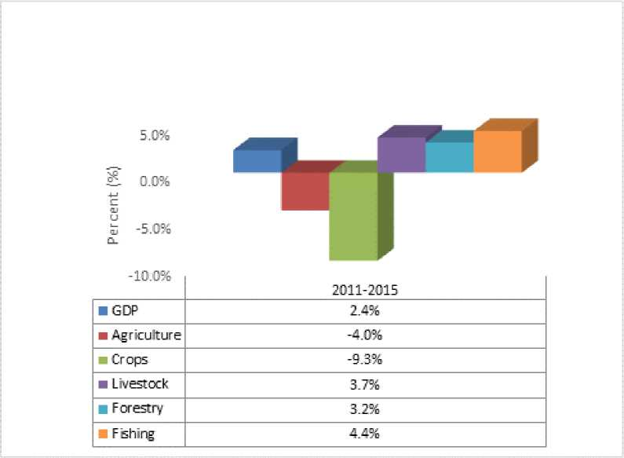

Source: Gambia Bureau of Statistics (GBOS)

The negative annual average growth rate registered in the crops sub-sector was indicative of the severity of weather conditions on the performance of the sub-sector. To corroborate this point, there were 3 years (2011, 2013 and 2014) of negative growth rates registered between 2010 and 2015 in the crops sub-sector thus rendering it highly vulnerable to exogenous shocks. However, Figure 1 also presents remarkable average annual growth rates in the livestock, forestry and more importantly in the fisheries sub-sectors. In the light of this, there is need to diversify the country’s productive base towards these growth centres.

The agricultural average growth rate of -4.0% between 2011 and 2015 fell far short of the NAFSIP targeted growth rate of 8% per annum by 2015 mainly attributed to less than expected agricultural performance during NAFSIP implementation period primarily aggravated by a myriad of challenges that plagued the sector. These challenges included: erratic and unfavourable weather conditions, low use of inputs (improved seeds and fertilizers), limited access and use of farm machinery, low adoption of the good agricultural practices (GAPs), limited value addition, high post-harvest losses, inadequate storage facilities and market opportunities. The negative agriculture average growth rate registered during NAFSIP implementation period would be compensated by the expected recovery of agriculture growth rate of 7% in 2015 (from - 7.1% in 2014) mainly to be propelled by the crops sub-sector growth of 12.3% in 2015 (from -20.0% in 2014) with supportive and recognizable growth rates from the livestock, forestry and fisheries sub-sectors as detailed in Figure 2 below.

Figure 2: Agriculture and Natural Resources Sectors' Contribution to Real GDP Annual Growth Rate (2005-2015)

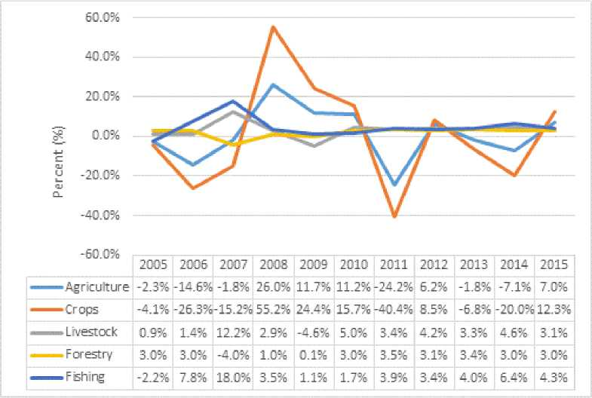

* 1. Investments in the GNAIP
     1. Public Sector Financing of the Agricultural sector

The Government has made several pronouncements indicating agriculture and natural resources as the key driver for economic growth and socioeconomic development during the GNAIP implementation period. Review of Government budgetary allocations indicate that during the GNAIP period, the annual allocations were 5.7% in 2011, 7.1% in 2012, 7.6% in 2013, 6.8% in 2014 and 6.2% in 2015. This indicate that government budgetary allocations did not meet the 10% required under the Maputo declaration (2003). Figure 3 provides information on annual allocations from 2011 to 2015.

Figure 3: Proportion of National Budget Allocated to The ANR Sector

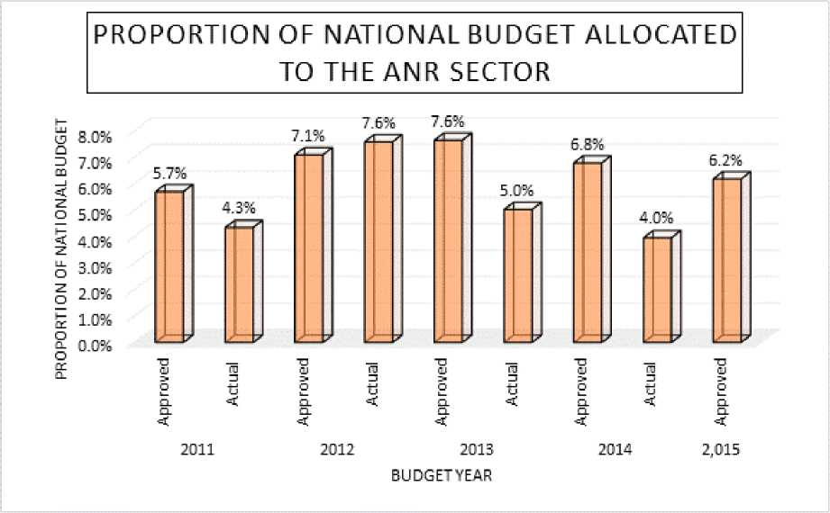

Data Source: GoTG. Estimates of Revenue and Expenditure (2012; 2013; 2014, 2015 & 2016)

Further analysis indicate that budget execution has generally been sub optimal and average around 80% for the GNAIP period. Analysis of data in figure 4 comparing approval and actual budgetary execution, show that only 2012 registered 110% execution. All the years registered less than 80% with a downwards trend from 2012.

Figure 4: ANR Sector Budget Execution

ANR Sector Budget Execution(GMD ’000)

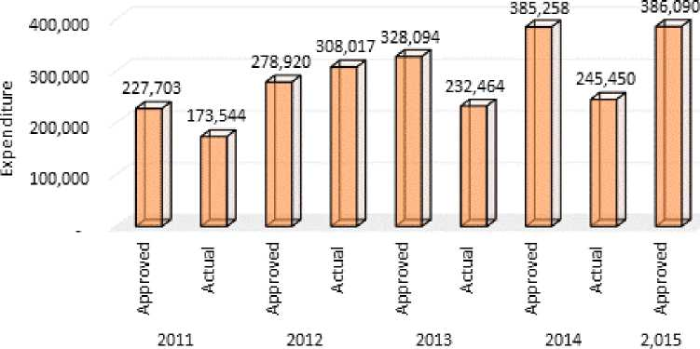

BudgetYear

Data Source: GoTG. Estimates of Revenue and Expenditure (2012; 2013; 2014, 2015 & 2016

* + 1. Public Sector Investment-project Interventions

In the bid to realize the objectives of the GNAIP, a resource envelop of US$ 297.7 million was estimated. This comprised both public and private sector (including NGOs and civil society) funding. The public sector projects during GNAIP mobilized 184, 600,770 US$ out of a US$ 200.96 million leaving a funding gap of US$ 16,359, 230 (8%). These comprised 7 projects under MOA; FAO TCPs, TELEFOODS and other managed projects: and, 5 projects in the other sectors with funding by development partners notably IFAD, AfDB, EU, World Bank, IsDB, Table 7 provides information on project interventions in the agriculture and natural resources sector and highlights funding source, duration and amount allocated.

Table 7: Projects to meet GNAIP Funding Gap

|  |  |  |  |  |
| --- | --- | --- | --- | --- |
| **No.** | **Project Title / Implementing Agent** | **Donors** | **Duration** | **Amount Allocated in**  **US$** |
| 1 | National Agricultural Land and Water Management Development Project (Nema) | IFAD / AfDB /IsDB | 2013 - 2019 | 64,900,000 |
| 2 | Gambia Agricultural Commercialization and Value Chain Management Project (GCAV) | WB | 2014 - 2019 | 15,900,000 |
| 3 | EU MDG 1(c) Project | European Union | 2013 - 2016 | 9,880,000 |
| 4 | West African Agricultural Productivity Project (WAAPP) | WB | 2011 - 2016 | 12,860,000 |
| 5 | Food and Agriculture Sector Development Project (FASDEP) | GAFSP / AfDB | 2013 - 2018 | 26,600,000 |
| 6 | Sustainable Land Management Project SLMP | GEF / AfDB | 2012 - 2015 | 4,400,000 |
| 7 | Gambia Emergency Agricultural Support Project (GEASP) | JSDF/WB | 2013-2014 | 2,850,000 |
| 8 | Other ANR Projects (EIF, BAANAFA, Coastal Resilience Project, Early Warning Phase II & GCCP) | GEF, UNDP, UNEP, LDF, NAPA, WB, EU | 2011 - 2019 | 35,689,929 |
| 9 | FAO - TCPs & Telefood | FAO/ Telefood | 2011-2015 | 2,795,552 |
| 10 | FAO implemented donor funded projects (excluding FASDEP & EU MDG 1c) | Multi-lateral | 2011-2015 | 8,725,289 |
|  | **Total** |  |  | **184,600,770** |

Source: Ministry of Agriculture 2014

NGO contribution during the GNAIP period amounted to US$ 6,980,748 mainly from ActionAid International The Gambia (AAITG), Association for the Development of Women and Children (ADWAC), Agency for Village Support (AVISU), Catholic Relief Services (CRS), Concern Universal (CU), Freedom form Hunger Campaign (FFHC) and Gambia Food and Nutrition Association (GAFNA).

* + 1. Commercial Sector Loans

Commercial bank loans constitute important sources of funding for private sector investment. Data sourced from The Central Bank of The Gambia on commercial Bank loans from 2011 to 2014 indicate that the agriculture sector share is relatively low averaging less than 5%. Table 8 shows a share of 7% in 2011, 4% each for 2012 and 2013 and 3% for 2014. With most of the resources in agriculture allocated to crop financing, only limited loans go to development of the sector. The dwindling credit resources constitute a key challenge to increasing output for the sector. The low share of agriculture in the commercial lending could be attributed to a number of factors including: the long gestation period of most agriculturalinvestments, the high interest rates charged, the risks (weather, pest and diseases) and the high discount rate of government bonds.

Table 8: Credit to Private Sector (and Personal loans) by sector, 2011 to 2014

|  |  |  |  |  |
| --- | --- | --- | --- | --- |
| SECTOR | **2011** | **2012** | **2013** | **2014** |
| AGRICULTURE | 7% | 4% | 4% | 3% |
| FISHING | 0% | 0% | 0% | 0% |
| MANUFACTURING | 5% | 6% | 5% | 4% |
| BUILDING & CONSTRUCTION | 10% | 11% | 13% | 12% |
| TRANSPORTATION | 7% | 7% | 6% | 8% |
| DISTRIBUTIVE TRADE | 28% | 30% | 31% | 33% |
| TOURISM | 5% | 5% | 5% | 3% |
| FINANCIAL INSTITUTIONS | 4% | 4% | 4% | 4% |
| PERSONAL LOANS | 11% | 9% | 8% | 8% |
| OTHERS | 24% | 25% | 23% | 25% |
| TOTAL (GMD’000) | 64,758,636 | 65,358,000 | 71,989,705 | 72,529,527 |
| Credit to GDP ratio | 2.43 | 2.23 | 2.25 | 2.25 |

Source: Central bank of The Gambia, August 2015

* + 1. Private Sector Investment

GNAIP anticipated complimentary funding from the private sector, these has been provided by a number of new entrants in the sector. Table 9 provides information of key investment registered through GIEPA.

Table 9: Private investments in the agriculture sector (2010-2014)

|  |  |  |  |
| --- | --- | --- | --- |
| Name | Subsector | Year Registered | Planned Investment |
| (US$) |
| Zain Group Ltd | Agriculture | 2010 | 263,024 |
| BSC Farms Enterprise | Agriculture | 2010 | 159,259 |
| Saadis Group Ltd | Agriculture | 2010 | 350,600 |
| EMPAS Poultry Processing | Poultry | 2012 | 5,000,000 |
| Teefarms | Poultry | 2012 | 2,000,000 |
| Ayesha Banana Enterprise | Horticulture | 2013 | 18,000,000 |
| The New Nut Co. Ltd. | Groundnut Production/  Processing | 2012 | 1,796,000 |
| Reliance Oil Mills Ltd | Groundnut Processing | 2012 | 300,000 |
| Busumbala Agricultural Enterprises | Agriculture | 2013 | 120,000 |
| MAK Foods | Horticulture | 2014 | 6.792,540 |
| CashewGam | Cashew processing |  | 1,000,000 |
| GACH Global Trading Company | Agro-processing | 2014 | 5,000,000 |
| TOTAL | | | 40, 781,423 |

Source: Own GIEPA

* 1. Priority Investment areas and major value chains
     1. Rice value chain

The principal priority areas for the rice value chain are covered under programmes 1,3 and 5 notably: improved land and water management; development of agricultural value chain and market promotion and sustainable farm management.

Under programme 1, the specific objective is to increase production and productivity of the lowlands through area expansion, improved water management and adoption of improved practices by farmers. These were to be achieved through land development, farmer training and provision of starter inputs. As presented in table 10 it was planned to develop 24,000 ha and improve yields in the various lowland ecologies.

Table 10: Achievement in Lowland Rice Area and Productivity by Ecology

|  |  |  |  |  |
| --- | --- | --- | --- | --- |
| **Ecology** | **Planned** | | **Achieved** | |
| **Area (ha)** | **Yield (Mt/ha)** | **Area (ha)** | **Yield (Mt/ha)** |
| Natural Depressions | 10,000 | 2.0 | 17,653 | 0.933 |
| Run-off inundated flood plains | 5,000 | 2.0 |
| Back swamps | 3,000 | 2.5 |
| Seasonally saline tidal swamps | 3,500 | 2.0 |
| Pump irrigated schemes | 500 | 10.0* | 150 | 4.0 |
| Tidal Irrigated schemes | 2,000 | 8.0* | 1,200 | 6.0* |
| Total | 24,000 |  | 19,003 |  |

Source: GNAIP and Personal Communications Note *= Annual production

Over the NAFSIP period, paddy cultivated area averaged 67,510 ha with much of the average cultivated area of 50,967 ha (75%) coming from arable upland ecology. During the corresponding period swamp rice cultivated area averaged 16,906 ha (25%) as detailed in figure 5 below. Paddy rice production averaged 58,137 Mt over the NAFSIP implementation period with the largest share contributed by upland rice of 43,001 Mt (74%) and only 26% contributed by swamp rice (see figure 6 below).

Figure 5: Paddy Rice Cultivated Area GNAIP Period

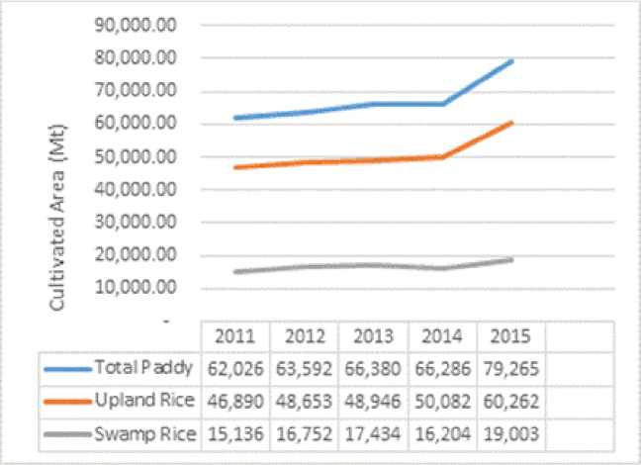

Source: NASS Reports, PSU, NB: 2015 figures are provisionary estimates for crops

The GNAIP targeted the production of 70,000 Mt from the 24,000 ha, it achieved only 24,270 Mt from 19,003 ha. This indicates an achievement of 35% of the targeted production. This can be attributed to low productivity in all the lowland ecologies. The relatively low yields in the four lowland ecologies (Natural depressions, Run-off, back swamps and seasonally saline) can be attributed to inadequate water control, droughts, low level of fertilizer consumption and low adoption of GAP. In the pump irrigated and tidal schemes the major limitations are incomplete infrastructure for water control (no drainage facilities in the pump irrigation consequently only dry season crop) low cropping intensity and low input use particularly during the wet season.

Figure 6: Total Paddy Rice Production NAFSIP Period

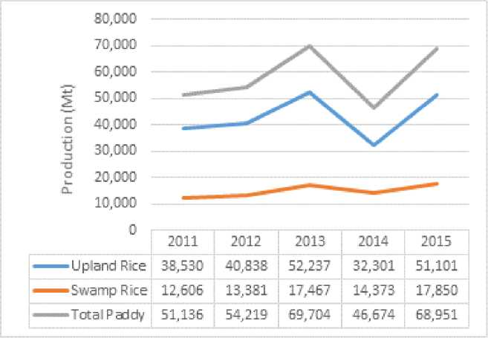

Source: NASS Reports, PSU

Under Programme 3: Development of Agricultural Value Chain, the aim is to transform the agricultural sector from a traditional subsistence economy to a modern market-oriented commercial sector with highly developed and integrated agricultural value chains characterized by vibrant and viable agro-processing private sector that ultimately result in increased incomes of value chain actors. In the specific case of rice value chains, the interventions planned comprised provision of drying floors, access to processing equipment (threshing, dehulling and milling) and, packaging and labelling as well as training on operation and maintenance. Results of GNAIP achievements comprise of project interventions in the provision of drying floors, processing materials principally to support the home grown School Feeding Programme through the EU funded and FAO/WFP implemented MDG 1C.

Under Programme 5, Sustainable Farm Development, the specific rice value chain strategies comprise productivity improvements of Upland rice from 0.89 Mt/ha to 2.5Mt/ha. The proposed actions comprise training of farmers on GAP through Farmer Field Schools. Results indicate that while area expansion took place registering 60, 262 ha out of a planned 70,000 ha (86%), the yield targets were however not realized registering 0.850 Mt/ha. The yield achievement is only 34% of the planned target yield. The low achievement is attributed to erratic and uneven distribution of rainfall during the growing season and low input use.

Key innovations worth considering are the System of Rice Intensification (SRI) aimed at optimizing water use and tillering; promotion of suitable fragrance/aromatic rice varieties and promotion of seed cleaning equipment. The complimentary institutional and human capacities necessary for the innovations comprise: supervision and monitoring of construction and O&M of water controlled infrastructure; management of farmer organizations; extension service delivery; seed technology and post-harvest practices; and, supply chain management.

* + 1. Coarse grain value chain

The principal programmes concerning the coarse grain value chains comprise programme 3 and 5. Under Programme 3, the strategy objective is to improve primary and secondary processing to increase value addition and income in this regard proposed actions include access to processing equipment (threshing, dehulling and milling) and, packaging and labelling as well as training on operation and maintenance.

Overall, coarse grains target cultivated area (Annex 2 table 4) was 156,000 ha for GNAIP with 183,371 ha achieved by 2015 resulting in an achievement of 118%. Similarly, 222,000 Mt were also targeted for production with 169,208 Mt produced in 2015 indicating a production achievement of 76% with 64% as yield achievement detailed in figures 11,12 and 14 below. On average, coarse grains cultivated area averaged 171,468 ha with average production of 151,088 Mt indicating an average yield of 0.88 Mt/ha, much less than the targeted 1.3 Mt/ha targeted. Figures 7 and 8 show the total cultivated area and production of coarse grains during the NAFSIP

|  |  |  |  |  |  |
| --- | --- | --- | --- | --- | --- |
| Early Milet | 2311 | 2312 | 2313 | 2314 | 2315 |
| 72,941 | 96,467 | 71,527 | 59,116 | 35,325 |
| ■ Late Mi .et | 14,293 | 19,622 | 22,272 | 17,701 | 18,472 |
| ■> Sorghum | 20,556 | 23,146 | 30,390 | 23.2B9 | 26,391 |
| 1 ■ Maize | 23,613 | 28,934 | 33,060 | 30,289 | 33,523 |

23,333

Source: NASS Reports, PSU

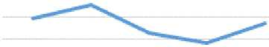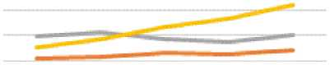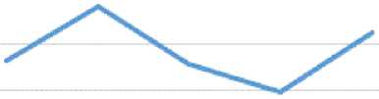

fl

0J UI L_ n

1C3333

90333

BDDDD

70000

60000

50000

40000

30000

20333

10333

0

Figure 7: Coarse Grain Total Cultivated Area NAFSIP Period

Make

| 2312 | 2313 | 2314 | 2315 |
| --- | --- | --- | --- |
| 95127 | B2566 | 78469 | 3712B |
| 21693 | 23226 | 22361 | 24329 |
| 31091 | 28720 | 27235 | 30048 |
| 23233 | 33173 | 36704 | 41B66 |

2311

Early Milet B9499

25256

LateM’ et 20986

Sorghum 29576

*Source: NASS Reports, PSU*

period. It should also be noted that the largest share of the total cultivated area and production of 94,215 ha (55%) and 99,242 Mt (66%) respectively came from early and late millet figures combined. Figure 7 also shows a declining trend in the cultivated area of early millet from 2012 to 2014 representing a decrease of 8.4%. It is also imperative to note that any increase in production is as a result of area expansion and not yield increases as yields are either stagnating at around less than 1 Mt/ha or declining over the NAFSIP implementation period.

***Figure 8: Coarse Grain Total Production NAFSIP Period***

IC 3,000

B3,C33

6C,333

40,333

Figure 9 below shows crops cultivated area achievements when NAFSIP cultivated area targets are compared with those of the 2015 (end of NAFSIP). At NAFSIP completion, as shown in the Figure below, the highest single crop cultivated area achieved was registered for sorghum (188%) which may not be due to its popularity among coarse grains crops rather its target area might have been under-estimated in 2009. Other achievements in order of sequence included: millet (124%), total coarse grains (118%) and groundnuts (106%) that surpassed their target cultivated areas while those underachieved (less than 100%) included: upland rice (86%), maize (84%), swamp rice (79%) and total cultivated area (88%).

Figure 9: % Crops Cultivated Areas Achieved by 2015

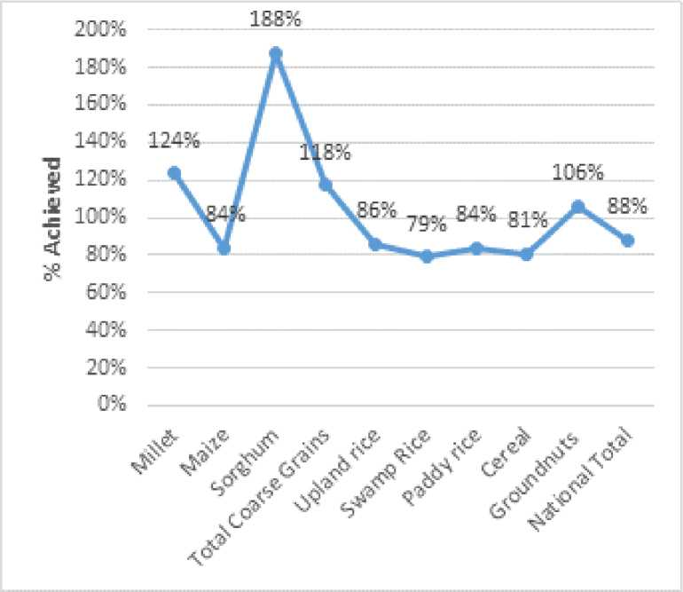

Source: NASS Reports, PSU

Crops yields in the Gambia in the last decade or so have been observed to be either declining or stagnating around less than 1Mt/ha due to several factors including: use of less improved seed varieties, low and untimely application of fertilizers in the right proportions, low adoption of good agricultural practices (GAPs), etc. Figure 10 presents an irregular trend in the percent achievement of crops yields. Yield underachievement trend has been registered in all crops listed in figure 10 with varying percent levels. For instance, while sorghum registered 11% underachievement swamp rice recorded 68% underachievement.

Figure 10: % Crops Yields Achieved by 2015

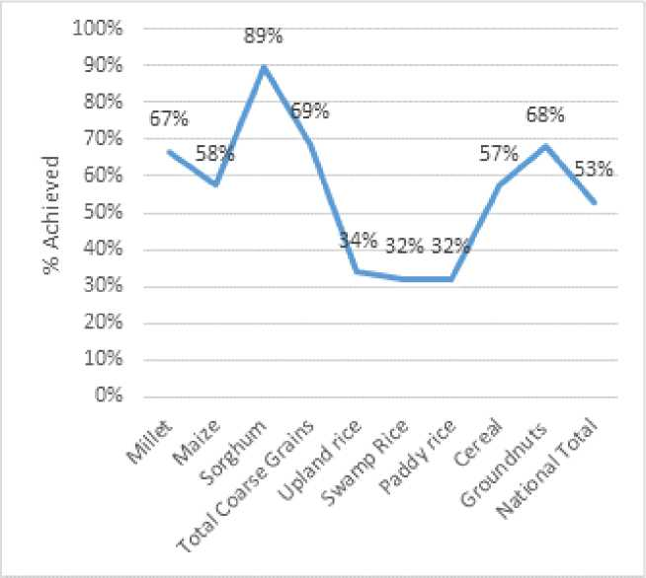

Source: NASS Report, PSU

Figure 10 above shows crops yield performance over the NAFSIP implementation period. For all crops, 88% was achieved for cultivated area (figure 9), 53% for crops yield (figure 10) and 56% recorded for production (figure 12). During the NAFSIP period, only 49% of estimated yield target for all crops was achieved at national level in 2015 while for individual crops the highest (89%) and lowest (32%) crop yields were recorded for sorghum and swamp rice respectively. In MDG1c supported sites, greater than 4 Mt/ha was recorded for paddy rice. As a commercial and food crop, groundnuts’ target yield achievement was recorded at 68%, 57% for cereals and 32% for paddy rice. The same figure also shows an underachievement trend in total coarse grains of 31%, upland rice 66%, swamp rice 68% and 32% for groundnuts.

Figure 11 below shows the production trend of coarse grains during NAFSIP implementation period. It can be noted that in principle production is a derivative of area cultivated and yield and therefore since yields are almost stagnant over NAFSIP implementation period (2011-2015), the production trend follows closely with the cultivated area pattern in Figure 11 below. This suggests that any production increase would be as a result of area expansion which compensates for poor yield performance during the period under review. Like cultivated area, the mean national production of coarse grains during the planned period (2011-2015) was estimated at 306,661 Mt which is slightly more than the NAFSIP implementation period average of 306,365 Mt representing an increase of 296 Mt. Of the NAFSIP production average, 80% constitutes the combined total coarse grains and groundnuts production while total paddy rice constitutes only 19%. This does not commensurate with the popularity and preference of rice over other cereal food crops of the country. Rice is the main staple food of most Gambians and due to this disposition, it is regarded as the key government priority target for food self-sufficiency to enhance national food security (Vision 2016).

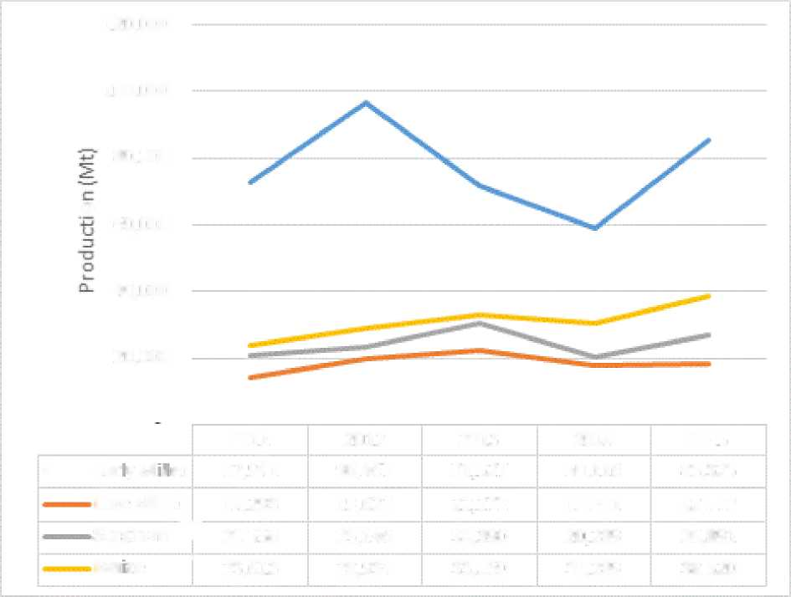

Figure 11: Coarse Grain Total Production NAFSIP Period

120,000

100,000

80,000

60,000

4D,DDD

20,000

o

| 2011 | 2012 | 2013 | 2014 | 2015 |
| --- | --- | --- | --- | --- |
| EaryM:et 72,941 | 96,467 | 71,52? | 59,116 | 85,325 |
| Late Mi Bet 14,29 3 | 19,622 | 22,272 | 17,701 | 18,472 |
| Sorghum T 20,556 | 23,146 | 30,390 | 20.2B9 | 26,891 |
| Maze | 25,613 | 2B,934 | 33,O6D | 30,289 | 38,520 |

In this regard, a number of programme/project interventions were made in the past geared towards the expansion of rice production for increased food security and commercialization. These programme/projects included: Lowland Agricultural Development Programme (LADEP), Small scale Water Control Project (SSWCP), Irrigated Rice Development Project (IRRIDEP), Farmer Managed Rice Irrigation Project (FMRIP) just a few worthy of mention. At NAFSIP design, 587,000 Mt have been targeted as overall crop production to be achieved by 2015 and in comparison, 327,500 Mt were instead produced in 2015 indicating an achievement of 56% Figure 12 below shows the percent production achievements of the major crops grown in the country over the NAFSIP implementation period. From the Figure, it is clear that only sorghum surpassed its production target (168%) in 2015. The remaining crops registered less than their targeted production levels and these included: 82% for millet, 48% for maize and 74% for groundnuts as detailed in Figure 12 below. These under-achievements in the crops sub-sector might have accounted for low and sometimes negative annual growth rates in the agricultural sector in which the crops sub-sector constitutes the largest share. The situation is even worsened by repeated vagaries of weather conditions (droughts) on crops performance, continued high post-harvest losses and limited use of improved crop varieties, fertilizers and agricultural machinery.

Figure 12: % Production Achieved by 2015

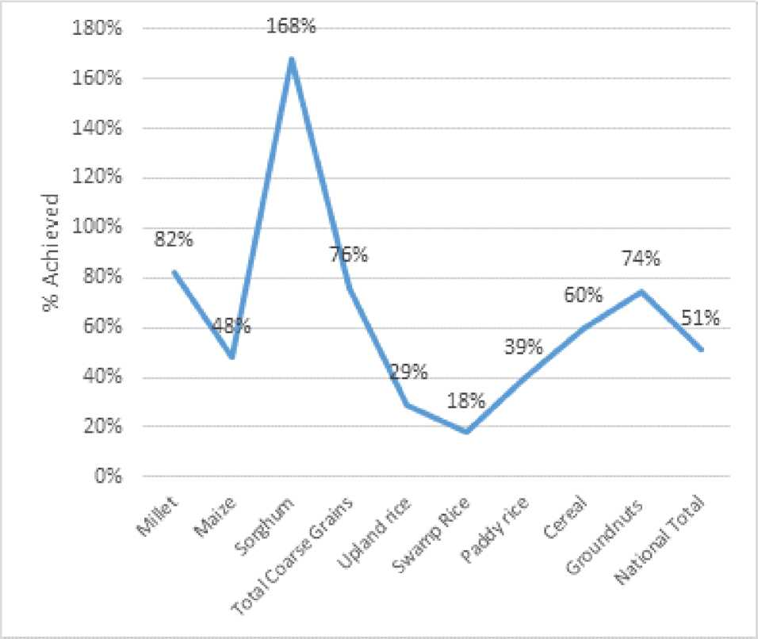

The foregoing analysis has therefore shown that the under-performance of the agricultural sector in tandem with its low economic growth contributions to GDP over the NAFSIP period of implementation has been propelled by a multitude of factors prominent among which have already been highlighted above. While there were cultivated area expansions, yields remained stagnant at around less than 1Mt/ha resulting in low production levels during NAFSIP period. To ameliorate this low sector performance, stricter macro and sectoral policies on agricultural production and productivity enhancements should be continuously pursued through production intensification, diversification of the productive base towards the growth centres and strong private sector investment in the sector for increased food, nutrition and income security of medium to small scale producers. Crops production increases emanating from cultivated area expansion cannot be sustainable over the long time horizon as arable land (558,000 ha) is a finite factor of production and may not stand the test of expansionary pressures for long.

Key innovations worth considering include drying on raised platform and post-harvest technologies including storage. Complementary institutional and human capacities required include good storage practices; promoting high quality seeds with resistance to aflatoxins; effective extension service delivery and O&M of infrastructure and machinery/equipment.

* + 1. Groundnuts Value Chain

The principal programmes concerning the groundnut value chain are programmes 3 and 5. Under Programme 3, the strategy objective is to improve groundnut quality to international standards through proposed actions comprising upgrading the groundnut marketing and processing facilities, enhance access to funds through existing credit lines by cooperative and private sectors and introduce high quality seeds and varieties and grading systems. GNAIP related interventions in this regard comprise the IDB funded Groundnut Value chain Projects currently under implementation and the EIF funded by ITC which conducted FFS training for groundnut producers to enhance quality production.

Under Programme 5, Sustainable Farm Development, the specific groundnut value chain strategies comprise productivity improvements of yields from 0.978 Mt/ha to 1.2 Mt/ha. The proposed actions comprise training of farmers on GAP through Farmer Field Schools (FFS). Results indicate that while area expansion took place registering 106,000 ha out of a planned 100,000 ha (106%), the yield targets were however not realized registering 0.815 Mt/ha. The yield achievement is only 68% of the planned target yield. The low achievement is attributed to erratic and uneven distribution of rainfall during the growing season and low fertilizer and poor seed quality.

Figure 13: G/nuts Total Cultivated Area NAFSIP Period

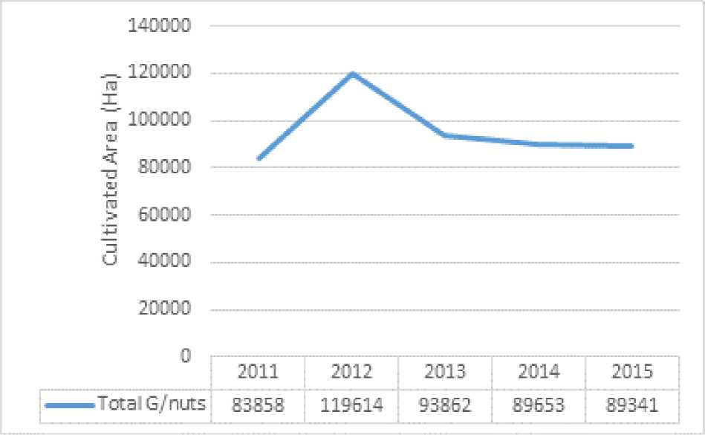

Source: NASS Reports, PSU

Figures 13 and 14 show the total cultivated area and production of groundnut over the NAFSIP period. NAFSIP target area for groundnut was 100,000 ha by 2015 but this target has been surpassed with the cultivated area of 106,157 ha indicating 106% achievement while for production 74% was achieved with a yield achievement of 68% as detailed in figure 10.

***Figure 14: G/nuts Total Production NAFSIP Period***

140000

120000

100000

i

§ 80000

D

"O

2 60000 O-

40000

20000

0

Total G/nuts

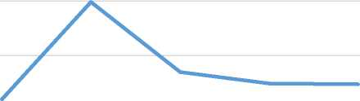*Source: NASS Reports, PSU*

2011 2012 2013 2014 2015

83858 119614 93862 89653 89341

Key innovations worth considering include: use of raised platforms for drying, appropriate storage facilities, use of Aflasafe and seed technology. Complementary institutional and human capacities requirements are in marketing and processing; storage and packaging; and, credit delivery and management.

* + 1. Horticulture Value Chain

The principal programmes concerning the horticultural value chain are programme 1 and 3.

Under programme 1, the strategic objective has been to establish year-round vegetable production schemes on 1,000 ha of land under various irrigation systems. Increased horticultural production is a sine qua non to poverty reduction through gainful diversification of the agricultural productive base and meaningful commercialization. In the light of this, the NAFSIP like other macro-policy strategies mentioned above called for all year-round production of horticultural crops basically quality vegetables for increased food, nutrition and income security particularly among the vulnerable cohort of society (mainly women and youth). The Plan focused on strengthening the horticultural sub-sector through the provision of relevant equipment/machinery and infrastructure to reduce the drudgery involved in laborious traditional horticultural production system widely practiced in the country. With 1,000 ha of land to be developed for the purpose, the Plan sought to provide boreholes, solar power generators for water lifting, overhead tanks for water storage and pressure generation and drip irrigation system for distribution, ground reservoirs with taps for water distribution, shallow open wells and small portable solar power generators. The Plan also targeted direct beneficiaries of 64 commercial farmers, 1,440 young farmers and 2,880 women farmers throughout the country with emphasis on small group formations and each group member allocated a quarter hectare for youth and one eighth hectare for women. In addition, each of the six agricultural regions would be allocated 20 ha piece of land for training and demonstration. In return, this planned investment was expected to translate into a market-oriented production of increased commercial quality fresh andprocessed horticultural products (with none or minimum post-harvest losses) that meet international quality and sanitary standards.

In response to this NAFSIP strategy for reinvigorating the horticultural sub-sector, numerous interventions were made in the horticultural sub-sector such as the preparation and operationalization of development projects with horticulture as a component or sub-component. More specifically during GNAIP implementation period, there were 7 projects that had horticultural components/sub-components and these projects included: GALDEP (2008-2013, US$12.71 million), LHDP (2009-2015, US$15.9 million), FASDEP (2013-2019, US$27.3 million), RFP (2009-2014, US$8.7 million), GCAV (2014-2019, US$19.27 million), Nema (2012-2019, US$19.27 million) and WAAPP (2010-2016, US$12.8). These projects combined provided the necessary inputs and infrastructure facilities in the garden schemes across the country to address the numerous challenges encountered by mainly vegetable growers. In reality, the projects provided some starter inputs (improved seeds, fertilizers, agro-chemicals for emergency purposes), fencing materials, boreholes and or concrete-lined wells, solar powered pumps and generators for drip and other forms of irrigation facilities, nursery sheds, overhead tanks, cottage processing facilities for value addition, improved market access, marketing and storage facilities and employment opportunities particularly for youths.

Figure 15 below depicts the number of horticultural farmers in communal and non-communal garden schemes by gender across the country. Overall, there were 77,857 horticultural farmers countrywide and of these, females constituted 88% (68,247) in both communal and non-communal garden schemes.

* 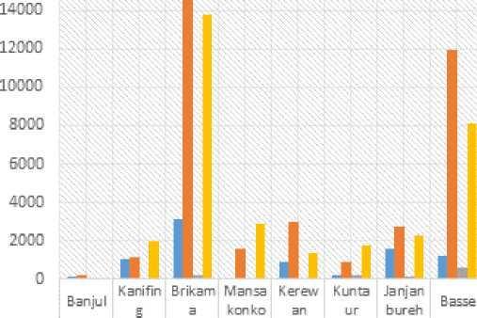M al e N on-comm u nal fa nr ers

16DDD

£

E

o

o

112

1072

3,10S

51

924

224

1135

14,537

396

2,766 11,960

£ E

1,623 3,012

217 1594 1,193

Figure 15: Communal & Non/communal Farmers by Sex & Region

* Female N on-communal farmers

■ Male Communal farmers

47

207

70

240

13 7 627

Female Communal farmers

1,950

13,750

2,390 1,336

1,777

2,266 3,115

Source: FAO survey, 2014 adapted from the National Horticulture Sector Master Plan (NHSMP)

The figure also shows that the highest numbers of horticultural farmers were concentrated in West Coast Region (WCR) and Upper River Region (URR) in 2013. More importantly, the largest population of horticultural farmers are found in female communal and non-communal horticultural schemes totaling 68,247 female farmers which is indicative their dominance in horticultural production particularly the cultivation of vegetables. Similarly, with 77,857 (88% females) horticultural farmers in 2013, GNAIP’s expected target population of horticultural farmers mentioned above has been surpassed in terms of women participation. But there are only 3 known big commercial farmers currently operating in the country as oppose to GNAIP’s 64 targeted big commercial farmers. These commercial operations include: Gambia Horticultural Enterprise (GHE), Radville Farms and M.A.Kharafi and Sons. They are located on between 25 ha and 100 ha pieces of land and sometimes with larger operations depending on land availability. There are also medium to small scale communal commercial garden schemes located in Banjulunding, Lamen and Sukuta found on between 5 ha and 25 ha land areas mainly supported by government, donor partners and non-governmental organizations (NGOs). Together they produce over 85% of the total national horticultural produce. According to the NHSMP, about 504 small-scale village-based communal gardens are operating in the country with a total area of 958.5 ha. Of these, about 250 ha were developed for year­round production achieving 25% of GNAIP’s target area of 1,000 ha.

With the provision of starter inputs, infrastructure facilities, equipment/machinery and capacity building (training) mostly through support by development projects, relevant government services institutions, donor partners and NGOs, total assorted horticultural production increased to 31,207 MT across the country in 2013 with onions constituting the highest production of 18% (5,851 MT) followed by Irish potatoes of 13% (4,000 MT) due to M.A. Kharafi and Sons’ domestic intervention in the industry as detailed in Figure 16 below. Irrespective of the provision of the aforementioned facilities and services by various stakeholders, all year-round production of horticultural crops could not be achieved due to inadequate water supply in most of the vegetable garden schemes excessive demand for water especially during the peak of the dry season when water supply requirements are generally considered very high. Some reasons advanced by vegetable growers related to the inadequacy of water supply in the garden schemes included inadequate pumping capacity of the solar-powered pumping units, poor water reticulation system, and or shallow hand dug and concrete-lined wells.

Figure 14: Production of Vegetables in 2013

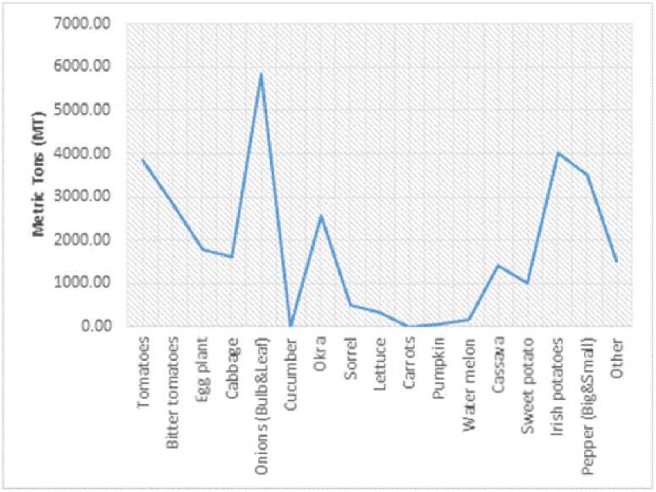

Source: NHSMP 2015, adapted from Table 16

The outcome of horticultural activities in 2014 was the production of 34,032 MT against a quantity consumption estimate of 108,096 Mt (figure 16), which reveals a deficit of 68.5% (74,064 Mt). Total consumption of vegetable at 108,096 Mt further reveals a per capita consumption of 57.5kg thereby meeting only 39.7% of WHO/FAO minimum recommended level of 145 kg per capita per year.

Under programme 3, the strategic objective of for the horticulture value chain is market oriented production systems in place, post-harvest losses reduced and increased quality of produce. Key interventions proposed in this regard focused on capacity building of institutions in public and private sector to promote quality segregation/pricing to international standards. Interventions have largely been project related with the provision of processing facilities e.g. Old Jeshwang (LHDP), Nyangen (FSCA), Banjulunding (Common Wealth. TATM, CPAP), GHE -Kembujeh (GCAV) and the private sector (Gambia/Angola/China) and few storage facilities.

Furthermore, the LHDP contributed immensely to the achievement of NAFSIP’s set targets for the horticultural sub-sector. Towards the realization of this objective, the AfDB Component of the LHDP made significant investments in the sub-sector and realized the following achievements: increased community income from a baseline value of GMD134,010 through GMD6,915,050 to GMD6,952,890 at project completion representing an achievement of 100.5%; increased vegetable production from 5,934 Mt to 9,051 Mt registering 152% achievement; improved vegetable production infrastructure constructed and operationalized comprising 10 vegetable gardens (5ha each) established, 10 boreholes with 10 solar pumping facilities provided, 10 overhead reservoirs with 210 secondary reservoirs linked to the main reservoir with piped network also provided; 10 multipurpose farm sheds constructed; 10 nursery sheds and production inputs (seeds and fertilizers) provided and 1 utility truck and a cold van procured and operationalized. For the IFAD Component of LHDP the following achievements were also realized: 10 (5ha each) gardens were established equipped with boreholes; 21 vegetable gardens fenced with chain-link; 82 concrete lined hand dug wells rehabilitated; starter kits (seeds, fertilizers and garden tools) provided; 10 galvanized overhead tanks of 60m3 capacity provided; construction of 480 field reservoirs (1m3 each) with tap and linked to the overhead tank with uPVC pipes; and 10 set of starter kits which included seeds, fertilizers, chemicals and small tools for the first year (two cycles, including seedling production), small equipment for watering, transport and the preparation of produce for markets (carts, watering cans, hoses, sprayers, tubs and tables, etc.).

Key innovations worth considering are promotion of medium scale processing facilities, developing and promoting win-win outgrower models for contract farming. Complementary institutional and human capacities need comprise developing and strengthening farmer organizations; extension service delivery; O&M of garden infrastructure and conducting studies on ground water.

* + 1. Livestock value chains

The principal programmes concerning the livestock value chain are programmes 3. Under programme 3, the strategic objective is to promote the production of small ruminants and poultry to increase farm incomes and save foreign exchange earnings. In this proposed actions comprised improving the genetics of small ruminants and improving timely access to veterinary services, expanding commercial poultry, providing training on good husbandry practices, facilitating access to credit lines for the subsector and creating/improving livestock markets.

The GNAIP promoted the revitalization of the livestock sub-sector through pro-poor intervention strategies which included: increased production of small ruminants, pigs and poultry to improve producers’ food, diet and income, encouraged active participation of farmers in the sub-sector’s development through intensive sensitization and capacity building as well as positioning farmer organizations to access and afford lines of credit for use in executing sub-sector value chain activities, improved local production of feed with due attention paid to processing and storage support and increased local dairy production to meet 25 percent of the national demand.

Figure 17: Livestock Population 2011 and 2014

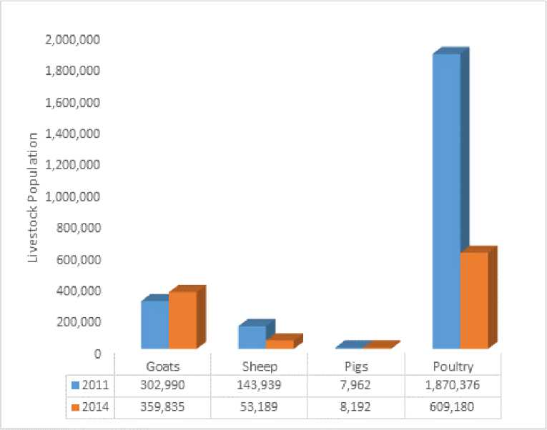

Source: NASS 2014, PSU

To achieve NAFSIP’s aforementioned objectives, many concerted interventions were supported by government, donor partners and NGOs in the livestock sub-sector to enhance the production and productivity of short-cycle livestock species (small ruminants, pigs and poultry) to augment the welfare status of producers. The 2011/2012 agricultural census estimated livestock populations at 355,636 of small ruminants (129,232 sheep and 226,404 goats), 7,962 pigs and 1,870,376 of poultry (mainly chickens), as detailed in table 17 above. In comparison with the NASS 2014 livestock population figures mixed results were obtained showing significant production increases for goats and pigs of 19% and 3% respectively while for sheep and poultry unprecedented declines of 63% and 67% were correspondingly registered. These results could also be translated into production achievements of 119%, 37%, 103% and 33% for goats, sheep, pigs and poultry respectively. Some production successes registered in the sub-sector could be associated with government’s collaboration with donor partners, NGOs and community-based organizations (CBOs) through projects’ and programmes’ support directed at the improvement of the sub-sector. Prominent among these projects were the AfDB/IFAD sponsored Livestock and Horticulture Development Project (LHDP), sub-regional Endemic Ruminant Livestock in West Africa (PROGEBE); and revitalization of the International Trypanotolerance Centre (ITC) into a livestock research center of excellence (Consolidated Indicator Based Performance Report, 2011-2014), and FAO funding and support for various livestock projects through Technical Cooperation Projects (TCPs) and Tele-food programmes.

The LHDP was co-financed by GOTG, AfDB, IFAD and beneficiaries to the tune of US$15.9 million to sustainably reduce rural poverty (increase rural incomes) through improved production and marketing of livestock and horticultural products and capacity building (trainings). For the livestock component of LHDP, basic infrastructure, processing and marketing facilities have been provided.

The AfDB component of LHDP achieved increases in rural incomes: D17,325,000 (95.2% of the project target) for poultry; D4,918,709 (107.7%) from sheep sales and D3,937,619 (16%) for goats totalling D8,856,328 as small ruminants; produced 518,800 birds, 7,306 sheep and 6,969 goats; provided 10 poultry housing and processing units; 10 hand dug wells equipped with hand pumps; feeders and drinkers; 40,006 day-old chicks with starter feed and veterinary drugs for poultry; 10 small ruminant housing units; 10 feed gardens and 30 animals (24 breeding rams and 6 bucks); 2 meat stalls equipped with processing facilities at Jeshwang in KMC; and 2 rehabilitated overhead tanks located at Banjulunding, WCR. For the PROGEBE intervention sites, households’ income earned from livestock sales increased from 5.7% to 11.0% (Consolidated Indicator Based Performance Report, 2011-2014).

The IFAD component of LHDP also provided 40 community-based breeding and fattening schemes for small ruminants and poultry; 3 pig breeding schemes and 2 integrated aquaculture/poultry schemes; a number of trainings for MOA staff and beneficiaries on a wide range of topics including GAPs in 2014. Capacity building provided included: 1,500 beneficiaries trained on livestock production, 300 (all women) on processing and value chain, 200 women on butcher training and 90 (80 females and 10 males) on business and entrepreneurship management. Similar projects like the sub-regional PROGEBE and FAO’s TCPs and Tele-food projects on livestock and livestock institutions like ITC and DLS also provided similar assistance to beneficiaries in the livestock sub-sector. Only limited information on the volume of milk production is available. What is available is from PROGEBE intervention sites where a total of 1,085,599 litres of milk were produced. In comparison with the project baseline value of 904,666 litres a 20% increment was registered.

Key innovations worth considering include: cockerel exchange for genetic improvement of local breeds. Complimentary institutional and human capacity requirements are in extension service delivery in GAP; marketing; improved feed and hygienic handling practices; development and expansion of commercial poultry; and, access to credit facilities.

* + 1. Fisheries Value Chains

The principal programmes concerning the fisheries value chain are programmes 2 and 3. Under programme 2, the strategic objective is to enhance sustainable fish production, reduce post-harvest losses, increase market access for fishery products, increase aquaculture production, increase youth involvement in the fisheries subsector and strengthen the department for effective service delivery. The following achievements were registered in the sector during NAFSIP implementation phase:

* Preparation of the fisheries strategic action plan (2012-2015) geared towards executing the fisheries policy which was harmonized with NAFSIP for greater government and donors support however, the sector received little or no donor funding window during the corresponding period. Although the Gambia Artisanal Fisheries Development Project (GAFDP) which operated between 2004 and 2009 (outside NAFSIP period) constructed infrastructure facilities such as the central fish market with cool storage facilities at Bakoteh, Wharf Njaggo fish landing site, 12km access road to the inland fishing ports of Bintang and Tendaba which were fully operationalized and used during NAFSIP period. In addition, a window of micro credit facility for the fisher folks was opened and being used by beneficiaries;
* Under the Japanese grant, similar infrastructure facilities were constructed for the industrial fishing sites of Tanji, Gunjur, Bakau, Tujereng and few others. This has to some extent enhanced sustainable fish production capacity, reduced post-harvest losses; increased market access and information on fishery products;
* During the NAFSIP period, fisheries production averaged 46,217 Mt with an annual growth rate of 4.2% in the artisanal sub-sector (including inland fisheries). A greater portion of artisanal fisheries production, 80.6% is constituted by Atlantic coastline fishery catches and 19.4% from the inland fisheries. At this level of national fisheries production and annual growth rate, the sector continued to immensely contribute to sustainable food, dietary needs and income security of the general population and in particular operators in the sector. Figure 18 shows the fishery catches from the Atlantic coastline

Figure 18: Atlantic and Inland Fishery Catches 2011-2015

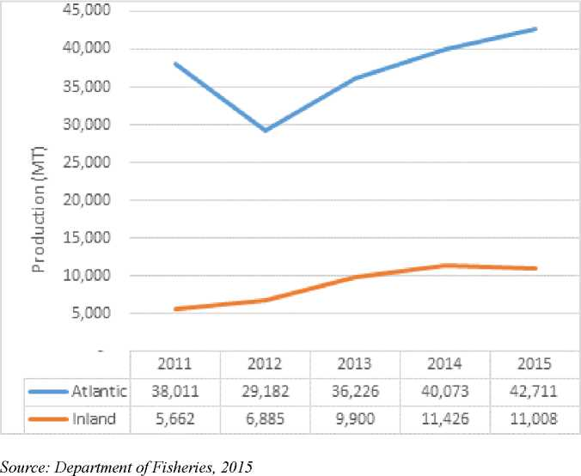

and inland fishing areas. The Figure also shows an increasing upward trend in fish catches from 2012 to 2015 after a 17.4% decline in 2012 and that fishery biomass is far greater along the Atlantic Coastline area than inland but the latter area is largely dominated by foreigners characterized by frequent occurrence of capital flight as remittances to families outside the country. Cumulatively, the capital losses incurred from off-country landings of industrial fishing trawlers coupled with capital flight encouraged by non-Gambian dominance robbed of the remarkable financial resources destined for the fisheries sector that could be efficiently used in the realization of the sector’s development agenda;

* Fish is one of the major constituents in Gambian diets as a cheap source of animal protein and in 2015 Gambians’ per capita consumption of fish (28.54 kg/capita) surpassed the world’s 16.4 kg/capita fish consumption (GreenFacts on Health & Environment) in 2005 (detailed in Figure 19 below) for the artisanal sub-sector only. At both artisanal and industrial sub-sectors’ level with fish production level of 75,000 Mt per annum, the country’s per capita consumption of fish is estimated at 39.84 kg representing a 143% increase over the global per capita fish consumption in 2015;
* Fish aquaculture refers to the breeding, rearing, and harvesting of fish in a fresh water environment mainly in ponds for the case of the Gambia. In the Gambia, aquaculture farming is carried out mainly as a commercial enterprise and the main fish species commonly raised in ponds are catfish and tilapia to increase and supplement households’ fish production for improved food, dietary needs and income security. During NAFSIP implementation period, increased agriculture production was expected through the establishment of commercial aquaculture farms to complement national fish production. At NAFSIP design, 300 fish ponds were expected to be established with annual production of 55.5 Mt.

Figure 19: Per Capita Consumption of Fish in the Artisanal Sub-sector

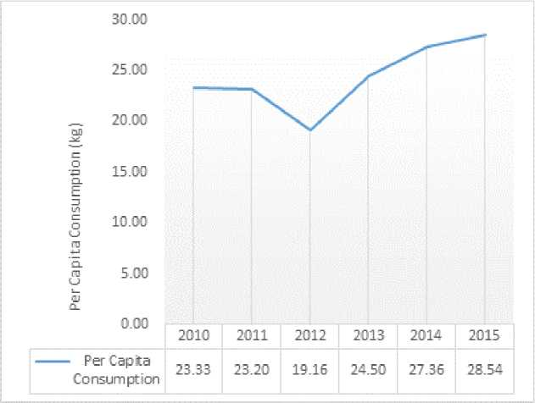

Source: Department of Fisheries, 2015

In comparison only 68 ponds were constructed indicating an achievement of 23% of the NAFSIP target. Of the 68 ponds, 33 ponds (49%) were funded through FAO Technical Cooperation Programme (TCP) with 20 ponds constructed in 2010. In addition, 14 fish ponds were also established by the Taiwanese Agricultural Technical Mission (TATM) all located in the Sapu rice fields. Ten (10) additional ponds were also constructed out of which 2 were established by Livestock and Horticulture Development Project (LHDP) in 2013 both located in WCR. The Food and Agriculture Sector Development Project (FASDEP) constructed 11 ponds (4 for Janjangburay, 3 for Pakaliba, Barro Kunda 2 and Sukuta 2) in 2015. Despite the increasing potential and economic gains usually accrue from aquaculture, limited progress has been made in the sub-sector during NAFSIP implementation. This is associated with lack of reliable data on the outputs of the ponds coupled with poor performance of the ponds over the period under review. In this regard, only 508 kgs were recorded in 2011, 117.7 kgs in 2013 and 134 kgs in 2014 as yields from the 33 ponds. No known production figures are available for the TATM ponds whereas FASDEP funded ponds have been stocked with 4,500 tilapia fingerlings in 2015. Aquaculture experts reported that the fingerlings when matured can yield 1,125 Mt at a survival rate of 75%; and the beneficiaries of this component will be the Fisheries Department, and more than 200,000 industrial and artisanal fishermen and young women processors (42% of whom are non-Gambian and well-integrated) engaged in the sector.

Key innovations comprise integrated aquaculture/poultry schemes. Complementary institutional and human capacity issues necessary for the innovations include extension service delivery; certified quality feed, handling, packaging and good storage practices; O&M of facilities; and, access to credit lines.

* + 1. Value chain Support Services and Cross Cutting Issues

A number of value chain services and cross cutting were detailed in the GNAIP. The key cross cutting issues comprised development of policies; development of domestic, intra- regional and extra regional markets as well as national food and nutrition security covering safety nets for the vulnerable, social protection and disaster response. The principal value chain services included communication networks, financial services, information services and other support services and structures.

* 1. **Institutional and Human Capacity Assessment**

Three levels of institutional and human capacity assessments were carried out: Level 1: Enabling environment, focusing on policy, legal and regulatory environment; resourcing of the GNAIP; institutional arrangements; coordination; and accountability; Level 2: Organisational capacity, focusing on strategic management; alignment of strategy and organizational structure; processes; human resources adequacy; financial resources; monitoring and evaluation systems; information and knowledge management and communication; infrastructure; and partnerships; and, Level 3: Individual staff of participating organizations, focusing on job skills and needs; professional development; access to information; performance and incentives; values, attitudes and motivation; relationships and interdependence; professional integrity; and communication skills.

* + 1. Level 1: Enabling Environment

Analysis of responses from 17 policy organizations comprising Legislation, Ministry of Agriculture, Donors, Other Ministries/Agencies and Civil Society were made covering parameters on level and type of involvement in GNAIP processes, availability of sector and subsector policies, role and responsibilities of different actors and institutional arrangements, coordination of different actors involved in GNAIP implementation, outreach and communication of GNAIP, inclusivity and stakeholder consultations, evidence based policy formulation and planning , resourcing of GNAIP and Accountability to non- State actors.

The results presented in Table 11 indicate that level and type of involvement in GNAIP processes received a low score of 2.6 (moderately unsatisfactory), a score only above evidence based policy formulation and planning (2.4). It should be noted that the parameters with high scores are political commitment (3.7) followed by availability of sector and subsector policies aligned with GNAIP (3.2), role and

responsibilities of different actors and institutional arrangements (3.2), inclusivity of stakeholder consultations (3) and availability of legal and regulatory instruments (3).

**While political support was highlighted as satisfactory, involvement in GNAIP processes, outreach and communication of GNAIP were considered moderately unsatisfactory. In this regards, the absence of a communication strategy was a major gap.**

Table 11: Average score for policy level institution

|  |  |  |  |  |  |  |
| --- | --- | --- | --- | --- | --- | --- |
| POLICY LEVEL ACTORS | **Average Scores** | | | | | |
| ***All surveyed institutions*** | **Legislature** | ***Average Scores -***  ***MoA***  ***Institutions*** | ***Average Scores - Donors*** | ***Average Scores - Other Ministries /Agencies*** | ***Average Scores - Civil Society*** |
| Level and type of involvement in GNAIP processes | ***2.6*** | 0.0 | ***3.9*** | ***3.5*** | ***1.9*** | ***2.3*** |
| Sector and Sub­Sector Policies | ***3.2*** |  | ***3.4*** | ***3.6*** | ***2.8*** | ***3.0*** |
| Legal and Regulatory Instruments | ***3.0*** |  | ***3.2*** | ***2.0*** | ***3.4*** | ***2.8*** |

|  |  |  |  |  |  |  |
| --- | --- | --- | --- | --- | --- | --- |
| Roles and Responsibilities of Different Actors and Institutional arrangements | ***3.2*** |  | ***3.2*** | ***3.3*** | ***3.4*** | ***2.9*** |
| Political Support for GNAIP | ***3.7*** | **4.0** | ***3.3*** | ***3.8*** | ***3.8*** | ***4.0*** |
| Outreach and Communication of GNAIP | ***2.6*** |  | ***2.3*** | ***3.0*** | ***2.6*** | ***2.9*** |
| Inclusivity and Stakeholder Consultations | ***3.0*** |  | ***2.8*** | ***3.4*** | ***3.1*** | ***2.9*** |
| Evidence-Based Policy Formulation and Planning | ***2.5*** |  | ***2.7*** | ***2.9*** | ***2.1*** | ***2.6*** |
| Resourcing of GNAIP | ***2.9*** | **3.0** | ***3.6*** | ***2.9*** | ***2.4*** | ***2.8*** |
| Accountability to Non-State Actors | ***2.7*** |  | ***3.4*** |  | ***1.7*** | ***2.9*** |

Key to scores: 0 = None, 1= very unsatisfactory, 2= unsatisfactory; 3 moderately unsatisfactory; 4= satisfactory; 5= very satisfactory

* + 1. Level 2: Organizational Capacity

Analysis of organizational capacity is presented in Table 12 covering DOA service units, DOA HQ and Regional Directorates, Agricultural Projects and Other service providers. Table 12 reveals the parameter on Strategic plan and leadership which comprised elements covering: availability of a functional governance structure, availability of clear vision and mission, regularity of planning, alignment of organizational structure to the strategic plan, clarity of the structure and reporting system and level of decentralization of decision making had the highest score of 3.8 (satisfactory). This is closely followed by Definition and participation of constituency in programming which comprised the following elements: clarity of definition of stakeholders and extent of stakeholder input into programming rated 3.5 (satisfactory); planning and programme implementation (3.3) and communication (3.3).

Table 12: Average score for Institutional/Organizational Level Capacity

|  |  |  |  |  |  |  |
| --- | --- | --- | --- | --- | --- | --- |
| SUMMARY | Average Score | | | | | |
| All surveyed institutions | DoA Service Units | DoA HQ & Regional Directorates | Agric Projects | Other Service providers | Others |
| Level and type of involvement in GNAIP processes | 3.1 | 3.1 | 3.3 | 2.9 | 3.4 | 2.2 |
| Strategic Plan and Leadership | 3.8 | 3.5 | 3.7 | 4.2 | 4.3 | 3.8 |
| Planning and Programme Implementation | 3.3 | 3.1 | 3.6 | 4.3 | 3.4 | 2.5 |
| Definition and Participation of Constituency in Programming | 3.5 | 3.3 | 3.2 | 4.2 | 3.4 | 4.3 |
| Communication | 3.3 | 2.6 | 3.3 | 4.0 | 3.4 | 4.0 |

|  |  |  |  |  |  |  |
| --- | --- | --- | --- | --- | --- | --- |
| Human Resources Capacity | 1.5 | 0.6 | 2.5 | 1.0 | 2.0 | 3.0 |
| For Agricultural Education Institutions: |  |  |  |  |  |  |
| Specific skills and knowledge of staff: | 2.8 | 2.3 | 3.3 | 3.7 | 3.1 | 2.5 |
| Critical Capacity Issues | 3.2 | 3.0 | 3.7 | 3.0 | 3.8 | 1.2 |
| Performance Management & Staff Development | 2.2 | 2.4 | 2.0 | 2.4 | 2.6 | 0.9 |
| Management of Financial Resources | 1.9 | 1.2 | 1.5 | 3.2 | 2.4 | 1.7 |
| Information and Knowledge Management | 2.6 | 2.1 | 2.7 | 3.8 | 2.6 | 3.3 |
| Physical Plant and Infrastructure | 2.9 | 2.4 | 2.8 | 4.3 | 3.1 | 2.9 |
| Partnership Development and Management | 3.1 | 2.7 | 3.1 | 3.4 | 3.2 | 4.1 |

Key to scores: 0 = None, 1= very unsatisfactory, 2= unsatisfactory; 3 moderately unsatisfactory; 4= satisfactory; 5= very satisfactory

Human resource capacity covering elements including staffing levels and qualifications, staff attrition and external training (1.5) and management of financial resources (1.9) comprising accounting and financial control and management systems, budget performance and extent of budgeting into planning processes and resource base and mobilization with were rated as unsatisfactory.

**While the governance issues related to clarity of missions/visions, planning and reporting processes of GNAIP were satisfactory the human resource capacity aspects of the organizations were considered unsatisfactory.**

* + 1. Level 3: Individual staff of Participating Organizations

The analysis of Level 3 comprised two distinct categories: individual human capacities for (a) senior and middle management staff of institutions and (b) farmers. Analysis of data in Table 13 for 3a indicate that the parameter on relationships/interdependence was rated (4.5) as satisfactory. This was followed by awareness of role in GNAIP (3.6), job skills and needs (3.2) moderately unsatisfactory.

Table 13: Level 3 (a) Individual Human Capacity (Institutional Staff)

|  |  |  |  |  |  |
| --- | --- | --- | --- | --- | --- |
| Components | *Average Scores* | | | | |
| *All staff* | *DoA Staff* | *DLS staff* | *Other*  *Govt. staff* | *Project staff* |
| Awareness of and role in GNAIP | 3.6 | 3.9 | 3.3 | 3.1 | 4.2 |
| Job Skills and Needs | 3.2 | 2.8 | 2.9 | 3.5 | 3.7 |
| Performance/Incentives | 3.1 | 2.7 | 3.1 | 3.2 | 3.3 |
| Relationships/Interdependence: Team player | 4.5 | 4.2 | 4.6 | 4.3 | 4.4 |

Key to scores: 0 = None, 1= very unsatisfactory, 2= unsatisfactory; 3 moderately unsatisfactory; 4= satisfactory; 5= very satisfactory

Analysis of Table 14 on farmers in 3b covers farmers in fisheries, coarse grain, groundnuts, horticulture, rice, livestock (poultry and small ruminants) value chains reveals a moderately unsatisfactory scores (3.0) on farming skills and needs and performance/incentives (3.3).

Table 14: Level 3 (b) Individual Human Capacity (farmers)

|  |  |  |  |  |  |  |  |
| --- | --- | --- | --- | --- | --- | --- | --- |
| **Components** | Average Score | | | | | | |
| **All value chains** | **Fishery** | **G/Nuts & Maize** | **Hort.** | **Poultry** | **Rice** | **Small Ruminan ts** |
| Farming Skills and Needs | 3.0 | 2.3 | 3.0 | 3.7 | 4.1 | 3.1 | 2.6 |
| Performance/Incentives | 3.3 | 1.7 | 4.0 | 4.5 | 3.5 | 3.7 | 2.7 |

Key to scores: 0 = None, 1= very unsatisfactory, 2= unsatisfactory; 3 moderately unsatisfactory; 4= satisfactory; 5= very satisfactory

* 1. Lessons Learnt

Key lessons learnt following the review process center on the following:

1. **Realistic performance targets**

Employment of realistic growth rate projections in the scenarios is key to developing realistic targets for outcomes and objectives. In the case of GNAIP (2011-2015), the annual growth rate projection of 8% was too optimistic and therefore not realized.

1. **Coordination structures**

Effective Coordination structures are pivotal where multitude of agencies and partners are to be engaged in programme implementation. During the implementation of GNAIP, the principal coordinating body experienced instability, a situation that did not enable effective implementation.

1. **Communication Strategy**

Availability and implementation of a communication strategy ensures effective dissemination of information to all relevant stakeholders using a variety of channels. In the case of GNAIP, no communication strategy was formulated or implemented. This culminated in key public sector agencies both within and external to ANR not fully conversant with the GNAIP.

**Capacity Building**

Capacity building support for all actors and at all levels of the value chain is crucial to the development of agricultural outcomes necessary for food security and poverty reduction. Results of the analysis of organizational and individual human capacities indicate that critical gaps remain and have been the main limitations to the realization of the objectives of the GNAIP.

4 CONCLUSIONS AND RECCOMMENDATIONS

* 1. Conclusions

The growth performance planned for the ANR sector during the design of GNAIP of an annual 8% growth was not realized during the period 2011-2015; the achievement averaged 4% per annum. The performance was mixed amongst the subsectors with livestock and forestry registering positive growth rates whilst the crop subsector registered negative growth rates during years when recurrent droughts were experienced. Due to the low performance the realization of outcomes and impacts envisaged for socio-economic development and poverty reduction could not be achieved.

Government’s budgetary allocations to the ANR sector during the GNAIP period, did not reach the 10% required under the Maputo Declaration. In a similar vein, investments through donor funded projects could not fill the gap and commercial bank loans to agriculture averaged less than 5% for the period 2011 to 2014.

Achievements in the priority investment areas were generally below the targets set, however, performances varied:

* In the rice value chain only 24,000 Mt of a planned 70,000 Mt for the lowlands was achieved despite achieving 19,003 ha of 24,000 ha planned attributed to the very low productivity(yield/ha). Similarly, 60,262 ha out of a planned 70,000 ha were achieved for upland rice with yields (0.850 Mt/ha and 2.5 Mt/ha) almost a third (34%) of the target.
* In the horticulture value chain some 250 ha out of a planned 1,000 ha have been developed and equipped with boreholes, overhead tanks and reticulation systems by public sector projects. The envisaged year-round vegetable production is yet to be effectively attained. A number of development models using outgrower schemes supported by GCP are being implemented with facilitation of the private sector (GHE and Radville).
* In the Coarse grain value chain, significant expansion of area took place, however productivity has been stagnant at 0.88 Mt/ha out of a targeted 1.3 Mt/ha and value addition limited. Achievements registered on production was 169,208 Mt of the targeted 222,000Mt/.
* In the groundnut value chain, significant area expansion was registered with an achievement of 106,000ha out a planned 100,000 ha, the productivity attained (0.815 Mt/ha) is below the targeted (1.2 Mt/ha). Furthermore, quality and health issues relating to high aflatoxin contamination remain critical for domestic consumption the export market of HPS.
* In the livestock value chains, a revamped Department of Livestock Services (DLS) has been established and a number of public sector projects implemented (LHDP, PROGEBE, FAO TCP and TELEFOOD) culminating with mixed results on the growth of the populations of the various species and measures taken to control diseases such as CBPP.
* In the fisheries value chain, a number of achievements were realized comprising: the formulation of strategic framework documents (Fisheries Strategic Action Plan 2012-2015); infrastructure comprising fish markets, jetty and access roads through public sector projects (GAFDP and Japanese Assistance).

Assessment of institutional and human capacities concluded as follows:

**Level 1: Enabling Environment**

Political support was highlighted as satisfactory, involvement in GNAIP processes, outreach and communication of GNAIP were considered moderately unsatisfactory. In this regards, the absence of a communication strategy was a major gap. The principal coordination structure- the Central Project Coordination Unit (CPCU) experienced several changes in coordinator. This together with changes at the senior policy level (Permanent secretary and Minster) resulted in less than optimal coordination during GNAIP implementation. Furthermore, the high level structure-the inter-ministerial body, the Council of Ministers could not convene during the whole of the GNAIP implementation period.

**Level 2: Organizational capacity**

The strategic plan was reported to have a clear mission/vision with an appropriate structure aligned for leadership. Stakeholders were clearly identified and their input into the planning/programming processes rated as satisfactory. However, the human resource capacity aspects of the organizations were considered unsatisfactory for their effective functioning and implementation of the Plan due to weaknesses in performance management and staff development; critical capacity issues; and, in management of financial resources.

**Level 3: Individual staff capacities**

Capacity gaps were considered significant with staff registering unsatisfactory scores for skills and incentives. Furthermore, resource gaps (finance, farming equipment, production inputs) were constraints to improving their production and productivity and expansion of enterprises.

* 1. Recommendations

Government needs to honour its commitment to the Maputo Declaration and allocate 10% of its budgetary resources to the ANR sector for investment. Similarly, the ANR sector Ministries needs to improve their budgetary execution rate to absorb the financial resources allocated.

Government needs to make concerted efforts to further promote the development in forestry and livestock subsectors through availability of increased investment resources, given their resilience and positive growth during the GNAIP period.

ANR sector Ministries need to make urgent efforts to update both the ANR Policy and medium-term GNAIP (2017-2020) through an inclusive participatory process involving all value chain actors.

Government need to ensure that clear, realistic and measurable benchmarks are established during the formulation and conduct Baseline surveys before commencement of implementation of GNAIP respectively to facilitate effective monitoring and evaluation.

**Level 1: Enabling Environment**

ANR Sector Ministries need to develop and implement an accompanying communication strategy for the follow-up GNAIP hinged on sharing information with all stakeholders at various levels of decision­making and for all value chain actors.

ANR Sector Ministries need to strengthen and capacitize the Central Project’s Coordinating Unit (GNAIP Coordinating Structure) with relevant manpower for coordination. Similarly, the various decision-making organs, including the high level inter-ministerial body need to convene regular meeting to provide oversight.

ANR sector Ministries need to undertake effective and vigorous resource mobilization to attract both traditional and non-traditional donors for increased investment resources to the sector. A key element of this has to be the creation of a forum to allow periodic but frequent Joint ANR Sector Reviews with donors in which private sector and civil society are active partners.

**Level 2: Organizational capacities**

ANR Sector Ministries to build the capacity of both public and private organizations particularly in performance management and staff development, critical capacity issues and management of financial resources for effective delivery on programmes/plans.

**Level 3: Individual human capacities**

ANR Sector Ministries to undertake capacity building at all levels of decision-making and for value chain actors at all stages. In this regards acquisition of relevant skills and provision of performance incentives are crucial

BIBLOGRAPHY

**GBOS (2015):** National Accounts Statistics

**GIPFZA & World Bank (2009).** An Integrated Value Chain Analysis of the Horticulture Sector in The Gambia

**GIPFZA (2012).** National Export Strategy 2013 - 2017

**GOTG (2008):** Draft Fishery Policy.

**GoTG (2009);** The Agricultural and Natural Resource Policy.

**GoTG (2014).** Vision 2016 Project Document

**GoTG.** Estimates of Revenue and Expenditure (2012; 2013; 2014, 2015 & 2016)

**GoTG/FAO (2015).** National Horticulture Sector Master Plan 2015-2035

**GoTG/MoA - PSU;** The National Agricultural Sample Survey Reports.

**GoTG/MoA (2010).** The Gambia National Agricultural Investment Plan,

**GoTG/MoA (2012).** Global Agriculture and Food Security Program (GAFSP) request for Funding, Public Sector Window

**GoTG/MoA (2014).** National Agricultural Sector Strategy (2015 -2020)

**GoTG/MoA (2015).** The Gambia National Agricultural Investment Plan (2011-2015), Progress Report

**GoTG/MoA/Nema (2014**). National Rice Development Strategy (NRDS)

**GoTG/MoECCWFW (2016).** National Climate Change Policy of The Gambia Final Report: Final Draft Policy

**GoTG/MoFEA (2011).** Program for Accelerated Growth and Employment 2012 - 2015

**GoTG/MoTIE (2011).** (The Gambia Trade Policy

**GoTG/MoYS (2009).** National Youth Policy (2010 - 2020)

**GoTG/NaNA (2009).** National Nutrition Policy (2010 -2010)

**GoTG/OVP (2009).** Women and Gender Policy (2010 - 2020)

**NEPAD (2015).** The CAADP Results Framework 2015-2025; “Going for results and impacts”; “Sustaining CAADP momentum”

**PACA (2016).** Situation Analysis of Aflatoxin in the Gambia (Draft)

**UNDP (2015).** Human Development Report 2014.

**WORLD BANK (2012).** Agricultural Innovation Systems; AN INVESTMENT SOURCEBOOK

**World Bank (2015).** Volume II. Macro-economy, Finance, Trade and Energy

ANNEXES

ANNEX 1: TERMS OF REFERENCE

**FOR**

**CONSULTANCIES TO CONDUCT A SCOPING STUDY, REVIEW THE NATIONAL  
AGRICULTURAL AND FOOD SECURITY INVESTMENT PLANS AND DETERMINE**

**IMPLEMENTATION CAPACITY GAPS**

**Reference: 2.4.1.1(a)/2014 (Part 1)**

**BACKGROUND**

CORAF/WECARD is an agricultural research and development council whose mission is to contribute to sustainable reduction of poverty and food insecurity in 23 West and Central African countries. The focus of CORAF/WECARD’s work is on promoting agricultural led economic growth by improving agricultural research systems in the sub-region. CORAF/WECARD is a constituent of the Forum for Agricultural Research in Africa (FARA).

FARA is the apex organization for agricultural research for development in Africa and, working closely with the AUC/NEPAD, has been instrumental in the implementation of Pillar IV of the Comprehensive Africa Agriculture Development Programme (CAADP) focusing on generation, dissemination and adoption of agricultural innovations. The mission of FARA is to create broad-based improvements in agricultural productivity, competitiveness and markets by supporting Africa’s sub-regional organizations in strengthening the capacity of regional stakeholders for agricultural innovation.

CAADP is Africa’s blueprint for agriculture-led growth. Unveiled in 2003, the framework rests on four mutually reinforcing pillars, viz.: Pillar I - extending the area under sustainable land management and reliable water control systems; Pillar II - improving rural infrastructure and trade-related capacities for improved market access; Pillar III - increasing food supply and reducing hunger; and Pillar IV - agricultural research, technology dissemination and adoption. By rallying support, focus and investments in the four key pillars, CAADP targets an average growth in agricultural production of at least 6 % per year, if Africa has to halve poverty and hunger by 2015. To realize this annual growth rate, total factor productivity will have to grow by at least 4.4% per year (FARA, 2006).

The CAADP implementation at national level occurs in two-stages: pre- and post-compact. The pre­compact stage involves stocktaking and diagnosis to define long-term strategic scenarios and options for growth and poverty reduction outcomes, stakeholder consultations, and partnership building. This stage culminates in the signing of a CAADP Country Compact. The Compact is a strategic agreement on joint collaborative action on agriculture that specifies key areas for investment, commitment from national government and partners, and stakeholder roles and responsibilities. The ensuing post-compact stage involves: i) elaboration of National Agriculture and Food Security Investment Plans (NAFSIPs), ii) technical review of the NAFSIPs, iii) design of specific programmes and projects, iv) government, stakeholder and development partner commitment to providing resources for implementation, v) implementation, monitoring and evaluation, and vi) appraisal and recouping of lessons to refine programme and project implementation.

Over 40 countries have so far launched CAADP engagement processes across the continent. Of these, about 30 countries have signed CAADP compacts and 27 have developed the CAADP-based NAFSIPs. About 11 countries have received funding from the Global Agriculture and Food Security Programme (GAFSP) for implementation of their respective NAFSIPs. Elaboration of NAFSIPs is expected to continue in the CAADP post-compact countries. As CAADP implementation gathers momentum, so will the demand for human and organizational capacity in an enabling policy and institutional environment to effectively and efficiently deliver results and sustain the impact.

Expectedly, huge gaps in human capacity to implement agricultural programmes (i.e. for technology generation, technology dissemination and technology adoption) exist in many African countries. Moreover, there is lack of critical mass as well as imbalances for scientists, technicians, managers, public administrators, and change agents. A study conducted by the Coalition for African Rice Development (CARD) to determine the required human capacity to implement rice research programmes revealed significant gaps in the number of researchers (Personal Communication, Rickman , 2010). Similar capacity gaps are expected for the other priority commodities.

A cursory review of sample NAFSIPs by FARA in 2012 pointed to significant capacity deficits and a near exclusion of key national stakeholders. These anomalies will have to be addressed to ensure successful implementation of programmes developed from the NAFSIPs. Addressing capacity deficits will require holistic needs assessments for all key commodities identified in the NAFSIPs and other national and regional food security strategies.

FARA and its constituent sub regional agricultural organizations (ASARECA, CORAF/WECARD, and CCARDESA) as well as key continental partners; including the NEPAD Planning and Coordinating Agency (NPCA) will embark on a comprehensive assessment of the CAADP NAFSIPs to delineate pertinent issues that will serve as an invaluable input towards elaborating an overarching human capital development framework to support CAADP implementation. This is in tandem with the aspirations of “Sustaining the CAADP Momentum” as promoted by NPCA. The European Commission has committed to supporting this initiative within the broad context of CAADP Pillar IV.

1. **OBJECTIVES OF THE ASSIGNMENT**

The assessment will be supervised and monitored in each sub region by the relevant SRO in relation with the FARA Secretariat. In that view, FARA has signed a sub-contract with CORAF/WECARD, to supervise the activities in 11 West and Central African countries.

These Terms of Reference (ToRs) are to solicit the services of a team of consultants to undertake the attendant NAFSIP country scoping study and review tasks detailed in the scope of work below in 7 pilot countries.

1. **SCOPE OF WORK**

There will be a Lead Consultant supported by Regional and Target countries consultants.

> The lead consultant will be hired by FARA and will:

1. Liaise with the FARA Secretariat and CORAF/WECARD Executive Secretariat to develop a methodology for the review exercise.
2. Facilitate an inception meeting for associate Regional and/or Country consultants to gain a common understanding of the objectives, tasks to be performed and expected outputs.
3. Liaise with Regional and/or National consultants to ensure exhaustive review of NAFSIPs and institutional capacity assessment of key implementing actors.
4. Collate and compile interim and final National and Regional review reports. The final report must contain a conceived framework for addressing the identified capacity gaps at the continental level.
5. Present the report to a stakeholders workshop

> The Sub-regional Regional Consultant will be recruited by CORAF/WECARD and will:

1. Liaise with the CORAF/WECARD Executive Secretariat and FARA lead Consultant, to adapt and validate the methodology for the review exercise.
2. Facilitate Regional and National inception meetings for Country consultants to gain a common understanding of the objectives, tasks to be performed and expected outputs.
3. Liaise with National consultants to ensure exhaustive review of NAFSIPs and institutional capacity assessment of key implementing actors.
4. Collate and compile interim and final review reports. The final reports must contain conceived frameworks for addressing the identified capacity gaps at the Regional levels.
5. Present the report to a regional stakeholders workshop

> The National Consultant will be recruited by The National Implementing Team under the coordination of the National Lead Implementation Agency and the supervision of CORAF/WECARD and will undertake a scoping study and a desk review of the NAFSIPs for each CAADP post-Compact country to map key action or programme areas, main actors and capacity deficits that need to be addressed for each programme area. Specifically, the consultant will:

1. Prepare an inception report, covering the background, objectives, methodological approach, work plan and deliverables
2. Review and identify priority areas in the NAFSIP and programmes
3. Undertake broad sector mapping to determine institutional arrangements, key actors and their inclusivity for programme implementation
4. Determine the duties and responsibilities of each actor in the programme implementation
5. Perform capacity budgeting (human and institutional) for each programme area
6. Perform institutional capacity assessment of national actor agencies to determine existing capacity (human and institutional) to implement their respective responsibilities
7. Identify capacity (human and institutional) gaps for each programme area and key actors
8. Provide recommendations on a framework to address the capacity gaps
9. **OUTPUTS OR DELIVERABLES**

The Sub-regional Consultants will deliver on the following:

1. A report on the Continental inception meeting by 20th May 2015
2. Draft Country reports by 15th August 2015
3. Draft Regional Report by 31st August 2015
4. Presentation of the report to a Regional stakeholders’ workshop by 15th September 2015
5. Validated report incorporating stakeholders’ comments by 30th September 2015
6. **DURATION OF THE ASSIGNMENT**

The sub-regional or country consultant is expected to undertake the exercise within 30 days (to undertake the reviews, facilitate in country inception workshops, write the interim report, and to compile the final report).

1. **LOCATION OF THE ASSIGNMENT**

The consultants will be home-based. The following 7 countries are targeted for the review: Cameroon, Burkina Faso, Gabon, Ghana, Guinea Bissau, Nigeria, and Senegal.

1. **PERFORMANCE CRITERIA**

The Consultants are expected to undertake the services with the highest standards of professional and ethical competence and integrity. They should be able to deliver the listed assignments in Section C in a most effective and efficient manner, within the period of the assignment stated in Section E.

1. **REPORTING**

The Sub-regional consultant will report to CORAF/WECARD.

1. **FACILITIES TO BE PROVIDED BY CORAF/WECARD**

CORAF/WECARD will provide the following to the Regional Consultants:

* Where necessary, literature material on the specific commodity value chains and country

publications on agricultural capacity

* Travel and accommodation while in Accra or anywhere else to attend the stakeholders

workshop

* Methodology for country value chain assessments
* Any other logistical support, as may be agreed, to facilitate execution of the country reviews

1. **QUALIFICATION AND EXPERIENCE**

The person to undertake this assignment should:

1. Have a Master degree in economics, applied statistics, agricultural economics, or development studies
2. Have over 10 years professional or post-PhD experience, with evidence (publications or testimonials) of similar econometric studies undertaken
3. Demonstrate nuanced knowledge of current African agricultural development agenda (e.g. the CAADP country processes) and the FARA Forum
4. Be conversant with contemporary thinking on capacity development for agricultural innovation
5. Be hands-on with quantitative techniques of (e.g. social) data analysis
6. Have conducted similar technical review assignments in the agricultural sector
7. Have demonstrable ability to write concise technical papers and synthesis reports
8. Have bilingual competency (i.e. English & French or English and Portuguese)

ANNEX 2: GNAIP Investment Programmes, Result Framework and Value Chain Actors

Annex 2 Table 1: GNAIP Priority Programmes, Commodity Value Chains and Proposed Strategies

|  |  |  |  |  |  |
| --- | --- | --- | --- | --- | --- |
| **Priority investment area** | **Value Chain** | **Strategic Objective** | **Proposed Action** | **Institutional capacity issues necessary for innovation** | **Human Capacity necessary for innovation** |
| **1. Improved Agricultural Land and Water Management**  - *increase food*  *security, income generating capacity and nutritional status of the farmer beneficiaries especially women and youth through land development and the use of sustainable land and water management practices for the cultivation of25,000 ha of land.* | **Rice** | a) Increase lowland area under improved water management for rice production to 24,000ha as follows: -  (i) 5,000 ha of run-off inundated flood plains; (ii) 3,000 ha of Back Swamps; (iii) 10,000 ha of Natural Depressions, (iv) 2000ha under tidal irrigation, (v) 500ha under pump irrigation, (vi) 3500ha of seasonally saline tidal swamps | Construct/provide appropriate infrastructure and facilities such as access and field roads, bridges, contour dikes/bunds, spillways, gated evacuation drains, irrigation and drainage canals, irrigation/watering facilities and management structures and land levelling) | Capacity of public and private institutions to contract, supervise and monitor infrastructure for water control | Capacity of individuals in public and private sectors in soil and water Engineering and management |
| Increased lowland rice productivity from 0.8mt/ha to 2.5mt/ha for natural depressions, 2mt/ha for  run-off inundated flood plains, 2mt/ha for back swamps, 8mt/ha/year for tidal schemes and 10t/ha/year for pump irrigated schemes and to 2mt/ha seasonally saline tidal swamps | Establish, develop and strengthen farmer organisations. | Capacity of extension and farmer agents to establish and manage farmer organisations | Capacity of farmers and extension staff on group/cooperative management |
| Provide initial production support (seeds, fertiliser, land preparation services). | Policy on input and fertiliser available; Capacity of public and private institutions to provide input and services on time | Capacity of farmer and extension on how to use and manage inputs and services |
| Train farmer representatives on operation and maintenance of the provided infrastructure | Capacity of extension and service providers to train beneficiaries on operation | Capacity of extension staff and service providers |

|  |  |  |  |  |  |
| --- | --- | --- | --- | --- | --- |
| **Priority investment area** | **Value Chain** | **Strategic Objective** | **Proposed Action** | **Institutional capacity issues necessary for innovation** | **Human Capacity necessary for innovation** |
|  |  |  |  | and maintenance of the provided infrastructure | on how to maintain infrastructure |
| Promote good agricultural practices including farmer training on on-farm water management (IWRM inclusive), seeds production and post-harvest techniques | Capacity of extension system to implement GAP;  Capacity of public and private institutions in seed technology and post­harvest practices | Capacity of extension staff to promote interventions and farmers to adopt innovations; Seed technology expertise in both public and private sector |
| Encourage private sector involvement in the provision of services and sustenance of supply chain development | Capacity of private sector in service provision and supply chain management | Capacity of public/private individuals in service provision and supply chain management |
| Support foundation seed production | Facilitate the acquisition of breeder seeds | Capacity of institutions to produce /acquire breeder seeds | Plant breeding expertise in breeder seed production |
| Provide support to foundation seed production for each ecology | Capacity of public institutions to produce foundation seed in each ecology | Seed production expertise |
| **Horticulture** | Establish year-round vegetable production schemes on 1000ha of land under various irrigation systems | Establish, develop and strengthen farmer organisations for horticultural crop production | Capacity of public and private sector institutions to establish, develop and strengthen farmer organisations in horticulture | Capacity of individual extension staff and individuals in development of farmer organisations |

|  |  |  |  |  |  |
| --- | --- | --- | --- | --- | --- |
| **Priority investment area** | **Value Chain** | **Strategic Objective** | **Proposed Action** | **Institutional capacity issues necessary for innovation** | **Human Capacity necessary for innovation** |
|  |  |  | Facilitate access to the established matching grant Fund for Garden development | Capacity of extension services to facilitate access to matching grant for garden development | Level of expertise of extension staff and service providers in facilitating access to grant funds |
| Construct/provide garden facilities (fence, water source, solar water lifting devices, distribution networks including driplines were necessary, overhead and field reservoirs) | Capacity of public and private institutions to construct garden facilities/infrastructure | Capacity of individual service providers with expertise in garden infrastructure/facilities provision |
| Increase productivity of vegetable gardens | Facilitate/support the acquisition of initial production support (seeds, fertiliser, land preparation services, crop protection, etc.) | Capacity of public and private input/service providers to acquire/facilitate quality input provision | Capacity of farmers and extension workers on how to use/access inputs and services |
| Promote good agricultural practices on horticultural crop production including post-harvest techniques | Capacity of horticulture services/extension system to implement GAP | Capacity of extension staff to promote and farmers adopt innovations |
| Link producer groups to market outlets and out-growers | Capacity of extension system to link farmers to markets | Capacity of individual extension staff to link farmers to markets |
| Establish model farms for demonstration and training within the six Agricultural Regions | Capacity of extension institutions to establish model farms in the six Agricultural Regions | Capacity of individuals in public and private institutions to establish model farms in the six Agricultural Regions |

|  |  |  |  |  |  |
| --- | --- | --- | --- | --- | --- |
| **Priority investment area** | **Value Chain** | **Strategic Objective** | **Proposed Action** | **Institutional capacity issues necessary for innovation** | **Human Capacity necessary for innovation** |
|  |  |  | Encourage private sector involvement in the provision of services and sustenance of supply chain development. | Capacity of private institutions in the provision of services | Capacity of individuals in private institutions in the provision of services |
| **Rice & Horticulture** | Support service institutions able to implement and sustain land and water development programmes | Support training (local and external) of professionals and technician of implementing institutions (DWR, DOA, NEA, NARI, etc.) | Capacity of public and private institutions to provide financial support and training to professionals and technicians in implementing institutions | Capacity of individuals in private and public institutions to be trained and acquire skills in the provision of financial support and training of professionals and technicians in implementing institutions |
| Provide support service institutions with adequate equipment/machinery and operating resources for satisfactory performance. | Capacity of public and private service providers to manage agricultural equipment/machinery | Capacity of individuals in public and private institutions to manage equipment/machinery |
| Conduct studies Nationwide on ground water and mapping. | Capacity of public and private institutions to conduct studies on ground water and mapping | Capacity of individuals in public and private sector to conduct studies on ground water and mapping |
| **2. Improved Management of the Other Shared Resources** | **Fish** | Sustainable fish production enhanced | Assess and document fish stock levels and regularly update collected biological and fisheries statistical data | Capacity of public and private institutions to collect and analyse fisheries data | Capacity of individuals in public and private sector to collect and analyse fisheries data |

|  |  |  |  |  |  |
| --- | --- | --- | --- | --- | --- |
| **Priority investment area** | **Value Chain** | **Strategic Objective** | **Proposed Action** | **Institutional capacity issues necessary for innovation** | **Human Capacity necessary for innovation** |
| - *Sustainable management and use of natural resources (rangelands, forests, fisheries, parks and wildlife, and effectively organised transhumance, resulting in improve livelihoods and food security, and reduce poverty of the dependent populations* |  |  | Restrict licensing on overexploited stock and enforce conservation measures (such as “Closed seasons”, “Closed areas” and size limitations of species most sought after) | Availability of policies/ regulations on fish stock exploitation | Capacity of individuals in fisheries with expertise on fish stock assessment |
| Enhance monitoring, control and surveillance capabilities (surveillance vessel) and incorporate ecosystem approach to fisheries | Capacity of public surveillance system to monitor/control and incorporate ecosystem approach in fisheries management | Capacity of individuals in public institutions to monitor/control and incorporate ecosystem approach in fisheries management |
| Post-harvest losses reduced and market access for fishery products increased. | Upgrade/establish landing sites and community fisheries centres including the provision of cold storage facilities | Capacity of public institutions to manage fisheries centres | Capacity of individuals in the management of community fisheries centres |
| Support the establishment of trained centre management committees | Capacity of public and private institutions to train fisheries centre management committees | Capacity of individuals in public and private institutions to train on community fisheries management |
| Aquaculture production increased | Promote aquaculture through the provision the guiding process and development of schemes | Existence of guiding principles on aquaculture; Capacity of public and private institutions in guiding process for development in aquaculture | Capacity of individuals in public and private institutions in guiding aquaculture development process |

|  |  |  |  |  |  |
| --- | --- | --- | --- | --- | --- |
| **Priority investment area** | **Value Chain** | **Strategic Objective** | **Proposed Action** | **Institutional capacity issues necessary for innovation** | **Human Capacity necessary for innovation** |
|  |  |  | Conduct training on the various aspects of aquaculture (pond construction and management, feed and fingerling production) | Capacity of institutions in public and private sector for training aquaculture | Capacity of individuals in public and private sector to train in aquaculture |
| Create enabling environment for private sector investment in fish pond development and production of feed and fingerlings | Policy for private sector engagement in sector;  Capacity of institutions in private sector engaged in fisheries | Capacity of individuals in private sector in pond design and construction, feed production and fingerling production |
| Strengthen capacity of Fisheries Department in effective service delivery | Provide short and long term training for frontline staff to improve skills and knowledge in various fisheries disciplines | Capacity of public institution (Fisheries Department) to support training programmes | Number of fisheries staff requiring training at different level and disciplines of fisheries |
| Improve capacity of fisheries staff in adaptive and socio-economic research | Capacity of fisheries staff in adaptive and socio­economic research | Number and level of staff expertise in adaptive research |
| Improve Human Resource and technical capacity of the Department - staffing level and equipment for effective service delivery | Capacity of public institutions in service delivery in the fisheries sector - technical advice, accurate weather forecast, etc. | Number and level of expertise of fisheries staff and meteorologist to provide technical advice, accurate weather forecast, etc. |
| Promote Gambian youth involvement in the fisheries sub­sector | Create an enabling environment for the involvement of youth in the sector | Policy for youth involvement in fisheries | Capacity of individual staff in policy research and formulation |

|  |  |  |  |  |  |
| --- | --- | --- | --- | --- | --- |
| **Priority investment area** | **Value Chain** | **Strategic Objective** | **Proposed Action** | **Institutional capacity issues necessary for innovation** | **Human Capacity necessary for innovation** |
|  |  |  | Provide training for youth in various aspect of the fisheries sub-sector and support initial start funds | Capacity of public and private institutions to train youth on fisheries | Individual capacity to train youth on fisheries |
| **3. Development of Agricultural Marketing Chains**  - *to transform the*  *agricultural sector from a traditional subsistence economy to a modern market- oriented commercial sector with highly developed and integrated agricultural value chains characterised by vibrant and viable agro-processing private sector, that ultimately result in increased incomes of agricultural Value Chain Actors (including input suppliers, farmers, processors, traders/marketers) and creation of job opportunities* | **All Food Crop (Rice and Coarse grains including maize)** | Improve primary and secondary processing to increase value added and incomes | Promote use of and provide drying facilities such as concrete floors and sheets (plastic or local materials) | Capacity of public and private institutions to provide drying facilities | Capacity of individuals in public and private institutions in post-harvest handling |
| Promote use of appropriate storage facilities (granaries, raised platform for cereals, hermetic storage containers) and link to cereal banks. | Capacity of public and private institutions on Good storage practices | Individual capacity (public and private) in good storage practices |
| Promote use of and facilitate access to processing equipment (threshing, dehulling, milling machines) and, packaging and labelling materials and provide training on operation and maintenance | Capacity of public and private institutions in the management of processing equipment | Capacity of individuals in public and private institutions in agricultural processing |
| Provide training for processors on packaging and labeling (including branding) and development of ready -to-use products | Capacity of public and private institutions in processing and labelling | Capacity of individuals in public and private institutions in packaging and labelling |
| Monitor and supervise machine operators and processors on the application of the recommended practices | Capacity of public and private institutions in monitoring and | Capacity of individuals in public and private institutions in monitoring |

|  |  |  |  |  |  |
| --- | --- | --- | --- | --- | --- |
| **Priority investment area** | **Value Chain** | **Strategic Objective** | **Proposed Action** | **Institutional capacity issues necessary for innovation** | **Human Capacity necessary for innovation** |
|  |  |  |  | supervision of machine operators | and supervision of machine operators |
| **Groundnut**  **(oil seeds - e.g. Sesame)** | Improve groundnut quality to international standards | Upgrade the groundnut marketing and processing facilities (storage, handling, transport, cleaning) | Capacity of public and private institutions to upgrade groundnut marketing and processing facilities | Capacity of individuals in public and private sector to upgrade the groundnut marketing |
| Facilitate access to funds through existing of credit lines by cooperatives and private sector enterprises involved in groundnut processing at industrial and cottage level | Capacity of institutions in public and private to provide funding through existing lines of credit to cooperatives/private sector | Capacity of individuals in both public and private sector to manage existing lines of credit |
| Introduce high quality seeds and varieties, and grading system to raise groundnut quality to international standards | Capacity of institutions in public and private sector to introduce and promote high quality seeds and varieties | Capacity of individuals in both public and private sector to introduce and promote high quality seeds and varieties |
| **Horticulture** | Market-oriented production systems in place, post-harvest losses reduced and increased quality of produce enhanced | Base production on market demand with quality upgraded to international standards. | Capacity of institutions in public and private sector to promote quality segregation/pricing to international standards ' | Capacity of individuals in public and private institutions to promote/implement quality segregation/pricing |
| Train stakeholders on good agricultural practices including use of pesticides and chemicals, | Capacity of institutions in Good Agricultural Practices (GAP) | Capacity of individuals in public and private sector in GAP |

|  |  |  |  |  |  |
| --- | --- | --- | --- | --- | --- |
| **Priority investment area** | **Value Chain** | **Strategic Objective** | **Proposed Action** | **Institutional capacity issues necessary for innovation** | **Human Capacity necessary for innovation** |
|  |  |  | preservation and traditional storage for products, processing technologies, marketing and quality standards. |  |  |
| Facilitate access to credit lines for the purchase of refrigerated vans to transport fresh horticultural products and innovations | Capacity of institutions in public and private sector in accessing lines of credit for refrigerated vans and innovations | Capacity of individuals in public and private institutions in management of credit lines |
| Monitor and supervise application of recommended practices in chemigation, preservation and storage | Capacity of institutions in public and private sector to monitor and supervise application of recommended practices | Capacity of individuals in public and private sector in monitoring and supervising application of recommended practices |
| **Short-cycle Livestock (small ruminants and poultry)** | Production of small ruminants and poultry expanded (to increased farm incomes and foreign exchange savings) | Promote small ruminant production by improving the genetics of small stock (sheep and goat), availability and timely access to veterinary services | Capacity of institutions in public and private sector in GAP with respect to improving small ruminant production | Capacity of individuals in public and private sector in GAP in animal husbandry |
| Promote/encourage development and expansion of commercial poultry production through initial restriction of imports and elimination of taxes on feed and day old chicks | Capacity of institutions in public and private sector in promoting/encouraging development and expansion of commercial poultry | Capacity of individuals in public and private sector in animal husbandry |
| Provide training on good husbandry practices including the production of improved feed from | Capacity of institutions in public and private sector in good husbandry | Capacity of individuals in public and private sector in good husbandry |

|  |  |  |  |  |  |
| --- | --- | --- | --- | --- | --- |
| **Priority investment area** | **Value Chain** | **Strategic Objective** | **Proposed Action** | **Institutional capacity issues necessary for innovation** | **Human Capacity necessary for innovation** |
|  |  |  | local materials for producers and on hygienic handling procedures for processors, including butchers | practices including the production of improved feed and hygienic handling procedures | practices including the production of improved feed and hygienic handling procedures |
| Facilitate access to credit lines for development of the small ruminants and poultry production sector (producers, feed production, hatcheries, processors, butchers, retailers, storage and transportation) | Capacity of institutions in public and private sector to facilitate access to credit lines for development of the small ruminants and poultry production sector | Capacity of individuals in public and private sector to manage credit lines |
| Create and improve livestock markets and promote annual livestock shows | Capacity of institutions in public and private sector to create and improve livestock markets | Capacity of individuals in public and private sector to establish and improve livestock market |
| **Fisheries Products** | Employment generated, diets improved and foreign exchanges earned through the expansion of fisheries sector. | Promote use of appropriate packaging (plastic trays and boxes) and hygienic storage practices | Capacity of public and private institutions to manage and utilise appropriate packaging and good storage practices | Capacity of individuals in public and private sector in appropriate packaging and storage practices |
| Promote adoption of hygienic and energy saving methods of fish processing (drying, smoking, etc.) | Capacity of institutions in public and private sector to undertake and promote the adoption of hygienic and energy saving methods of fish processing | Capacity of individuals in public and private sector to promote hygienic and energy saving methods of fish processing |

|  |  |  |  |  |  |
| --- | --- | --- | --- | --- | --- |
| **Priority investment area** | **Value Chain** | **Strategic Objective** | **Proposed Action** | **Institutional capacity issues necessary for innovation** | **Human Capacity necessary for innovation** |
|  |  |  | Facilitate access to credit lines for operators for investment refrigerated vans and packaging | Capacity of institutions in public and private sector to facilitate access to credit lines for operators | Capacity of individuals in public and private sector to manage credit lines |
| Facilitate fish export - airlines sensitized on opportunities to export fish and security (police, customs) on the ECOWAS trade facilitation procedures for the goods in transit. | Capacity of institutions in public and private sector to facilitate fish export | Capacity of individuals in public and private sector staff to promote fish export |
| **All value chains** | **Communication network** effectively functioning to provide market support | Improve road network by (i) upgrading main feeder roads, (ii)repair and construct secondary feeder roads and bridges, and (iii) instituted a national road maintenance programme | Capacity of public and private institutions to improve the road network by (i) upgrading main feeder roads, (ii) repair and construct secondary feeder roads and bridges, and (iii) instituting a national road maintenance programme | Capacity of individual in public and private sector staff to upgrade and maintain road network |
| Support improvement of sub­regional road networks | Capacity of public/private sector institutions to support improvement of sub-regional road network | Level of knowledge and skills in road construction |
| Improve river transport facilities and infrastructure | Capacity to run and manage river transport network | Capacity of individual in public and private sector to manage river transport facilities |

|  |  |  |  |  |  |
| --- | --- | --- | --- | --- | --- |
| **Priority investment area** | **Value Chain** | **Strategic Objective** | **Proposed Action** | **Institutional capacity issues necessary for innovation** | **Human Capacity necessary for innovation** |
|  |  |  | Promote access to credit lines for river transports (barges, boats, etc.) | Capacity of public/private sector to manage and promote access to credit for river transport operators | Capacity of individuals in public and private sector to manage credit lines |
| Advocate for attractive airport charges and support the establishment of regional private cargo enterprises (by sea and air) | Capacity of public and private sector to advocate and support the establishment of regional private cargo enterprises | Level and skills of staff to advocate and support the establishment of regional private cargo enterprises |
| Encourage the extension of the telecommunication network with an expanded band width countrywide | Capacity of public and private sector to provide telecommunication infrastructure for greater out-reach (telephone, mobile, internet) | Number and level of individual staff skills in telecommunication infrastructure for greater for greater outreach |
|  | **Financial Services** are accessible and affordable throughout the country | Improve and or develop policies and regulations for financing agricultural services sectors. | Availability of policies and regulations for financing Agricultural sector | Level of expertise of individual public and private sector staff in development of policies and regulations |
| Support the establishment of an agricultural development bank and advocate for a single digit interest rate for the agriculture operators. | Capacity in the private/public sector to establish and manage agricultural development Bank which can provide affordable interest rate charges | Level of expertise in managing/operating and agricultural development;  Capacity of agricultural operators to acquire and repay loans |

|  |  |  |  |  |  |
| --- | --- | --- | --- | --- | --- |
| **Priority investment area** | **Value Chain** | **Strategic Objective** | **Proposed Action** | **Institutional capacity issues necessary for innovation** | **Human Capacity necessary for innovation** |
|  |  |  | Consolidate existing and develop new micro-finance institutions nationwide to provide credit adapted to producers and agro­processors' needs. | Capacity of institutions in public and private sector to consolidate the existing and develop new micro­finances | Level and knowledge of staff in operating micro­finance schemes |
| Promote, review and introduce new conditions to guaranty/loan recovery (e.g. guaranteed funds, grants covering a percentage of loan, etc.) | Capacity of public and private sector institutions in promoting new conditions to guarantee/ loan recovery | Capacity of individual public and private sector staff in promoting and managing new conditions to guarantee/loan recovery |
| Facilitate access to credit services from micro-finance and commercial bank by agro­processors and natural resources sector actors | Capacity of financial institutions (micro-finance and commercial banks) to provided credit to agro­processors and other natural resource sector actors | Level of expertise of staff to promote credit facilities from the private sector |
|  | **Information Services** are available and accessible to all relevant stakeholders | Improve market information system and establish database for processing technologies, various facilities, project documents, production, processing, export, etc. | Capacity of institutions in public and private sector to manage market information system and establish database | Number and level of staff with expertise in managing market information system and establish database |
|  | **Training Services -** Agro­processors become professional and well trained. | Provide specialized long and short term training (including networking and study tours), mobility support and equipment | Capacity of institutions in public and private sectors to provide specialised training and operating equipment for FTS | Capacity of individuals in public and private sector to conduct specialised trainings |

|  |  |  |  |  |  |
| --- | --- | --- | --- | --- | --- |
| **Priority investment area** | **Value Chain** | **Strategic Objective** | **Proposed Action** | **Institutional capacity issues necessary for innovation** | **Human Capacity necessary for innovation** |
|  |  |  | for Food Technology Services (FTS) staff |  |  |
| Establishment and operationalize a national agro-processing training centre | Capacity of institutions in public and private sectors to establish and operate an agro- processing unit | Level of skills in training and knowledge agro­processing technologies |
|  | **Other Support Services and Structures -** Value chain stakeholders updated in technologies and sanitary standards, access market infrastructure and necessary energy sources and organized in well integrated value chains**.** | Strengthen capacity of service providers (NARI, AES & PPS) in research and development of agro-food technologies | Capacity of institutions in public and private sectors to build capacity of service providers in research and development | Level and knowledge of individual staff in research and development |
| Promote effective transfer of appropriate technologies for agro­products complemented with inspection and monitoring of operators | Capacity of public and private institutions to undertake and promote effective technology | Capacity of individuals in public and private sector promoting effective technology |
| Provide laboratory equipment and materials for NARI to facilitate certification of products (sanitary and phytosanitary standards) | Capacity of public and private institutions to provide laboratory equipment and materials to NARI | Level of knowledge and skills of individual staff in laboratory technology, and sanitary and phytosanitary standards |
| Encourage operators in product export to upgrade laboratory at the processing units | Capacity of public and private sector inspire operators upgrade processing unit laboratories | Capacity of individuals in public and private sector to provide guidance for laboratory upgrading processes |

|  |  |  |  |  |  |
| --- | --- | --- | --- | --- | --- |
| **Priority investment area** | **Value Chain** | **Strategic Objective** | **Proposed Action** | **Institutional capacity issues necessary for innovation** | **Human Capacity necessary for innovation** |
|  |  |  | Promote alternative energy source for agro-processing equipment to complement the national grid. | Capacity of public and private institutions to manage and promote alternative energy source for agro-processing | Level and knowledge of staff in managing and promoting alternative energy source for agro­processing |
| Establish inter-professional platforms and develop draft supplier/buyer agreement and model markets for the ANR sector value chains | Capacity in public and private institutions to establish inter­professional platforms and develop draft supplier/buyer agreement and model markets for the ANR sector value chains | Capacity of individuals in public and private institutions managing the establishment of inter­professional platforms and develop draft supplier/buyer agreement and model markets for the ANR sector value chains |
|  | **Development of Domestic, Intra-regional and Extra- regional markets -** Value chain stakeholders have access to markets and their products suit the needs and are familiar to consumers. | Establish a VCMIS platform for collection and dissemination of information on product demand and standards required | Capacity of public and private institutions to establish VCMIS platform for collection and dissemination of information | Level and knowledge of individual staff establishment of VCMIS platform for collection and dissemination of information |
| Support private sector participation at trade fares (national and international) and provide relevant skills and knowledge on product presentation and marketing | Capacity of institutions in public and private sector to support private sector participation at trade fares | Level of skills and knowledge of individual entrepreneurs on product presentation and marketing |

|  |  |  |  |  |  |
| --- | --- | --- | --- | --- | --- |
| **Priority investment area** | **Value Chain** | **Strategic Objective** | **Proposed Action** | **Institutional capacity issues necessary for innovation** | **Human Capacity necessary for innovation** |
|  |  |  | Ensure access to standards and regulations, and monitor adherence and control | Availability of standards and regulations; Capacity of institutions in public and private sector to implement, monitor adherence to standards and regulations | Ability to interpret and disseminate standards to operators;  Capacity to implement standards and regulation |
| Create traders’ network and facilitate resolution of informal tax cases in-line with the ECOWAS and international regulations | Capacity of institutions in public and private sector to create traders’ network and facilitate resolution of informal tax cases in-line with the ECOWAS and international regulations | Level of expertise of individual staff of public and private sector in group development and resolution of informal tax cases in-line with the ECOWAS and international regulations |
| Support promotion of Gambian products at all targeted markets | Availability of product promotion strategy/ instrument for local commodities and for export | Level of expertise of public and private sector staff in product promotion/ marketing strategies |
| 4. **National Food and Nutrition Security**  - *to improve national*  *and household food and nutrition security levels, including during periods of disaster, with attention to targeting the most vulnerable* | **All value chains** | Food security agencies effectively coordinated to better inform and oversee policy and programmes. | Improve institutional and strategic planning capacity of food security working group and task force to coordinate and operationalize food security policies and programmes | Capacity of institutions in the public and private sector to undertake capacity building in institutional and strategic planning | Capacity of the food security working group and task force to coordinate and operationalise food security policies and programmes |
|  | Enhance accurate and timely availability of food security information for decision making | Expand and strengthen Multi­Disciplinary Working Group (MWG) on early warning with | Capacity of the multi­disciplinary working group to operationalise | Level of expertise of individual members of the |

|  |  |  |  |  |  |
| --- | --- | --- | --- | --- | --- |
| **Priority investment area** | **Value Chain** | **Strategic Objective** | **Proposed Action** | **Institutional capacity issues necessary for innovation** | **Human Capacity necessary for innovation** |
| *groups and households of rural and urban*  *communities* |  | of policy, strategic and programmatic planning intervention | skills/knowledge and equipment to operationalize Food Security and Nutrition Information System (FSNIS) | food security and nutrition security early warning information system | MWG to operationalise FSNIS |
| Upgrade data collection infrastructure (flood monitoring stations and equipment) and staff skills/knowledge on operation and maintenance of equipment | Capacity of public and private institutions to establish and manage data collection infrastructure | Level and expertise of individual staff in management of data collection infrastructure |
| Develop vulnerability analysis and mapping (VAM) tools and harmonized information system for compatibility | Capacity of public and private institutions to develop VAM tools and harmonized information system for compatibility | Level of expertise to develop and use VAM tools and harmonized information system for compatibility |
| Upgrade skills and knowledge of MWG on data collection, analysis, storage and dissemination of food security and nutrition indicators | Capacity of the MWG to undertake data collection, analysis, storage and dissemination of food security and nutrition indicators | Skills and knowledge of individual MWG members on data collection, analysis, storage and dissemination of food security and nutrition indicators |
| Facilitate production of FSNIS bulletins (early warning, food security monitoring, etc.) and diversify dissemination channels to enhance out-reach | Capacity of public and private sector institutions to facilitate production of FSNIS bulletins and diversify dissemination channels to enhance out­reach | Capacity of individual staff in dissemination of FSNIS (early warning, food security monitoring, etc.) |

|  |  |  |  |  |  |
| --- | --- | --- | --- | --- | --- |
| **Priority investment area** | **Value Chain** | **Strategic Objective** | **Proposed Action** | **Institutional capacity issues necessary for innovation** | **Human Capacity necessary for innovation** |
|  |  |  | Promote integration of food security and nutrition information in development planning at policy makers, Regional and Community level with systematic monitoring of information use and assessment of application | Capacity of public and private sector institutions to promote the integration of food security and nutrition information in development planning | Level and knowledge of staff in food security and nutrition information, and development planning |
|  | **Social Protection for Vulnerable Groups -** Vulnerable households’ risk to food insecurity reduced through targeted livelihood interventions | Expand and institutionalize the food for education programme (as per impact assessment recommendations) | Capacity of public and private sector institutions to expand and institutionalize the food for education programme | Level of knowledge and skills of implement the food for education programme |
| Support development of a social protection policy and action plan | Capacity of public and private sector institutions to implement social protection; policy and action plan | Level of knowledge in social protection policy and action plan |
| Conduct training of vulnerable households on improved diet and nutrition practices | Capacity of public and private sector institutions to conduct training of vulnerable households on improved diet and nutrition practices | Number and level of expertise of individual public and private institutions staff on improved diet and nutrition practices |
| Provide technical support and facilitate expansion of school and community gardens | Capacity of public and private sector institutions to provide technical support and expand | Number and expertise among of public and private sector staff in garden establishment and |

|  |  |  |  |  |  |
| --- | --- | --- | --- | --- | --- |
| **Priority investment area** | **Value Chain** | **Strategic Objective** | **Proposed Action** | **Institutional capacity issues necessary for innovation** | **Human Capacity necessary for innovation** |
|  |  |  |  | school and community gardens | horticultural crop production |
| Develop and implement a supplementary (micro-nutrients) feeding programme for vulnerable groups including pregnant and lactating women, infants, PLW HIVA, OVC, children U5 and U2) | Availability of a supplementary feeding programme for vulnerable groups;  Capacity of public and private sector institutions to develop and implement a supplementary feeding programme | Number and level of expertise in public and private sector in (i) supplementary feed development; and (ii) management of feeding programme |
|  | **Institutional Support to Disaster Preparedness, Response and Mitigation -** effective organization and coordination of man-made and natural disaster preparedness, response and mitigation | Enhance capacity of institutions of disaster management (National Disaster Management Agency (NDMA) and partners) in disaster risk preparedness, rapid response and mitigation (training and material support) | Capacity of public and private sector institutions to enhance capacity of institutions engaged in disaster management | Number and level of expertise of Disaster management staff |
| Establish and strengthen the national platform for Disaster Risk Management (DRM) | Capacity of institutions in public and private sector to establish and strengthen the national platform for DRM | Number and level of expertise of staff of NDMA and partners to service the national platform for DRM |

|  |  |  |  |  |  |
| --- | --- | --- | --- | --- | --- |
| **Priority investment area** | **Value Chain** | **Strategic Objective** | **Proposed Action** | **Institutional capacity issues necessary for innovation** | **Human Capacity necessary for innovation** |
|  |  | **Operational Support to Disaster Risk Preparedness, Response and Mitigation -** Household resilience to disaster and risk enhanced and coping strategies broadened, decreasing vulnerabilities to shocks. | Provide training for Disaster Management Committees - national, regional and district, wards and village levels (including development of contingency plans for immediate, medium and long term response). | Capacity of public and private sector institutions to provide training for Disaster Management Committees | Number, level of expertise and training skills of staff of NDMA and partners |
| Promote establishment and operationalization of cereal/seed storage facilities | Capacity of public and private sector institutions to promote establishment and operationalization of cereal/seed storage facilities | Number and level of expertise in establishment and operationalisation of storage facilities for cereals and seed storage facilities |
| Support establishment of emergency stocks (seed/cereal, food/NFI) at national and district levels and equip village development committees (VDCs) with necessary management skills to maintain the facilities | Capacity of public and private sector institutions to support establishment and management of emergency stocks | Number and level of expertise among staff in emergency stock management |
| Support/cost-share in increasing national disaster management fund (e.g. public works, infrastructure rehabilitation for preparedness). | Capacity of public and private sector institutions to support cost-sharing in increasing national disaster management fund | Number and level of expertise of personnel of public and private sector institutions in cost sharing in increasing disaster management fund |
|  | **All crops** (especially coarse grains, | Improved sustainable land management practices (SLMP) integrated into the farming | Support agro-ecological base research and studies to develop | Capacity of public and private sector institutions | Number and level of expertise among staff of public and private sector |

|  |  |  |  |  |  |
| --- | --- | --- | --- | --- | --- |
| **Priority investment area** | **Value Chain** | **Strategic Objective** | **Proposed Action** | **Institutional capacity issues necessary for innovation** | **Human Capacity necessary for innovation** |
| **5. Sustainable Farm Development** | upland rice and groundnuts) | systems for land productivity to be increased with the following yield increments realised: -  ***Millet*** from 0.894 to 1.4mt/ha  ***Maize*** from 0.871 to 1.6mt/ha  ***Sorghum*** from 0.832 to 1.0mt/ha  ***Groundnuts*** from 0.978 to  1.2mt/ha  ***Upland rice*** from 0.89 to  2.5mt/ha | appropriate recommended sustainable on-farm practices | to conduct agro-ecological base research and studies | to conduct agro-ecological base research and studies |
| Extension agents trained and equipped for transfer of appropriate sustainable farm management technologies | Capacity of public and private sector institutions to train and equip extension agents for transfer of appropriate sustainable farm management technologies | Number and skills/knowledge of individual extension agents on appropriate sustainable farm management technologies |
| Farmer field schools on good agricultural practices (integrated pest management, soil and water conservation, conservation agriculture, integrated soil fertility management, etc.) established and operationalized | Capacity of public and private sector institutions to operation of farmer field schools on Good Agricultural Practices (GAP) | Capacity of staff of public and private sector institutions in the operation of farmer field schools and GAP and farmers to adopt innovations |
| Support realization appropriate erosion control structures/measures (contour bunds, diversion structures, reforestation of farm boundaries and marginal lands) to reduce soil erosion and valley siltation | Capacity of public and private sector institutions to undertake construction and maintenance of appropriate soil erosion control structures/measures to reduce soil erosion and valley siltation | Level of knowledge and skills among staff of public and private sector institutions to construct and promote maintenance of appropriate soil erosion control structures and farmers to adopt the innovations |
| Promote use of quality improved seeds and facilitate timely farm operations | Capacity of public and private sector institutions to promote use of quality inputs (seeds fertilizer, | Capacity of staff from public and private sector to promote use of quality inputs and timely farm |

|  |  |  |  |  |  |
| --- | --- | --- | --- | --- | --- |
| **Priority investment area** | **Value Chain** | **Strategic Objective** | **Proposed Action** | **Institutional capacity issues necessary for innovation** | **Human Capacity necessary for innovation** |
|  |  |  |  | chemical) for timely farm operations | operations, and farmers to adopt innovation |
| Land suitability classified and efficiently use | Develop land use suitability map with guidelines for use by category | Capacity of public and private sector institutions to develop land use suitability map with guidelines for use by category | Number and level of expertise of public and private sector staff on land suitability classification and use |
| Land accessible to productive sector especially youth, women and commercial farmers | Review and update land tenure policy through participatory approach ensuring secured access to land for youth, women and commercial farmers | Availability of a land tenure policy;  Capacity of public and private sector institutions to review and update land tenure policy through participatory process | Number and level of expertise among staff of public and private sector in participatory policy review and formulation |
| ***Capacity Building: -*** Farmer organisations effectively support members in sustainable farm development and management | Facilitate establishment of farmer organisation and develop capacity of apex body in management, resource mobilisation and basic technical skill in sustainable farm management | Capacity of public and private institutions to facilitate establishment of farmer organisation and develop capacity of apex body in management, resource mobilisation and basic technical skill in sustainable farm management | Number and level of expertise of public and private sector staff on establishment and development of farmer organisation;  Capacity among individual members of farmer organisation in resource mobilisation sustainable farm management |

|  |  |  |  |  |  |
| --- | --- | --- | --- | --- | --- |
| **Priority investment area** | **Value Chain** | **Strategic Objective** | **Proposed Action** | **Institutional capacity issues necessary for innovation** | **Human Capacity necessary for innovation** |
|  |  | ***Capacity Building: -*** Support service institutions able to implement sustainable farm development programmes | Improve support service institutions’ capacity through staff training and provision of physical and financial resources for effective implementation of programmes on sustainable bases | Capacity of public and private institutions to provide support service to improve capacity of institutions through training and support in physical and financial resources | Number and level of expertise of support service staff on sustainable farm management |

***Annex 2 Table 2: CAADP 2015-2025 Results Framework and the Components of The GNAIP***

Annex 2Table 2A: Level 1 - Agriculture’s Contribution to Economic Growth and Inclusive Development

|  |  |  |  |
| --- | --- | --- | --- |
| ***1.1 Increased contribution to income generation*** | ***1.2 Improved Food and Nutrition Security*** | ***1.3 Economic opportunities and prosperity - jobs and poverty alleviation*** | ***1.4 Increased Resilience to climate change and disasters preparedness and sustainability*** |
| 1. Increased income generating   capacity of vulnerable group  (youth, women, and landless) through expanded rice and  vegetable production   1. Transformed agricultural sector to a modern market- oriented   commercial sector with well integrated food chain and viable agro-processing private sector (farmers, input suppliers,  processors, traders and exporters)   1. Boost market access for value chain actors (improved market analysis and responses so that products meet national, regional and international demand and safety norms) | 1. Improved national and household food security and adequate nutrition levels (rice, vegetables, Coase grains, oil seeds, poultry and poultry products, small ruminant products and fish products) 2. Sustainably managed and used natural resources (rangelands, forest, fisheries, parks and wild - life, and effectively organised transhumance)   iii)Use of improved tools and methodologies for data collection, analysis, storage and dissemination   1. Expand and intensify Food for Education (school feeding) programme 2. Promote BFI and use of fortified foodstuff 3. Increased use of cereal banks | 1. employment opportunities   created on-farm and off-farm (area expansion and increased produce for value addition   1. improved market access (feeder roads improved/constructed and new markets constructed) | 1. Emergency preparedness 2. Early warning systems 3. Strengthen weather forecasting capability for agriculture 4. Use of weather-related insurance products 5. Disaster risk reduction management and food security for the vulnerable social protection |

**Annex 2 Table 2B: Level 2 - Sustained inclusive agriculture growth: agriculture growth, jobs, poverty reduction**

|  |  |  |  |  |
| --- | --- | --- | --- | --- |
| ***2.1 Increased agriculture production and productivity*** | ***2.2 Increased intra-Africa regional trade and better functioning national agriculture andfood markets*** | ***2.3 Expanded domestic agro-industry and value chain development inclusive of women and youth*** | ***2.4 Increased access to productive safety nets*** | ***2.5 Improved management of natural resources for sustainable agriculture*** |
| Increased production through area expansion, production intensification, improved productivity and quality assurance:   1. Timely use of improved production inputs (seed, fertilizers and agro­chemicals, quality feed, quality breeds) 2. Facilitate timely access to production services (land preparation, veterinary, pest control) 3. Promote good agricultural practices (for crops and livestock) 4. Promote irrigated agriculture and conservation farming (measures to address erosion and land degradation) 5. Facilitate availability of secured fencing, adequate watering facilities and appropriate distribution networks for gardens 6. Diseases, pest and vector control 7. Intensification of sustainable production systems   (viii)Reduced post-harvest losses (handling, storage) and aflatoxin controlled | Improved domestic and export market access and trade:   1. Improve access to production site - road networks 2. Promote contract farming and out-grower schemes for irrigated crops (vegetables, rice, maize, etc.) 3. Establish and operationalize a value-chain market information system 4. Adequate food safety regulation and control mechanisms established and adhered to. 5. Institute and consolidate compliance to market standards (grading, packaging, labeling, volumes demanded, timing of exports, delivery requirements sanitary and phytosanitary standards etc.) 6. Provide cold storage facilities for perishables, fish, poultry product and meat (Small ruminant) 7. Support product promotion through participation in national and international shows and trade fares, as well as media outlets   (viii)Upgrade NARI and phytosanitary laboratories for analysis of soil, pesticides efficacy, and pesticide residues in food crops | Development of agriculture and natural resource marketing chains, agri-business development, and improved preservation and processing Import substitution for food:   1. Promote development of local agro­processing industries oriented towards food production 2. Promote producer organizations for specific value chains 3. Establish and operationalize a value­chain market information system and an effective communication and coordination mechanisms amongst the various value chain actors 4. Promote appropriate preservation and storage technologies for food commodities (food crops, oil seeds including groundnut, horticultural crops, short-cycle livestock and fisheries products) 5. Facilitate access to credit lines (e.g. matching grants) by value chain actors (individuals, cooperatives, private sector enterprises) for development of the processing industry at both industrial and cottage level 6. Strengthen capacity of value chain actors in hygienic processing, packaging and labelling of the ready- to-use products as per market demand 7. Provide financial, physical and technical leverage system for youth and women involved in agriculture and natural resource value chains (e.g. cereals, oil seeds, horticulture, short­cycle livestock and fisheries) | Out-reach strategies to prevent asset depletion at household and community level expanded:   1. Promote garden development that ensures full security against stray animals and source of adequate water supply 2. Expand area provided with water retention and/or diversion structures 3. Increase area under irrigated agriculture 4. Establish differed grazing area, watering points 5. Promote feed production and storage 6. Promote reforestation of marginal lands and mangrove restoration programmes 7. Promote development/expansion of aquaculture 8. Establish and   operationalise cereal banks | Sustainable farm development and management of natural resources for increased agricultural productivity:   1. Promote appropriate   sustainable farm management techniques (integrated pest management; soil and water conservation and/or conservation agriculture; and integrated soil fertility management)   1. Promote improved watershed management technologies that arrest/reduce soil erosion and valley siltation 2. Establish a land use suitability map and ensure use as per recommendation 3. Promote secured access to land by the productive sector - youth, women and commercial farmers 4. Promote good agricultural practices - use of quality seed/breeders stocks, feed 5. Develop farmers’ capacity in feed production, storage and conservation techniques 6. Establish and operationalise disease control and surveillance system   (viii)Promote agro-forestry through establishment and management of woodlots (for increased production of wood and non­wood products) |

|  |  |  |  |  |
| --- | --- | --- | --- | --- |
|  | 1. Facilitate financial services for acquisition of processing equipment/machinery for improving hygienic conditions 2. Support/promote producer cooperatives, organizations, associations for specific value chains 3. Explore the export markets for commodities of comparative advantage and those in high demand by Gambian diasporas (horticultural crops, processed fish, packaged local recipes of cereals, etc.) 4. Establish dialogue and credible partnership between value chain actors - producers, suppliers, processors and exporters   (xiii)Strengthen capacity of value chain actors | (viii)Train value chain actors (farmer organisations, cooperatives, producer marketing societies, private operators, industrialist and traders) on technical issues, business management, marketing, quality control, sanitary practices and processing   1. Improve transportation network between production, processing and market sites - road and river transportation 2. Upgrade marketing and processing facilities/ infrastructure of specific value chain commodities (groundnuts, fisheries, etc.) 3. Introduce high quality production inputs (seeds and varieties) and grading of output as per market demand 4. Review and streamline quality standards to international standards - residue analysis of agricultural pesticides and agro chemicals maintained within the acceptable limits   (xiii)Enhance public sector investment to better leverage collateral investments by the private sector to achieve longer term gains  (xiv)Develop farmer knowledge and choice regarding new technologies and production plans based on market demand to eliminate erratic supply  (xv) Commercialise Agriculture - farmer organisation strengthening, input supply, access to finance and basic services  (xvi)Promoting private sector participation |  | 1. Promote community base forest management and enterprise development around the sustainable of the forest 2. Promote mangrove restoration and management - spawning ground of fish and sea foods enhanced 3. Promote use of appropriate fishing nets and adoption of conservation measures 4. Promote climate smart agriculture - improve water use efficiency, water harvesting, establishment of backup water source, appropriate varieties, etc. |

**Annex 2 Table 2C: Level 3 - Transformational change as a result of CAADP; Conducive environments, systemic capacity**

|  |  |  |  |  |  |
| --- | --- | --- | --- | --- | --- |
| ***3.1 Improved and inclusive policy design and implementation capacity for agriculture*** | ***3.2 More effective and accountable institutions to drive planning and implementation ofpublic policies and investment programmes*** | ***3.3 More inclusive and evidence based agriculture planning and implementation processes*** | ***3.4 Improved multi-sectoral coordination, partnerships and mutual accountability within the ANR sector and agriculture related sectors*** | ***3.5 Increased public and private sector investment in the ANR sector*** | ***3.6 Improved capacity in data administration systems, information systems, knowledge and skills for agricultural planning and development along the value chain*** |
| Policy and institutional framework - clear and predictable policies:   1. Review and update the Agriculture and Natural Resource (ANR) Sector policy through inclusive stakeholder consultation 2. Facilitate development and or review of various ANR sub-sector policies ensuring alignment to the overarching ANR policy   (iii)Develop/update strategic plans for the various ANR sub­sectors and compile the plans into a strategic framework for the sector  (iv)Develop a communication policy for the ANR Sector and support/outreach within the sector  (v) Provide legal and | Strengthen institutional capacity to plan, coordinate and implement programmes and improve service delivery:   1. Develop institutional staff capacity in programme development, planning, coordination and implementation, policy analysis and formulation, and data management (collection, analysis and interpretation) 2. Improve knowledge and skills of existing frontline (Regional Directorates and Service Units) staff through long term and short term 3. **Conducive working environment -** Increase remuneration and job security for mainstream staff to attract and retain qualified and experience staff 4. Improve institutional service delivery capacity through additional resource allocation and staffing levels (filling of vacancies) 5. Upgrade technical skills and knowledge of individual institutional staff through professional development in domains required for implementing GNAIP 6. Encourage and support the UTG and Gambia College to design and execute appropriate curricular for | Evidence-based policy formulation and programme planning:   1. Improve level of awareness on the importance of accurate statistical data for policy formulation and planning in agriculture 2. Strengthen institutional and individual staff capacity in data collection, storage and utilisation 3. Increase the availability of statistical data necessary for policy formulation | Strengthen sectoral and institutional coordination within and among ministries, public­private sectors, donors:   1. Review the GNAIP coordinating arrangement, assess strength and weakness to determine appropriate ways to coordinate and manage the implementation of activities under GNAIP 2. Reconstitute and strengthen the Programme Coordination Office to effectively manage implementation of GNAIP activities and provide linkage within the ANR sector and amongst key stakeholders in the agricultural sector including the Public Private Partnership (PPP) Office of the Ministry of Finance 3. Establish effective communication mechanisms for dissemination of GNAIP programmes and activities amongst stakeholders (government, donors, civil society organizations, and the private sector including producers) | Increased public and private sector investment in the ANR sector   1. Create an enabling environment for private sector participation and public-private partnerships: 2. Promote/support partnership development amongst commodity value chains actor with strong linkages and effective dialogue backed by signed Memoranda of Understanding and Codes of Conduct 3. Encourage/promote increased private sector participation in the collaborative development of the commodity value chains 4. Increase financial resources available to implement GNAIP through timely and efficient/effective donor engagement 5. Improve efficiency of incentive provision for private sector involvement in the ANR sector - duty waiver, exemption of sales tax and turnover tax, access | Developed stakeholder capacity in accessing and sharing information for agricultural development at all levels of the commodity value chain:   1. Review and improve effectiveness and efficiency of the Gambia National Agricultural Data base (GANAD) system through skills development in system management at National and Regional Directorate levels, strengthen data collection and input skills of field staff 2. Increase the availability of statistical data necessary for planning, policy formulation and early warning - planning and M&E |

|  |  |  |  |  |  |
| --- | --- | --- | --- | --- | --- |
| regulatory instruments to support policy implementation | policy makers, technical and extension staff, farmers and other actors engaged on the GNAIP priority targets  (vii) Improve leadership and management capacity systems and procedures  (viii)Support/strengthen adaptive research on appropriate technologies/ techniques focused on priority GNAIP targets   1. Improve institutional capacity to set and regulate food safety standards including quarantine/phytosanitary capacity 2. Increase capacities of the research and extension systems to respond to farmers’ technology needs 3. Provide technical services to farmers for crop and livestock production, aquaculture, apiculture, and management of forest resources 4. Improve capacity of farmer organizations, civil society, private sector and community-based institutions to design and implement priority programmes   (xiii)Train farmers on use of technologies  (xiv)Provide capacity for gender and HIV/AIDS mainstreaming in programmes |  | 1. Promote and support PPP along the value chain (increased private sector coverage in agricultural development - service provision, input supplies, provision of financing facilities, value addition, marketing, transportation, etc.) 2. Promote/support partnership development amongst commodity value chains actor with strong linkages and effective dialogue backed by signed Memoranda of Understanding and Codes of Conduct 3. Encourage/promote increased private sector participation in the collaborative development of the commodity value chains | to land, amongst others   1. Empower small-scale value chain actor (farmer producers inclusive) by mobilizing them into organized groups 2. Upscale contract farming with improvement on the conditions of contract to ensure a sustainable stream of benefits to all actors   (viii)Ensure availability of and access to credit lines at low (single digit) interest rate for commodity value chain actors   1. Consolidate the financial leverage systems for private agro-business enterprise development (e.g. matching grants) 2. Encourage the Central of The Gambia to facilitate formulation and implementation of favourable policies to promote the creation of an Agricultural Development Bank (financed by Commercial Banks) for financing GNAIP programmes at a relatively low interest rate | within the ANR sector enhanced   1. Upgrade technical and professional skills and capacity of the CEES to effectively and efficiently disseminate agricultural information through modern mass media approaches and communication strategies 2. Increase availability and access to information on improved technology, production inputs and market and marketing facilities to value chain actors 3. Strengthen individual staff capacity to support commodity value chain actors in implementing the GNAIP activities |

Annex 2 Table 3: Value Chain Actors for Gambia’s NAFSIP (GNAIP)

|  |  |  |  |  |
| --- | --- | --- | --- | --- |
| **Priority Area** | **Commodity**  **Value Chain** | **Actors** | **Composition** | **Responsibility** |
| **NATIONAL LEVEL** | | | | |
|  |  | National Council of Ministers (NCM) | * Office of the President * Minister of Agriculture * Minister of Forestry * Minister of Environment, Climate Change, Fisheries,   Water, Wildlife   * Minister of Finance * Minister of Basic and Secondary Education * Minister of Trade, Regional Integration and Employment | Provide high-level coordination at policy level including decision making on key matters |
| All priority areas | All commodities | Programme Steering Committee (PSC) | • Participating ministries and institutions listed below | Serves as a technical guide to orient and inform the NCM; Responsible for supervision, harmonization of programmes and general management of GNAIP, ensuring that potential synergies and complementarities are fully exploited.  Review key reports (monthly, quarterly, semi-annually, annually) including programme progress and technical reports |
| • Permanent Secretary (PS), Ministry of Agriculture (MoA) | Lead ministry, chairs the Executive Committee responsible for decision making and has principal responsibility for delivery of the programme;  Water control infrastructure development and rehabilitation |
| • PS, Ministry of Regional Government and Lands  (MoRGL) | Ensuring high quality, efficient, and effective implementation of GNAIP through their existing Governance Structures at all levels;  Ensuring that land issues are properly managed as the MoA intensifies agricultural activities |
| • PS, Ministry of Forestry | Provide guidance on the effective use of land cover the protection, restoration and use of forest reserves on a sustainable basis |
| • PS, Ministry of Fisheries | Ensures the sustainable exploitation of the fish reserves |
| • PS, Ministry of Environment, Climate Change, Fisheries  Water and Wildlife | Ensuring that natural resources are used in a sustainable manner. |
| • PS, Ministry of Trade Regional Integration and  Employment | Ensuring that there is a market available for the increased production. |
| • PS, Ministry of Finance and Economic Affairs | Supporting role with finance |

|  |  |  |  |  |
| --- | --- | --- | --- | --- |
|  |  |  | *•* PS, Ministry of Basic and Secondary Education | Supporting role - market promotion through home grown school feeding programme and inclusion of Agriculture in school curricula |
| *•* Executive Secretary, Women’s Bureau | Supporting role with gender mainstreaming |
| • Director Generals of Agriculture, National Agricultural  Research Institute and Livestock Services | Supporting role with implementation |
| • Executive Director, Association of Non-Governmental  Organisations (TANGO) | Supporting role |
| • Executive Director, Gambia Investment and Export  Promotion Agency (GIEPA) | Supporting role - entice investor to |
| • Farmers Platform |  |
| • Gambia Chamber of Commerce | Supporting role in processing and marketing |
| GNAIP Secretariat (Central Programme Coordinating Unit, CPCU) | * CPCU Coordinator * ANR-Working Group * Project Directors | * Serve as technical arm of GNAIP; * Consolidates work plans, liaises with development partners; * Convenes meetings of the ANR Working Group and the   Programme Steering Committee;   * Ensures timely reporting; monitor execution of programme   activities and adherence to the GNAIP;   * Coordinates liaison with implementing programme support units   and institutions and the annual progress review; and   * Prepares proposals for the PSC endorsement and onwards   transmission to potential donors.   * Provides dialogue between government, civil society, private   sector, and development partners on financial management, planning, and monitoring & evaluation |
| PSU |  | * Responsible for implementation of Agricultural   projects/programmes under different funding agreement   * Oriented on technical matters by the CPCU |
| Technical Working Groups | * ANR Working Group * Food Security Working Group * Multi-disciplinary Working Group on early warning   System   * Disaster Management Committees * Climate Change Working Group | * Support implementing line departments/institutions on technical   issues and methodologies for implementation of activities;   * Advise the MoA on broad policy issues; and * Reflect informal feedback from stakeholders. |

|  |  |  |  |  |
| --- | --- | --- | --- | --- |
|  |  | Task Forces | **•** Food Security Task Force | **•** Handle specific technical and management issues |
| Technical Service providers | * Department of Agriculture through its six Regional   Directorates and eight Service Units (Agri-business, Agricultural Engineering, Communication, Education and Extension, Food Technology, Horticulture Technical, Planning, Plant Protection and Soil & Water Management);   * Department of Livestock Services * National Agricultural Research Institute * Department of Water Resources * Department of Fisheries * Department of Forestry * National Environment Agency * National Nutrition Agency * National Disaster Management Agency * Ministry of Work Communication Infrastructure | **•** Provides technical backstopping and services to implementing  agencies |
| **REGIONAL/DISTRICT/WARD/VILLAGE LEVEL** | | | | |
|  |  | Regional Steering Committees | * Governor * Regional Agricultural Director * Regional Livestock Director * Regional Education Director * Regional Forestry Officer * Regional Officer - NDMA * Regional Officer - NEA * Regional Community Development Officer * Regional Community Development Officer | * Responsible to PSC at regional level and informs on matters   arising from the grassroots;   * Vet Regional Development programmes and resolve land tenure   issues   * Review progress and technical reports * Resolve implementation issues * Review implementation progress at Regional to village level * Ensure information flow, especially to the PSC |
| Regional Development Committees | * Development Officer - Governor’s Office * Regional Agricultural Directorate * Regional Livestock Director * Regional Education Director * Regional Forestry Officer * Regional Officer - NDMA * Regional Officer - NEA * Regional Community Development Officer * Proj ect Field Officers * Farmers Platform representative * Representative of TANGO | * Ensure n mainstreaming of GNAIP and coordination of activities   at the District, Ward and Village levels   * Collate development programmes * Prioritize Regional Development programmes * Facilitate land acquisitions and transfers |

|  |  |  |  |  |
| --- | --- | --- | --- | --- |
|  |  | District Development Committees | * District Chief * District Parliamentarian * Ward Development Committees * MDFT for District | * Planning, monitoring and evaluation, supported by District   Extension Agents of Agriculture and other participating ministries   * Implementation, supported by Agricultural Development   Proj ects/programmes |
| Ward Development Committees | * Directorates of Agriculture, Natural Resources and   Irrigation   * Directorate of Planning and Development * Directorate of Industry and Trade * Other supporting ministry directorates | **•** Reviews progress in implementation and represents  stakeholders’ views at ward level. |
| Village Development Committees |  | • Reviews progress in implementation and represents  stakeholders’ views at village level. |
| **NATIONAL AND REGIONAL/DISTRICT LEVELS** | | | | |
| **All priority areas** | **Each value chain** | **Primary Production:**  Research services | * Government institutions (NARI, Fisheries Department,   etc.),   * Private Sector ?? * University of the Gambia (UTG) and other tertiary   technical institutions) | * To improve productivity of various commodities * To develop, test and introduce improved technologies including   agro-food technologies and energy saving processing techniques   * To introduce appropriate high quality seed and crop varieties,   and livestock spices into the farming system   * To develop sustainable natural resource management plans * To administer some regulations on behalf of Government |
| Extension services | * Government departments, * Private companies (GHE, Kharafi, Radville Farm, Kombo   Farms, etc.)   * Tertiary Institutions (UTG, Gambia College School of   Agriculture, Rural Development Institute)   * NGOs | * Develop capacity of extension agents to service farmers * Provide agricultural extension services to farmers and other   value chain actors, administer some regulations   * Establish, develop and strengthen Farmer Organization/   cooperatives |
| Producers | Farmers, Fisher Folks, Farmer groups and organizations, Growers Association, Contract Farming Enterprises, Estates, Farmer Cooperatives | * Production of the various agricultural produce (crops livestock,   fish and forest food products (e. honey, edible fruits, etc.)   * Improve and maintain soil fertility and land productivity * Represent farmers of different categories producing different   commodities |
| Civil Society Organisations | • NGOs  • CBOs  • Women’s Groups | * Promote community empowerment * Support dissemination of information on pertinent issues   including agricultural development |

|  |  |  |  |  |
| --- | --- | --- | --- | --- |
|  |  |  | *•* Youth Associations | • Compliment Government in providing extension services in  crop, livestock, fisheries and forestry amongst others |
| Production Input (seed fertilisers, agro­chemicals, equipment/machinery) Suppliers and service providers | * Seed Growers Associations (Rice Seed Growers of CRR) * Fertilizer and agro-chemical suppliers ( NFSPMC[6] [7],   GHE7, Sangol Farms, Government, etc.)   * Seed suppliers (GHE, Kanilai Farms, NFSPMC,   Government, etc.)   * Suppliers of farm machinery and equipment * Individual/private land development and preparation   service | * Ensure availability of production inputs and services * Represent the interests of service providers (land development   and preparation) and input suppliers (seed, fertilizer and agro­chemicals, farm equipment and machinery)   * Marketing of inputs and services |
| Policy makers and regulatory authorities | Government (Ministries, Departments, Projects, Agencies), NGOs and Private Sector | * Lead the policy formulation process * Develop and monitor the implementation of regulations |
| **Post-production:**  Research Services | * Government departments and institutions * Private Sector (large and small scale processors) * Tertiary technical Institutions (GTTI) | * Conduct adaptive research on proven post-harvest technologies * Select and promote the most appropriate post-harvest   technologies to improve post-production processes   * Conduct market research * Administer regulations on behalf of Government |
| Extension Services | • Government departments/institutions   * Private Sector * NGOs | • Provide extension services to farmers and other value chain  actors |
| Marketing | * Private Sector (GHE, Radville, Kharafi, Moggi Farms,   etc.)   * Prastatals/Quasi-Government (NFSPMC, GLMA) * Livestock dealers Association * Producer marketing societies * Fish Traders Association * Government Departments/institutions (PPS/DoA; Food   Safety and Standards Bureau) | * Facilitate marketing of agricultural products * Administer regulations and ensure compliance of standards * Assure availability of commodities |
| Storage, handling and transport agents | * Private Sector (Kharafi, other producers) * Contract Farming Firms (GHE, Radville Farms, Moggi   Farms)   * Market vendors * Transporters | * Finance agricultural production * Provide an assured market to producers * Provide transportation and marketing facilities * Assure availability of food commodities |

|  |  |  |  |  |
| --- | --- | --- | --- | --- |
|  |  | Processors and Packagers | * Agribusiness firms (e.g. Kombo Farms, GamCashew,   GHE, Moggi Farms, etc.)   * Small scale agro-processors (e.g. fish smoker/driers, de-   haullers/millers, Oil seed processors, etc.)   * Cooperative/Producer Marketing Societies | • Processing, value addition and marketing of agricultural  products |
| Marketing Agents | * Livestock dealers Association * Fish Traders Association * Agricultural commodity exchange * Buying agents * Traders (including Women Groups) | • Market agricultural commodities |
| Food Safety and Standards | * Public Health Unit of the MoHSW * Plant Protection Services of DoA (Phytosanitary Section) * Food Safety and Standards Bureau * CORDEX committee | • Set and monitor standards on food quality and safety |
| Retailers and Traders | • Retailers’ Associations  • Traders’ Associations | • Conduct retail trade and dialogue with policy makers on issues  of concern to their members |
| Financial Services | * Microfinance Institutions * Commercial Banks * Donor F unded Proj ects * Bi-lateral support | * Provide finance in form of credit * Funding in the form of Matching Grant * Grant to promote local production, products, commodities and   initiatives |
| Consumer  Representatives | • Consumers’ Associations | • Represent consumer interests and dialogue with Government and  service providers |
| Agricultural training institutions | * Gambia College School of Agriculture * University of the Gambia * Rural Development Training Institute * External Training Institutions | * Provide in-country training to certificate, diploma and bachelors   levels to extension agent and development workers   * External trainings to in specialized fields and also to Masters and   PhD levels to development agents in external institutions |
| Policy makers and regulatory authorities | • Government ministries, departments Institutions and  Agencies | * Lead the policy making processes * Monitors implementation of policies |

|  |  |  |  |  |  |  |  |  |  |  |
| --- | --- | --- | --- | --- | --- | --- | --- | --- | --- | --- |
|  | **Area, Yield and Production of Major Crops** | | | | | | | **% Achievement of GNAIP Targets** | | |
| **Crops** | **Targeted Area (HA) by 2015** | **Yield (Mt/ha) as of 2009** | **GNAIP Yield (Mt/HA) by 2015** | **GNAIP Production (Mt) Targets** | **GNAIP Actual Area (HA) by 2015** | **2015 Yield (MT/HA)** | **2015 Actual Production (Mt)** | **% Area Achieved by 2015** | **% Yield Achieved by 2015** | **%**  **Production Achieved by 2015** |
| **Millet** | 90,000 | 0.894 | 1.40 | 126,000 | 111,457 | 0.93265 | 103,797 | 124% | 67% | 82% |
| **Maize** | 50,000 | 0.871 | 1.60 | 80,000 | 41,866 | 0.92008 | 38,520 | 84% | 58% | 48% |
| **Sorghum** | 16,000 | 0.832 | 1.00 | 16,000 | 30,048 | 0.89493 | 26,891 | 188% | 89% | 168% |
| **Total Coarse Grains** | **156,000** | **0.866** | **1.42** | **222,000** | **183,371** | **0.91589** | **169,208** | **118%** | **64%** | **76%** |
| **Upland rice** | 70,000 | 0.890 | 2.50 | 175,000 | 60,262 | 0.84798 | 51,101 | 86% | 34% | 29% |
| **Swamp Rice** | 24,000 | 0.979 | 2.92 | 70,000 | 19,003 | 0.93933 | 17,850 | 79% | 32% | 26% |
| **Paddy rice** | **94,000** | **0.935** | **2.88** | **245,000** | **79,265** | **0.89365** | **68,951** | **84%** | **31%** | **28%** |
| **Cereal** | **250,000** | **0.895** | **1.58** | **467,000** | **202,374** | **0.90636** | **238,159** | **81%** | **57%** | **51%** |
| **Groundnuts** | **100,000** | **0.978** | **1.20** | **120,000** | **106,157** | **0.81479** | **89,341** | **106%** | **68%** | **74%** |
| **National Total** | **350,000** | **0.895** | **1.68** | **587,000** | **308,531** | **0.89618** | **327,500** | **88%** | **53%** | **56%** |

Annex 2 Table 4:

Area, Yield and Production of Major Crops by end 2015

|  |  |
| --- | --- |
| ***Annex 2 Table 5: Contributions to GNAIP Funding Gap through other sectors*** | |
| **Agency** | **Expenditure US$** |
| ***FAO - Gambia*** | |
| FAO - TCP & Telefood | 2,795,552 |
| FAO implemented donor funded projects (excluding FASDEP & EU MDG 1c) | 8,725,289 |
| **Total contribution through FAO -Gambia** | **11,520,841** |
| ***Other Ministries*** | |
| EIF | 2,351,406 |
| BAANAFA | 4,438,523 |
| Coastal Resilience Project | 8,900,000 |
| Strengthening Climate Service & Early Warning in the Gambia Phase II | 8,000,000 |
| GCCP | 12,000,000 |
| **Total Contribution through other Ministries** | **35,689,929** |
| **NGOs** | |
| ADUWAC | 187,500 |
| AVISU | 162,258 |
| CRS | 304,479 |
| GAFNA | 350,617 |
| AATG | 1,330,894 |
| CU | 4,400,000 |
| FFHC | 245,000 |
| **Total NGO contribution** | **6,980,748** |

Annex 3: Value Chain Maps

Annex 3 Figure 1: Rice Value Chain Map

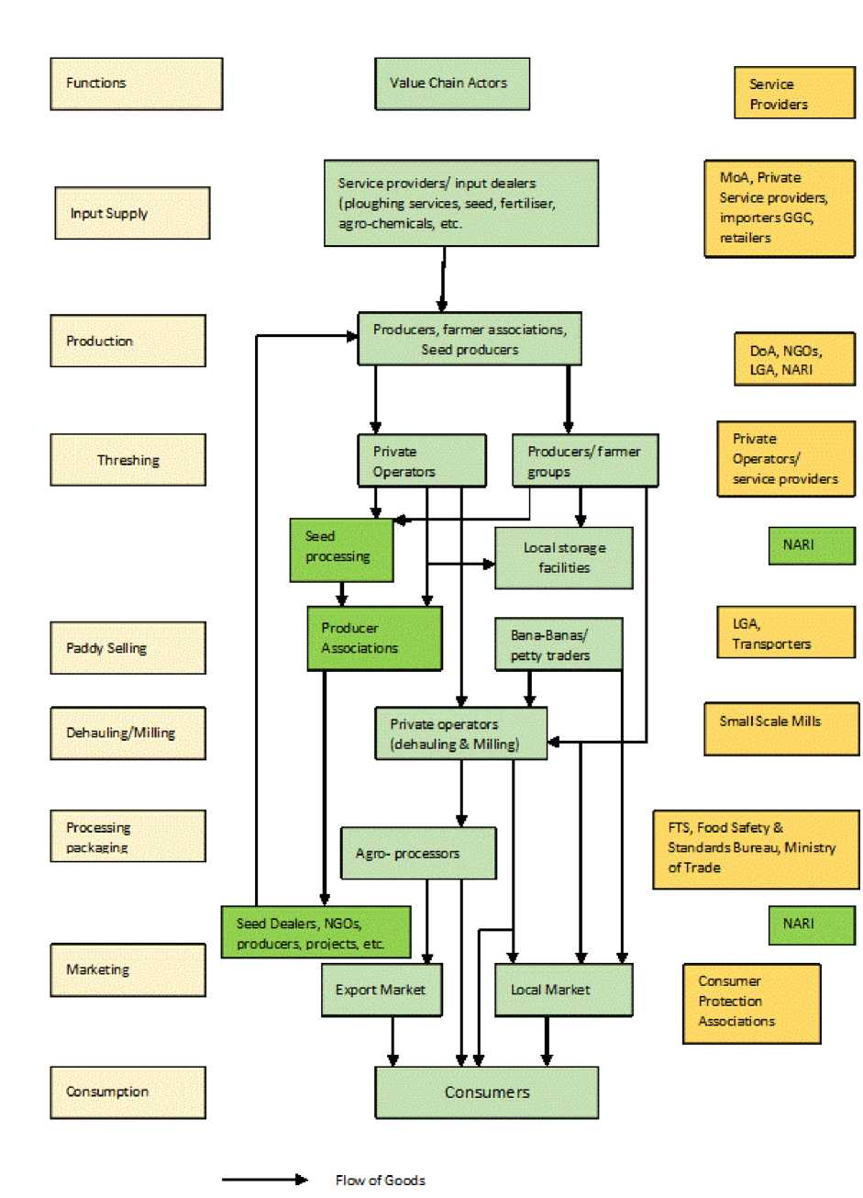

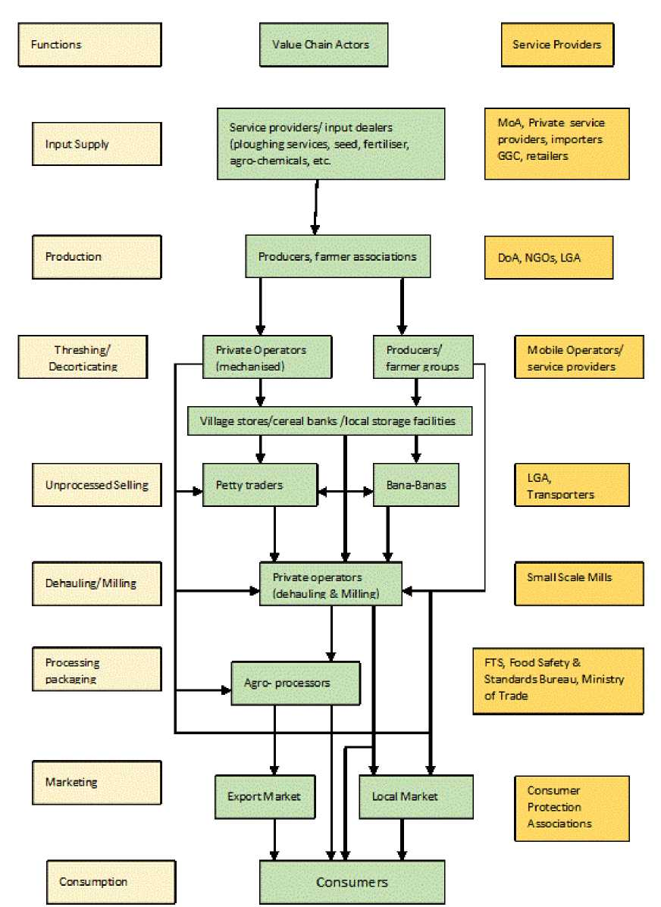

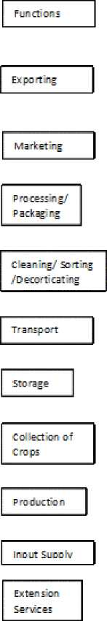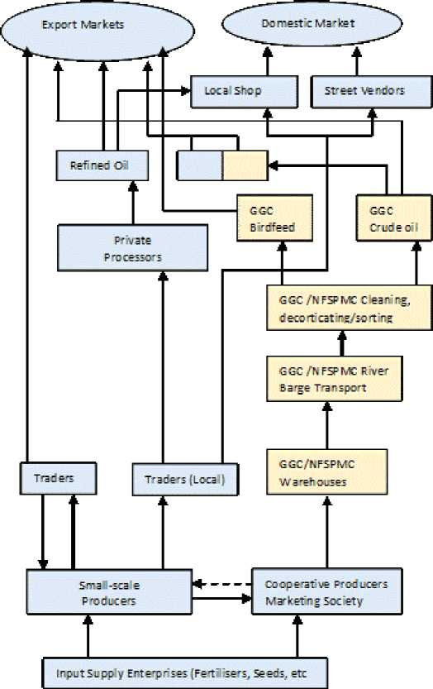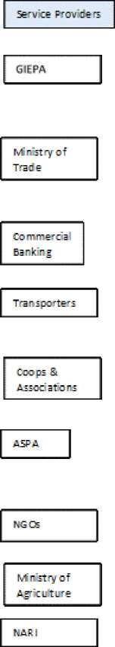

\ atonal Food Security, Processing a nd Market'ng Cooperation/ Gambia Groundnut Co unci

Flow of Goods

Flow of Finance

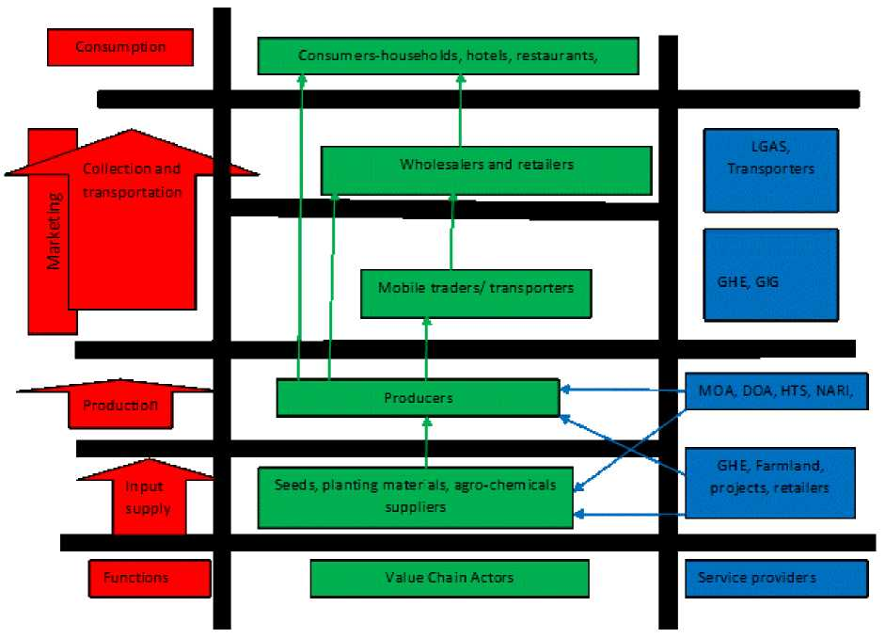

***Annex 3 Figure 5: Commercial Broiler Meat Marketing Chain***

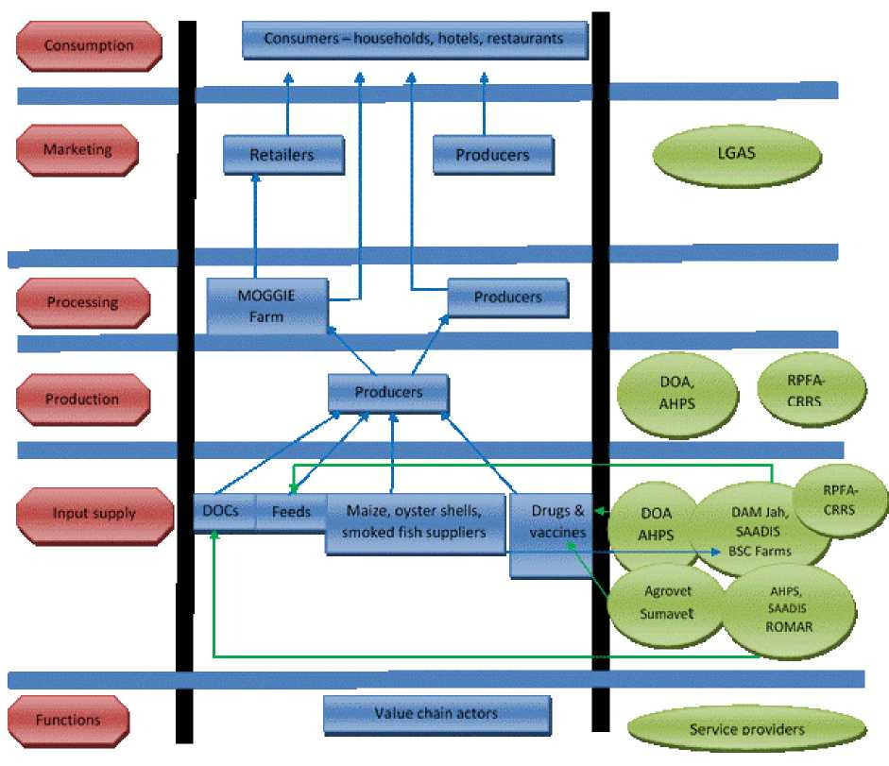

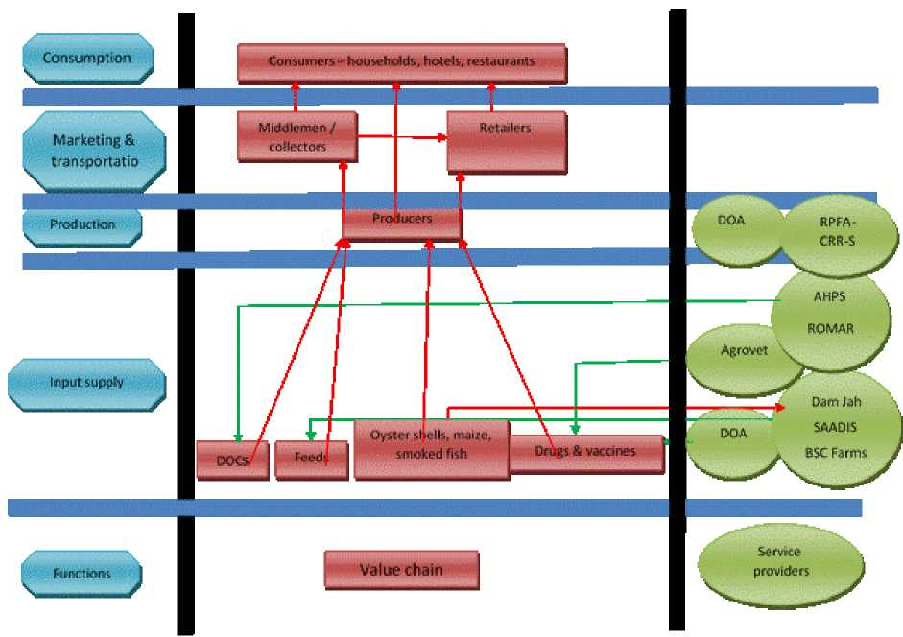

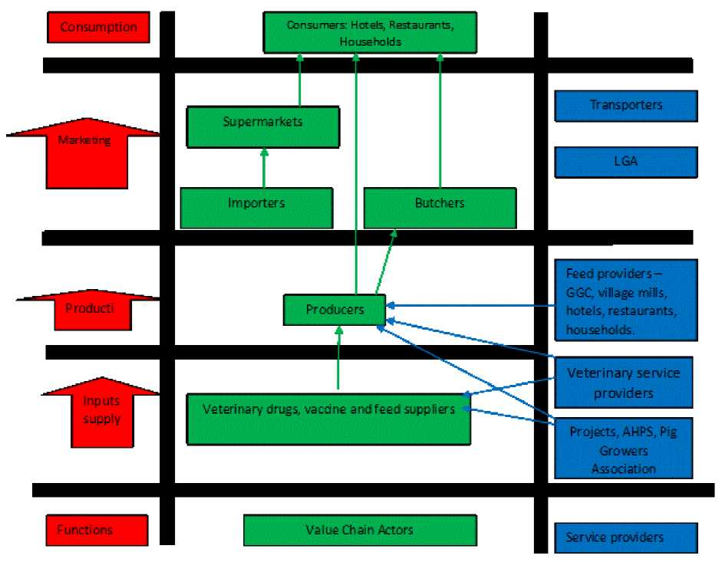

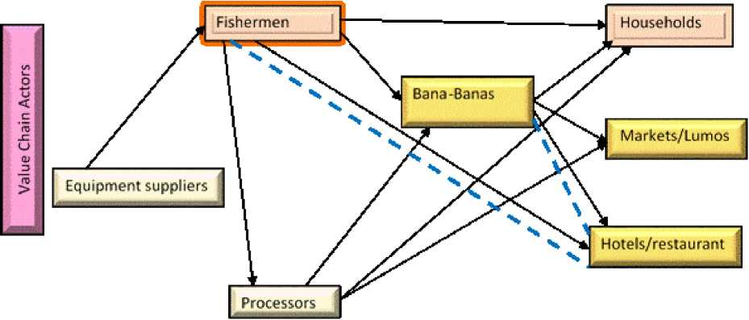

1. Integrated Household Survey
2. Food security (is) a situation that exists when all people, at all times, have physical social and economic access to sufficient, safe, and nutritious food that meets their dietary needs and food preferences for an active healthy life.
3. SMART is *Standardized Monitoring and Assessment of Relief and Transition*), a methodology used to conduct a national nutrition and mortality survey of The Gambian population
4. PAGE mid-term review 2014
5. 55 Regional Workshop to harmonize the methodologies for conducting the AHC-STAFF project’ studies, 25-26th January 2016-Abdijan- Cote D’Ivoire
6. National Food Security, Processing and Marketing Cooperation
7. Gambia Horticultural Enterprise